**CSA1667 Data warehousing and Data mining**

# Day-1

**Q1:**

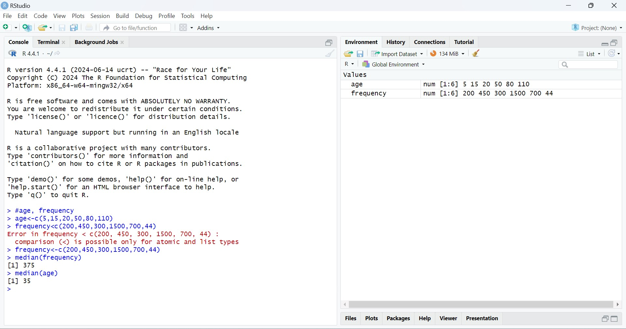

Q2:

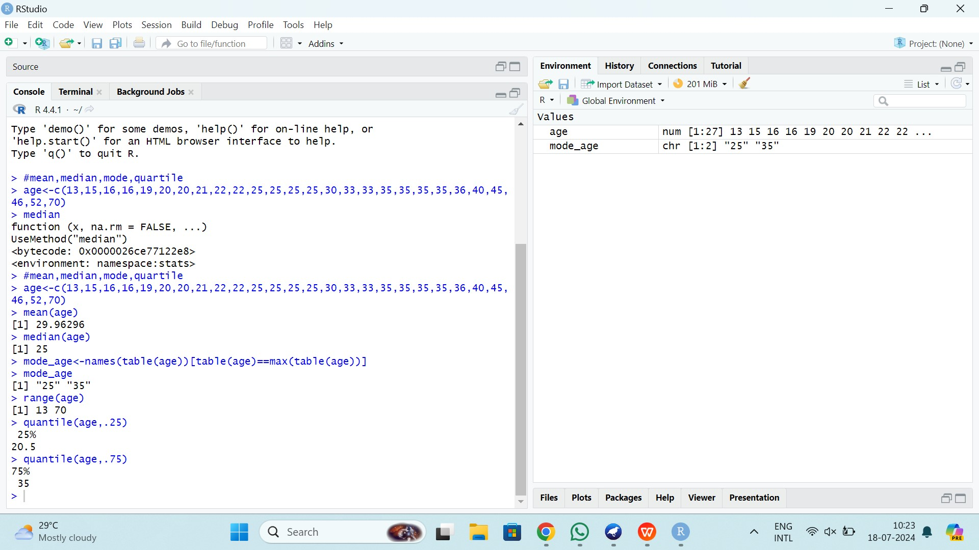

Q3:

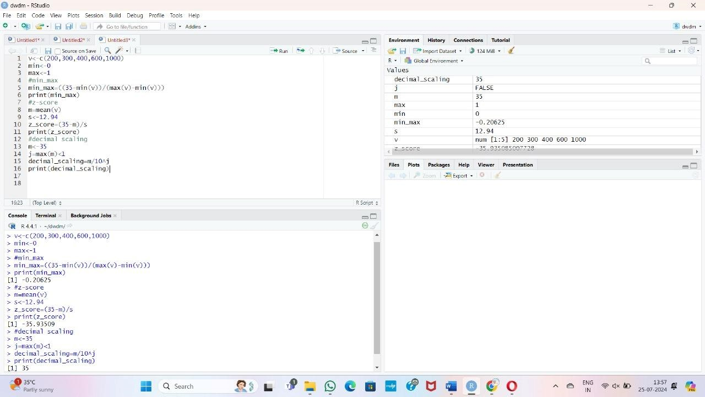

Q4:

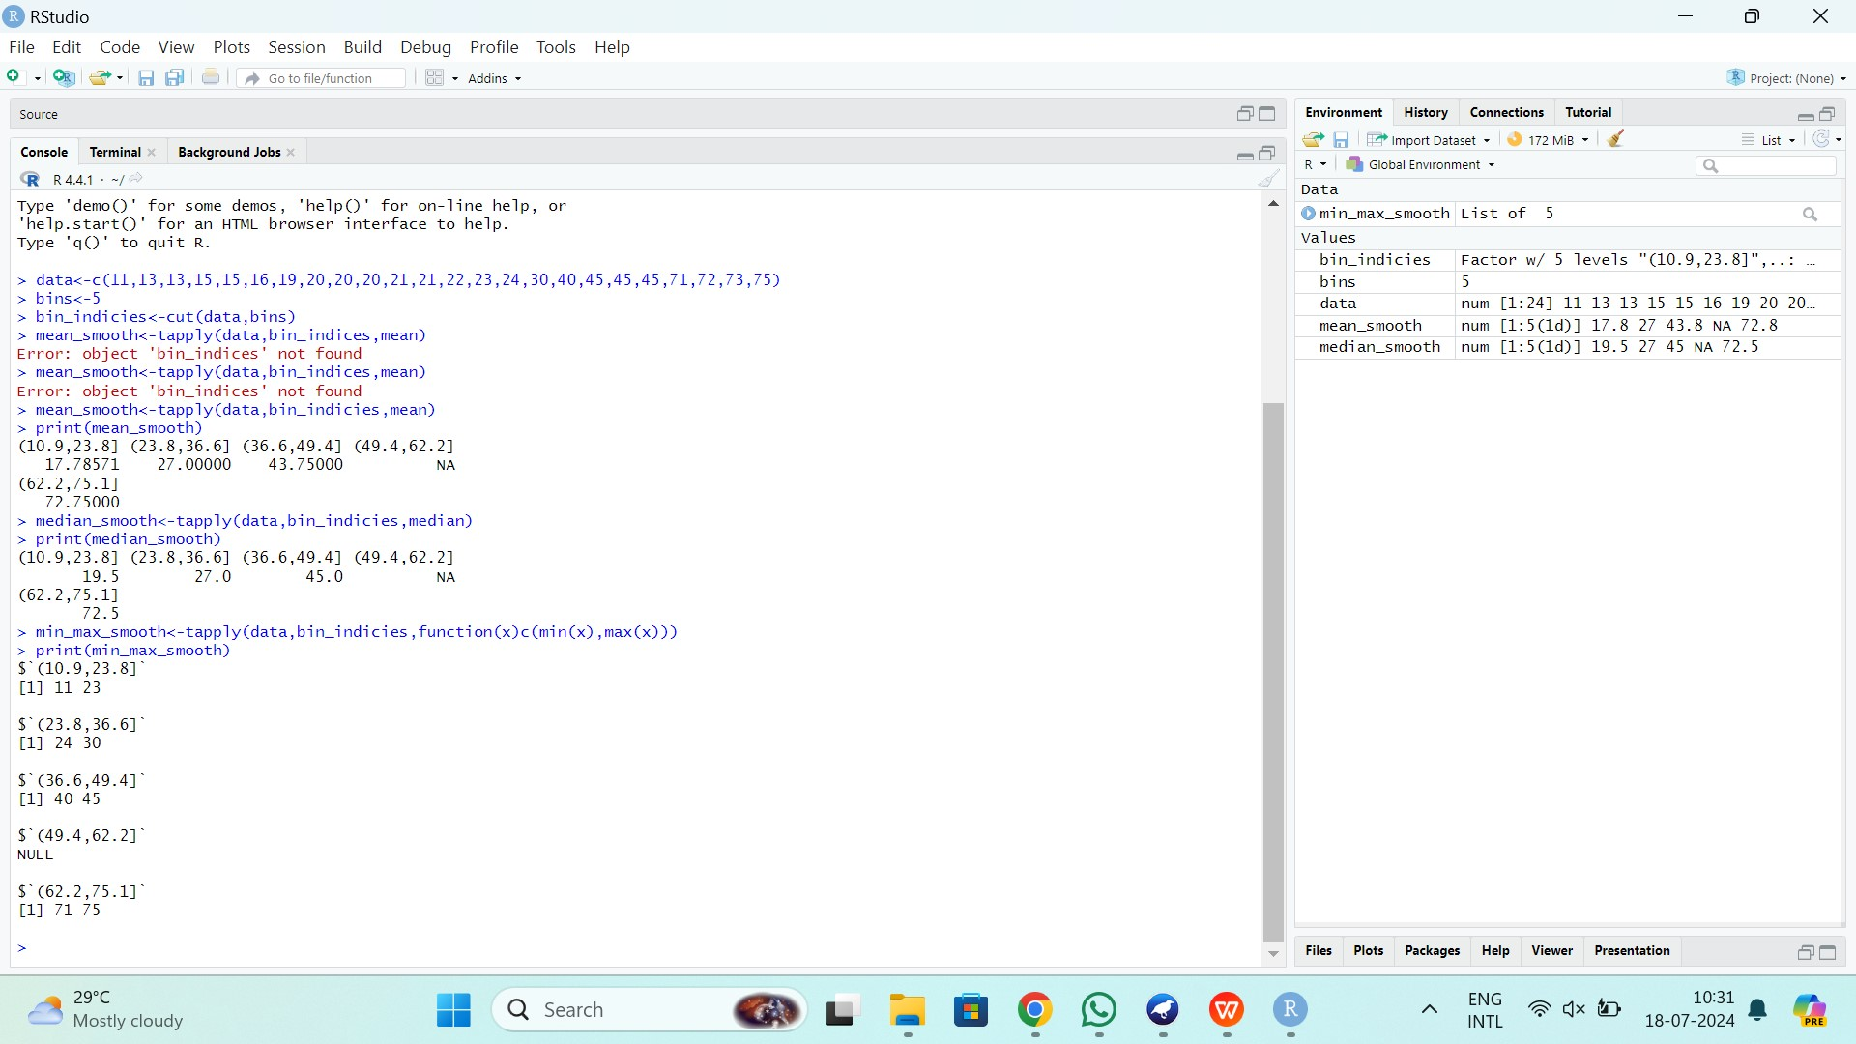

**Q5:**

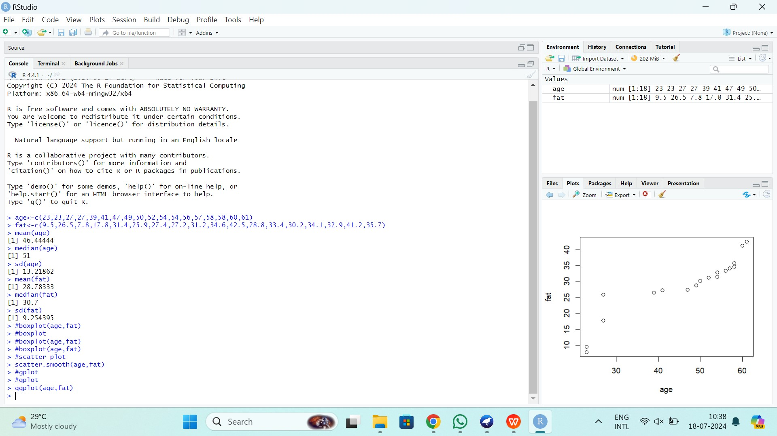

Q6:

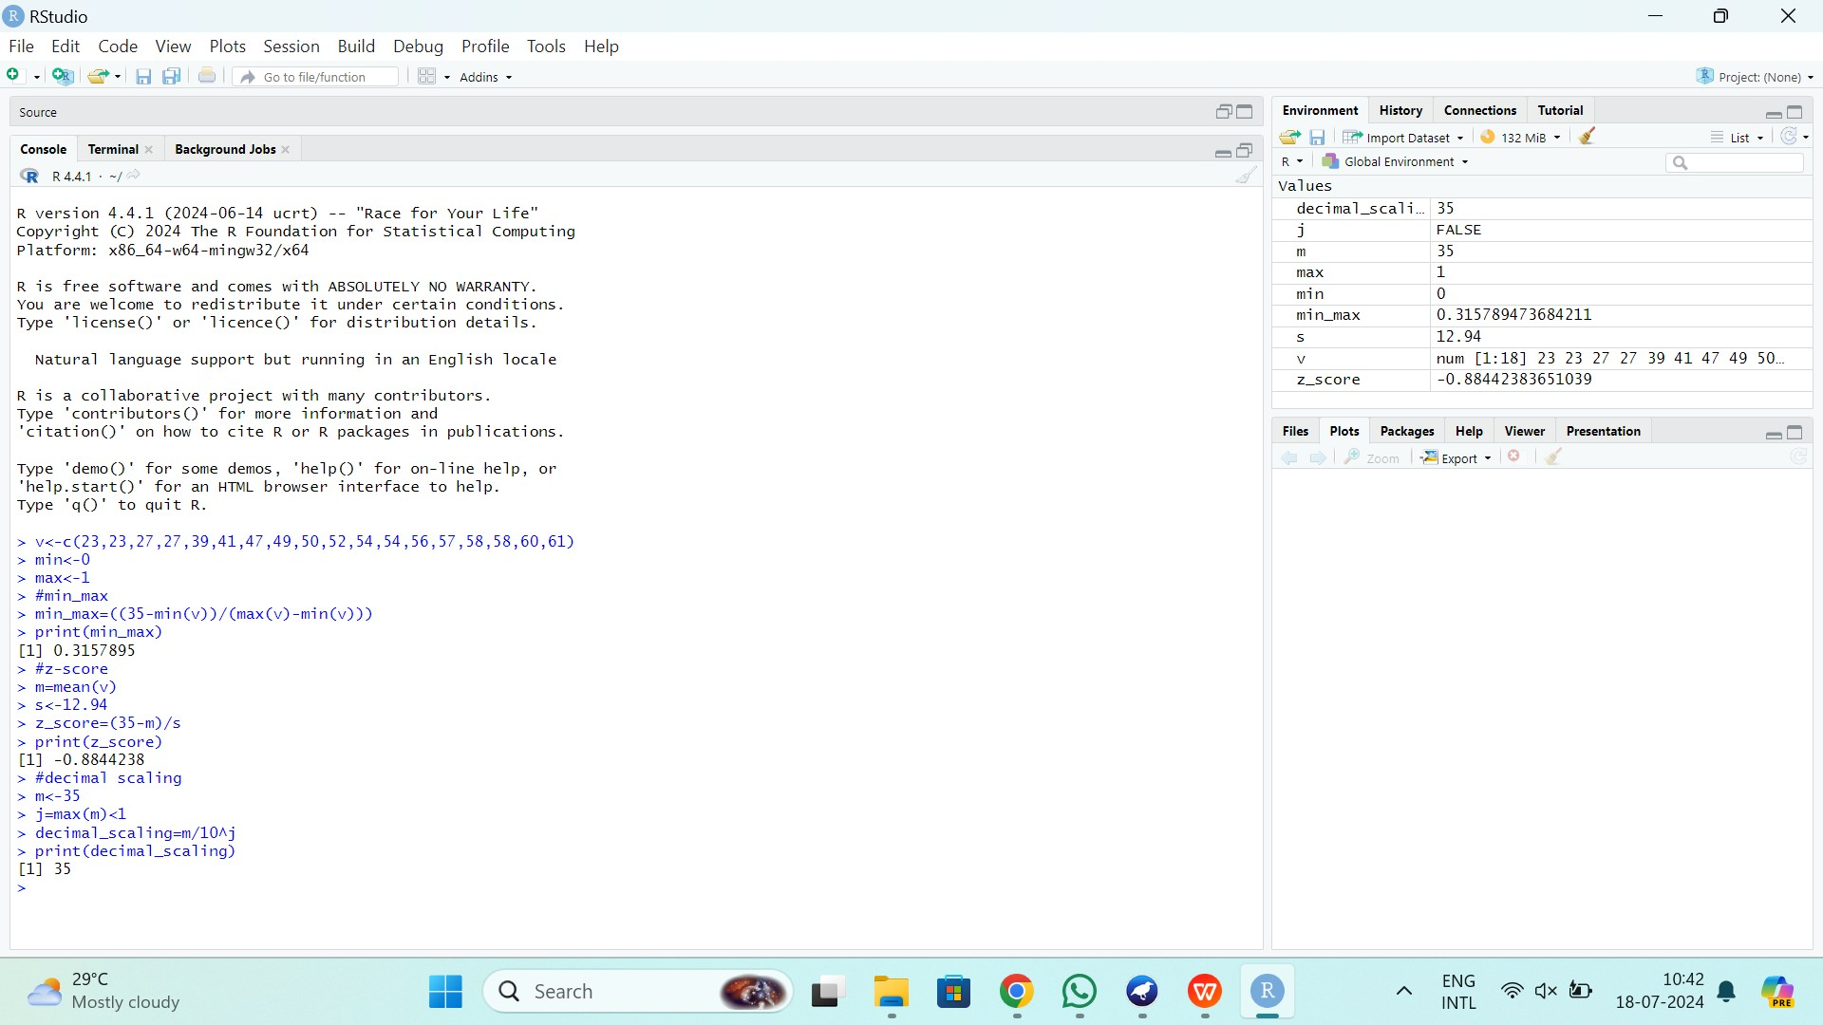

**Q7:**



**Q8:**

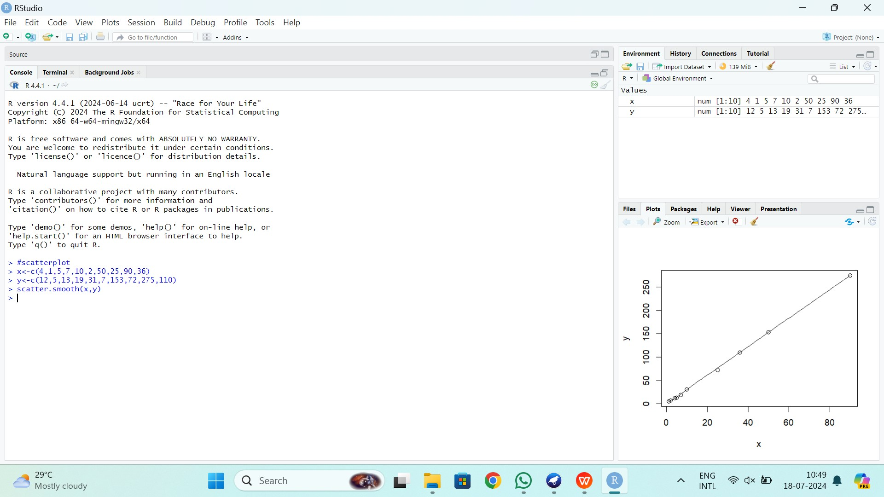

**Q9:**

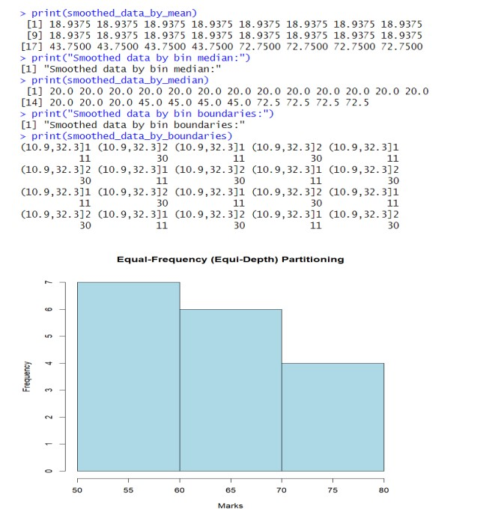

**Q10:**

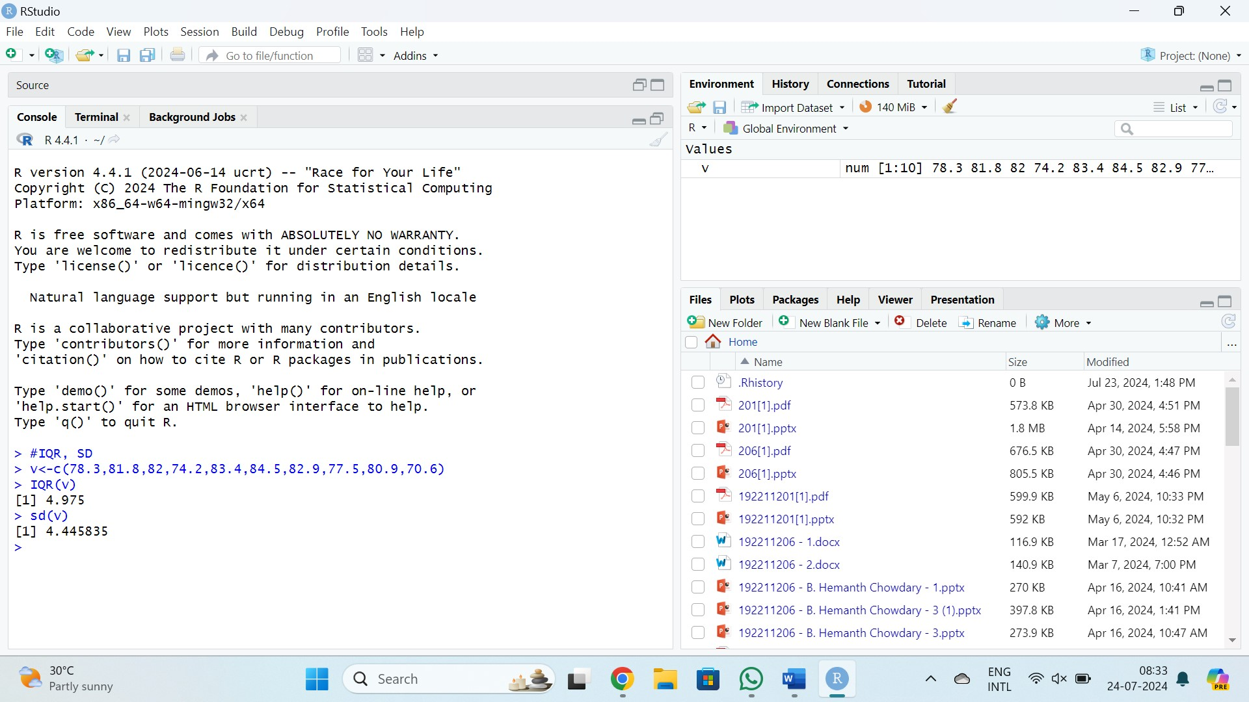

**Q11:**

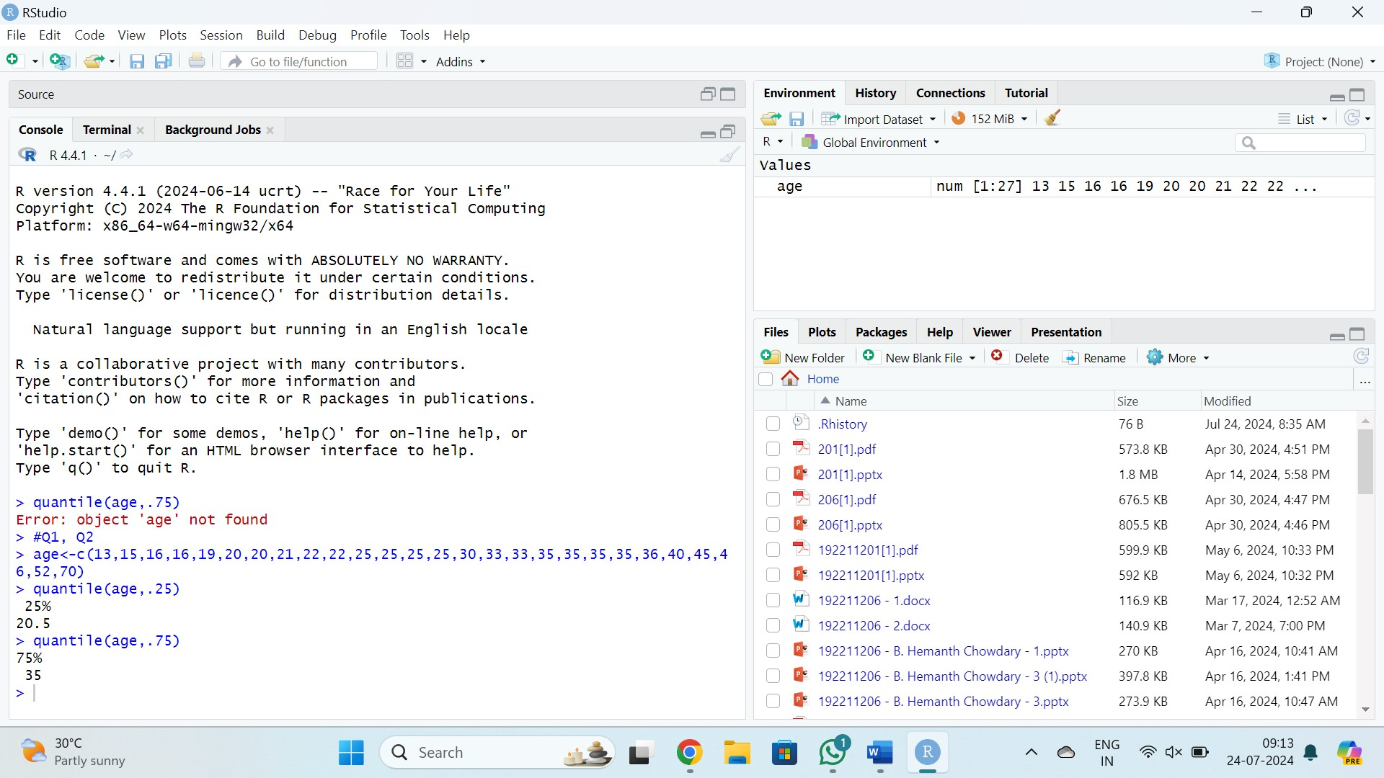

# Day-2

**Q1:**



**Q2:**

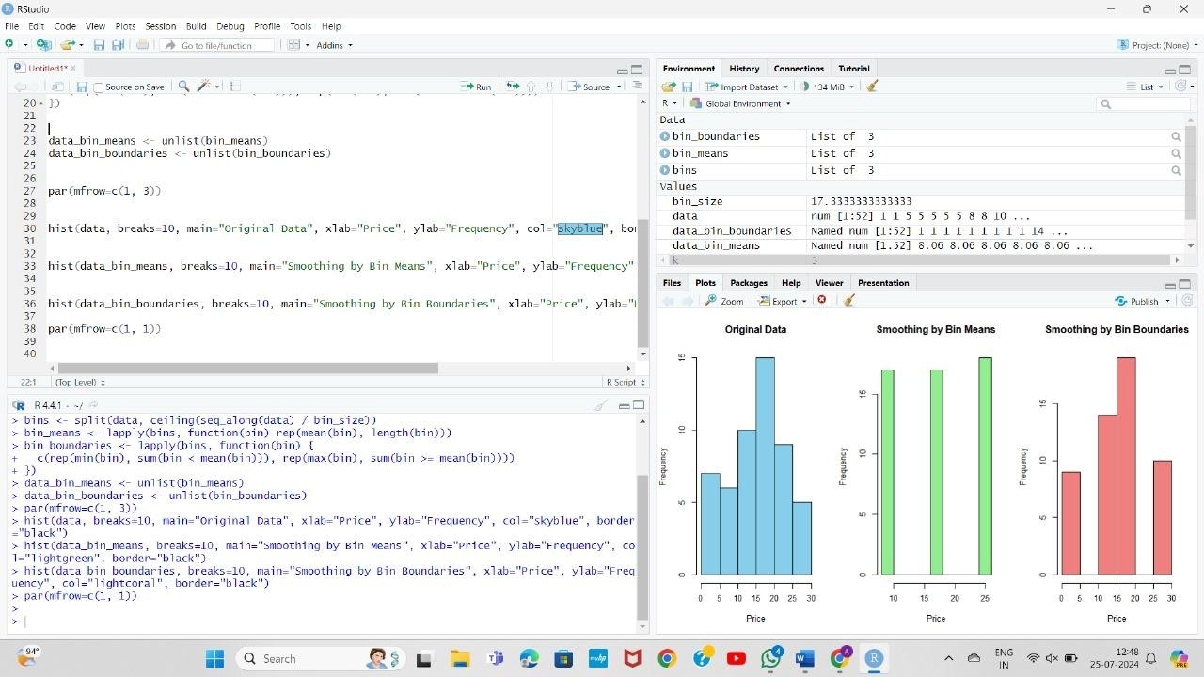

**Q3:**

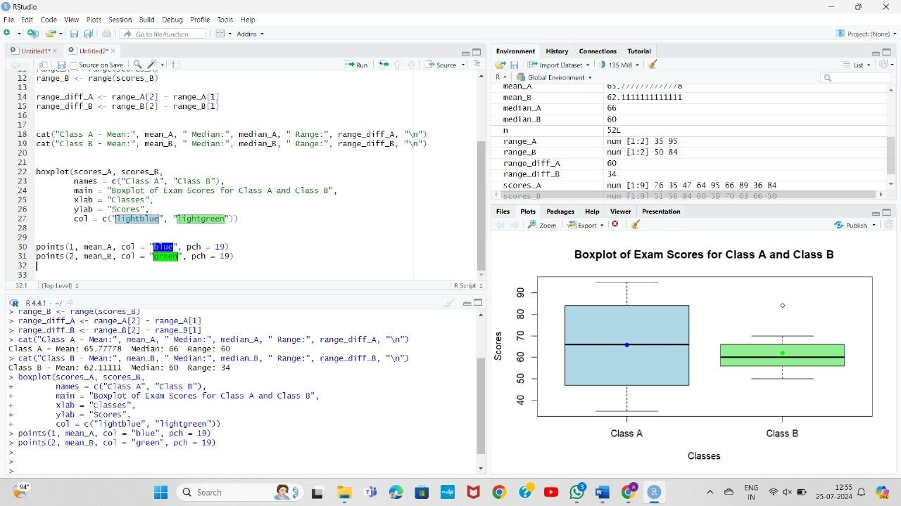

**Q4:**

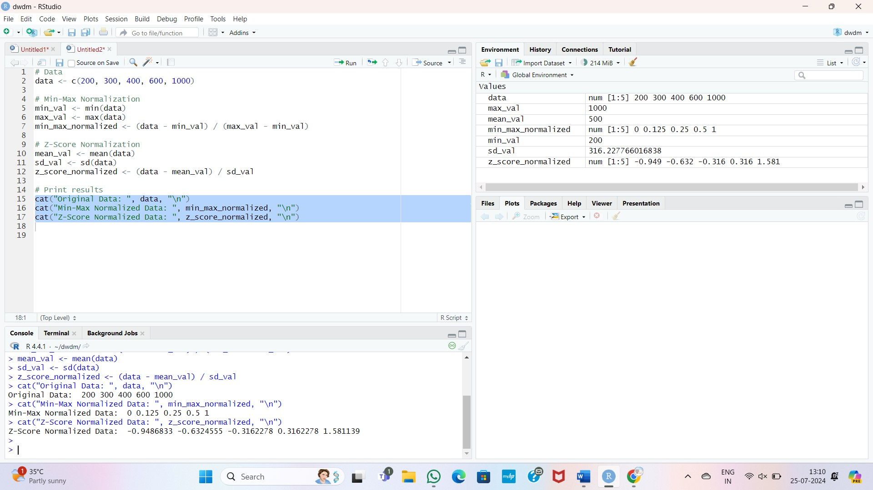

**Q5:**

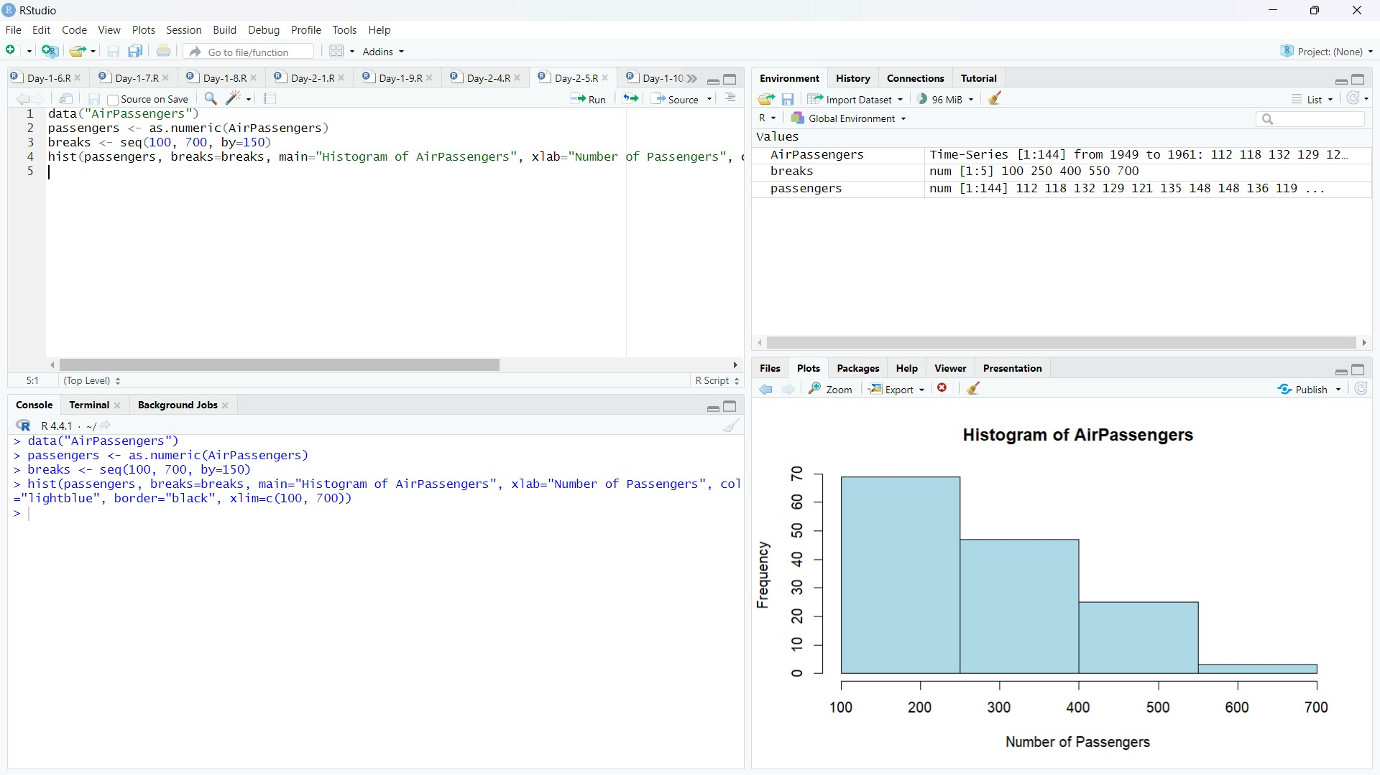

**Q6:**

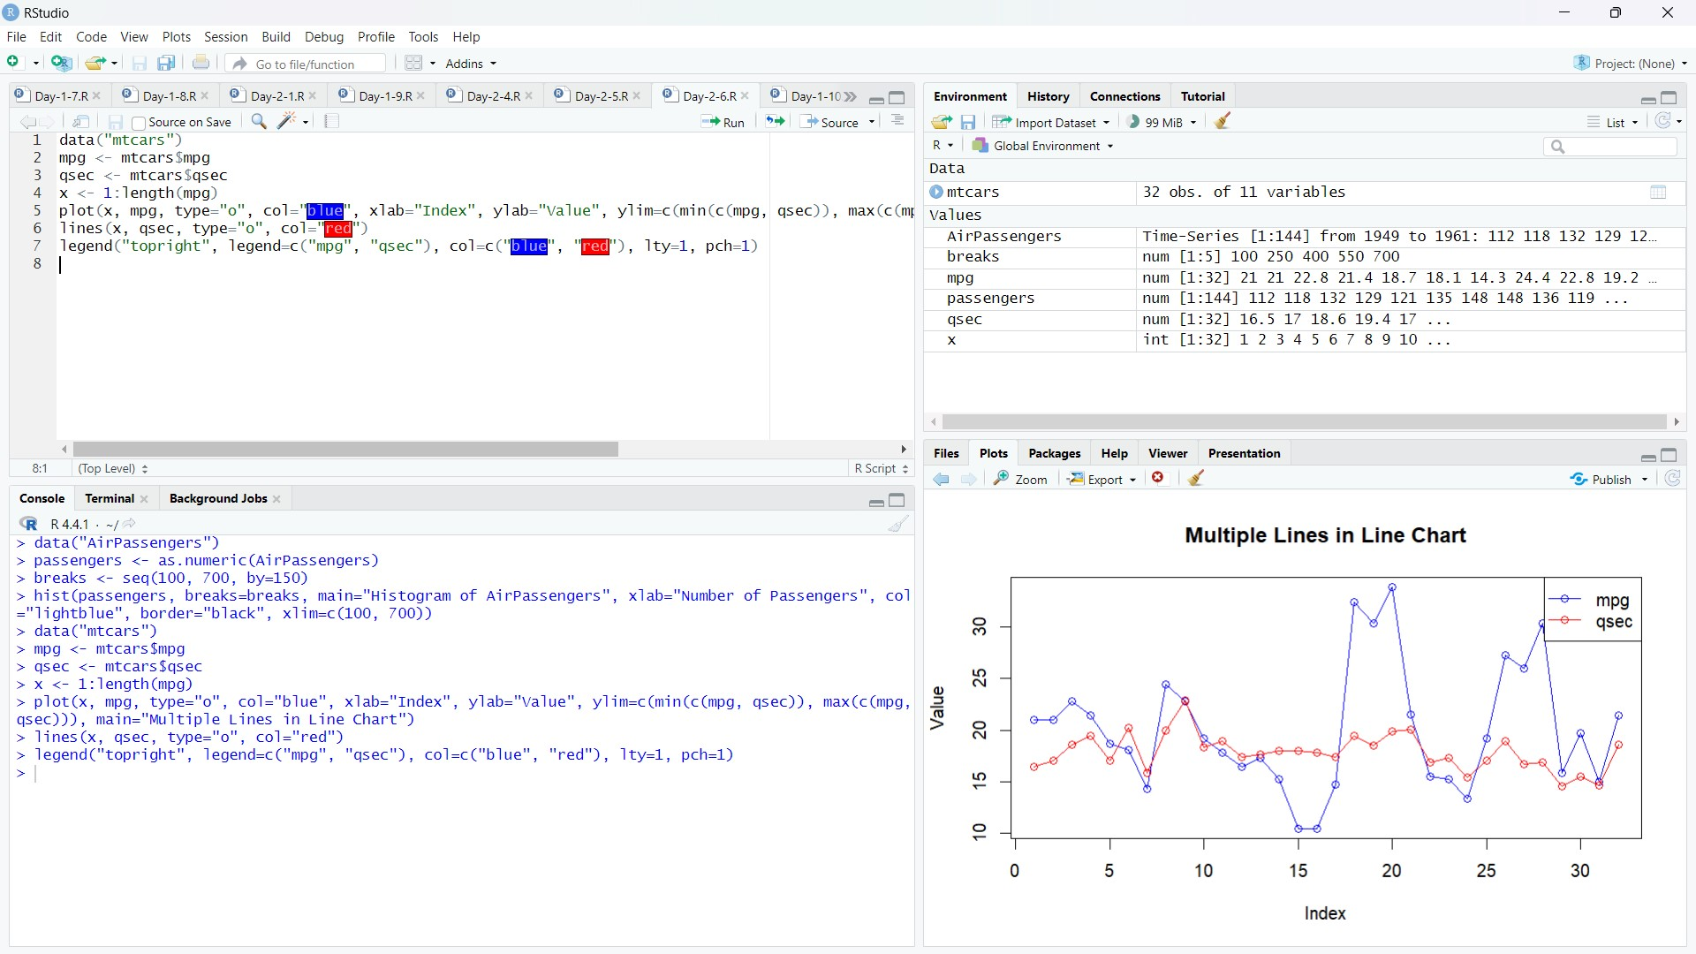

Q7:

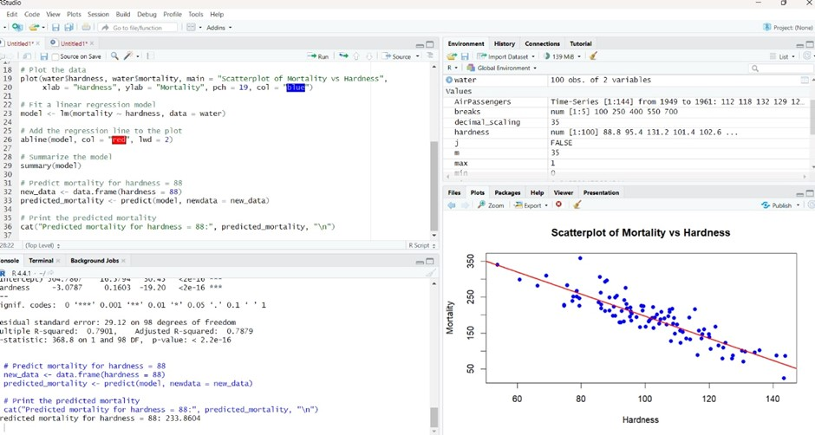

Q8:

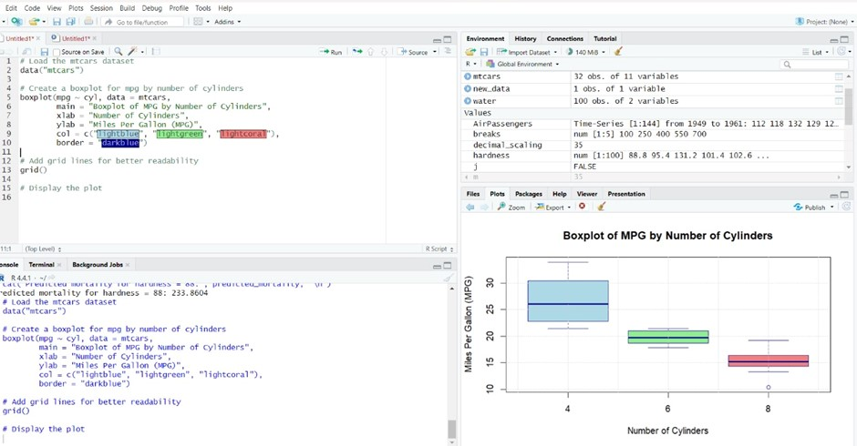

Q9:

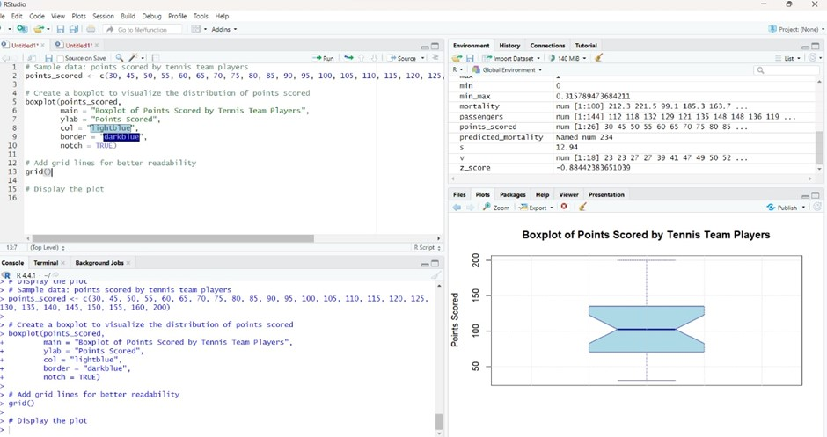

Q10:

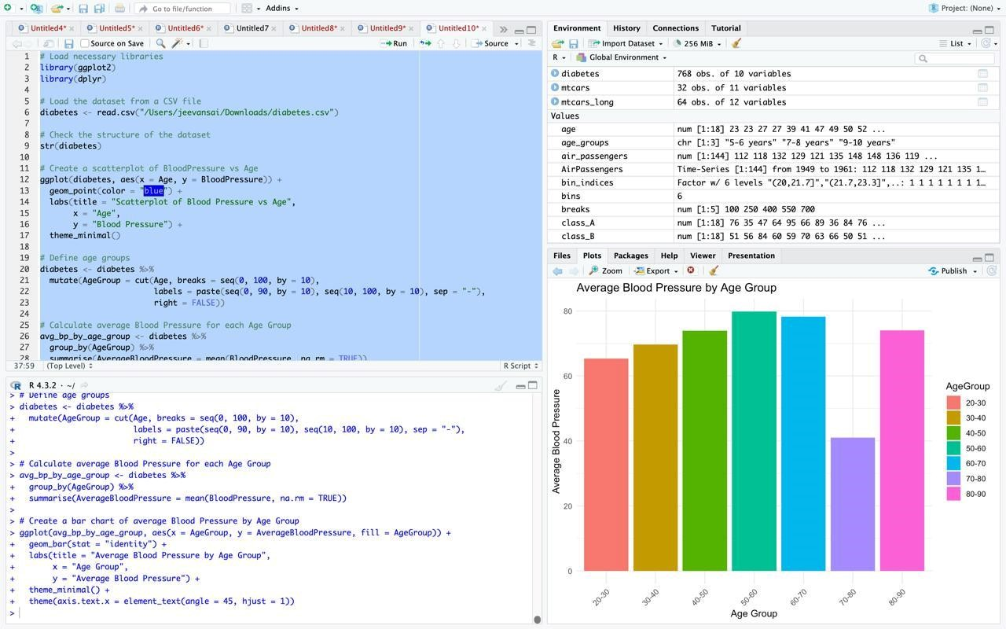

# Day-3

**Q1:**

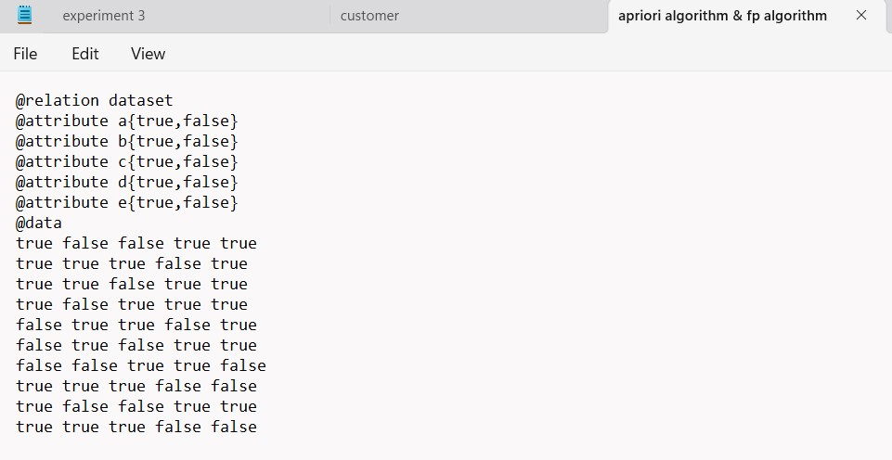

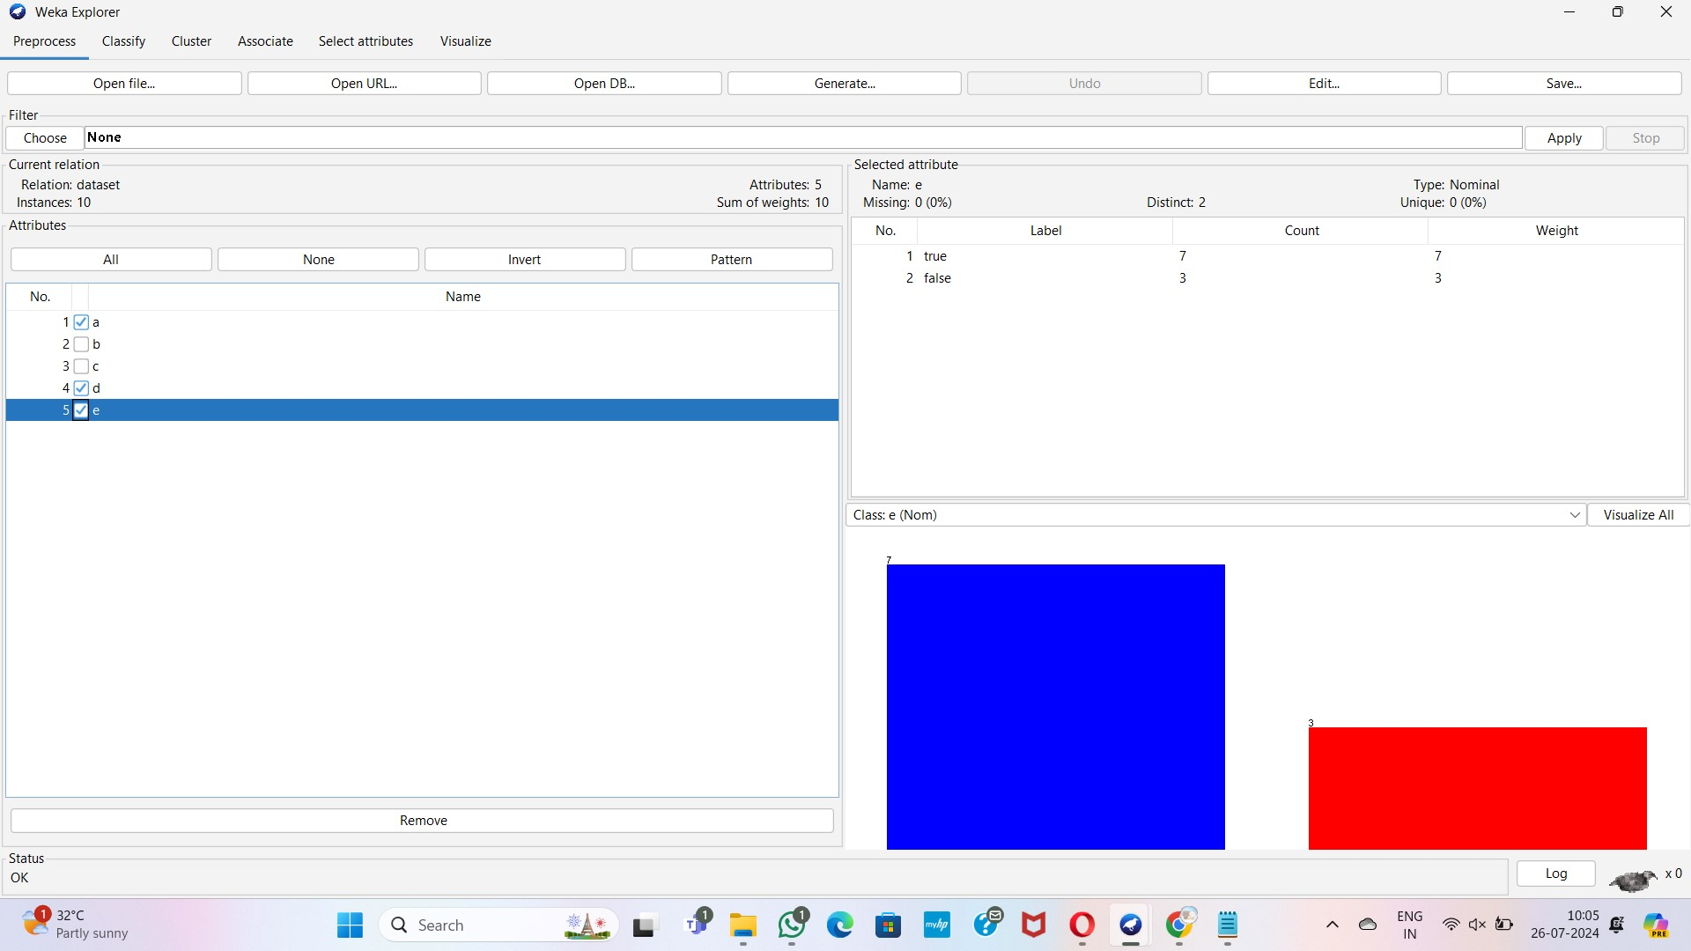

**Apriori algorithm**

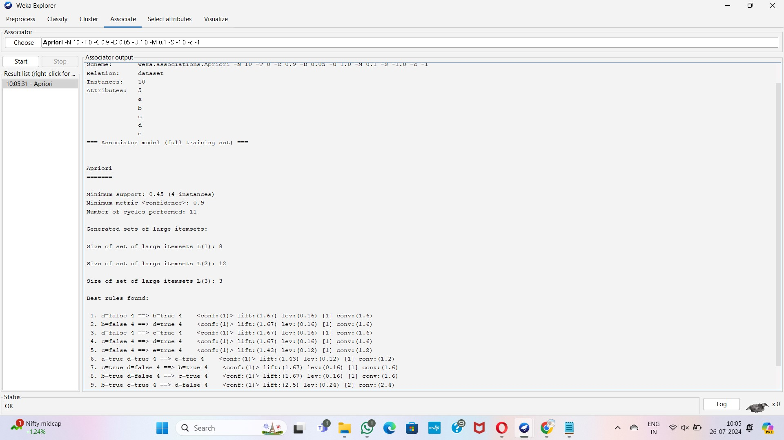

**FP growth**

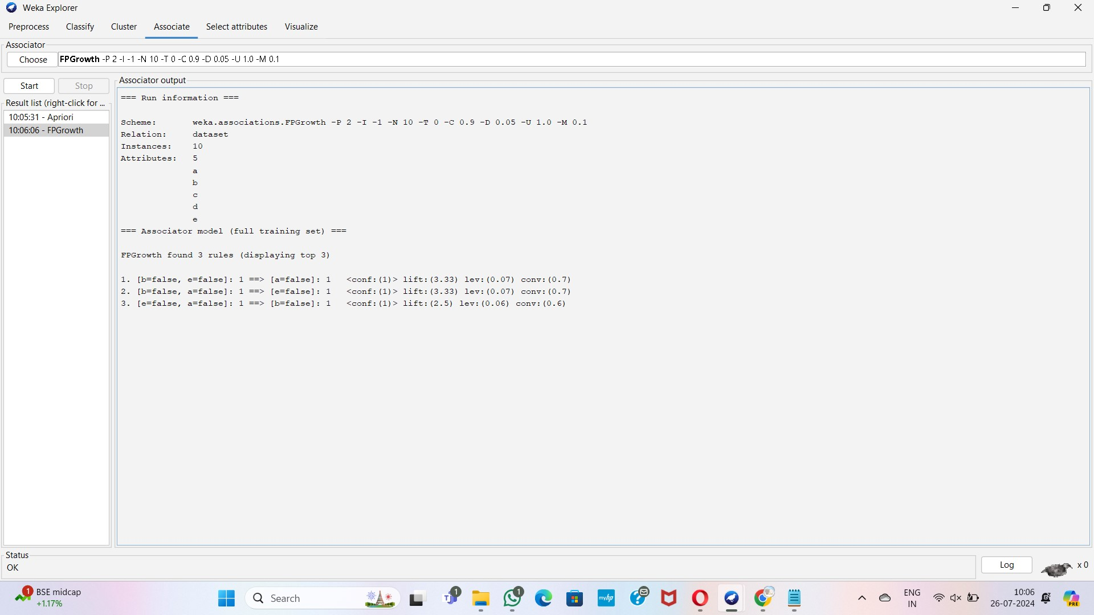

**Q2:**

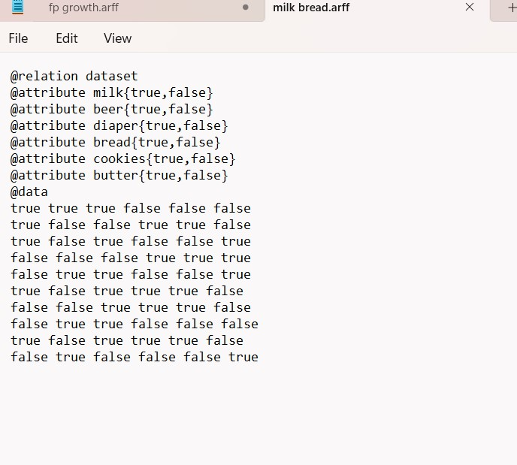

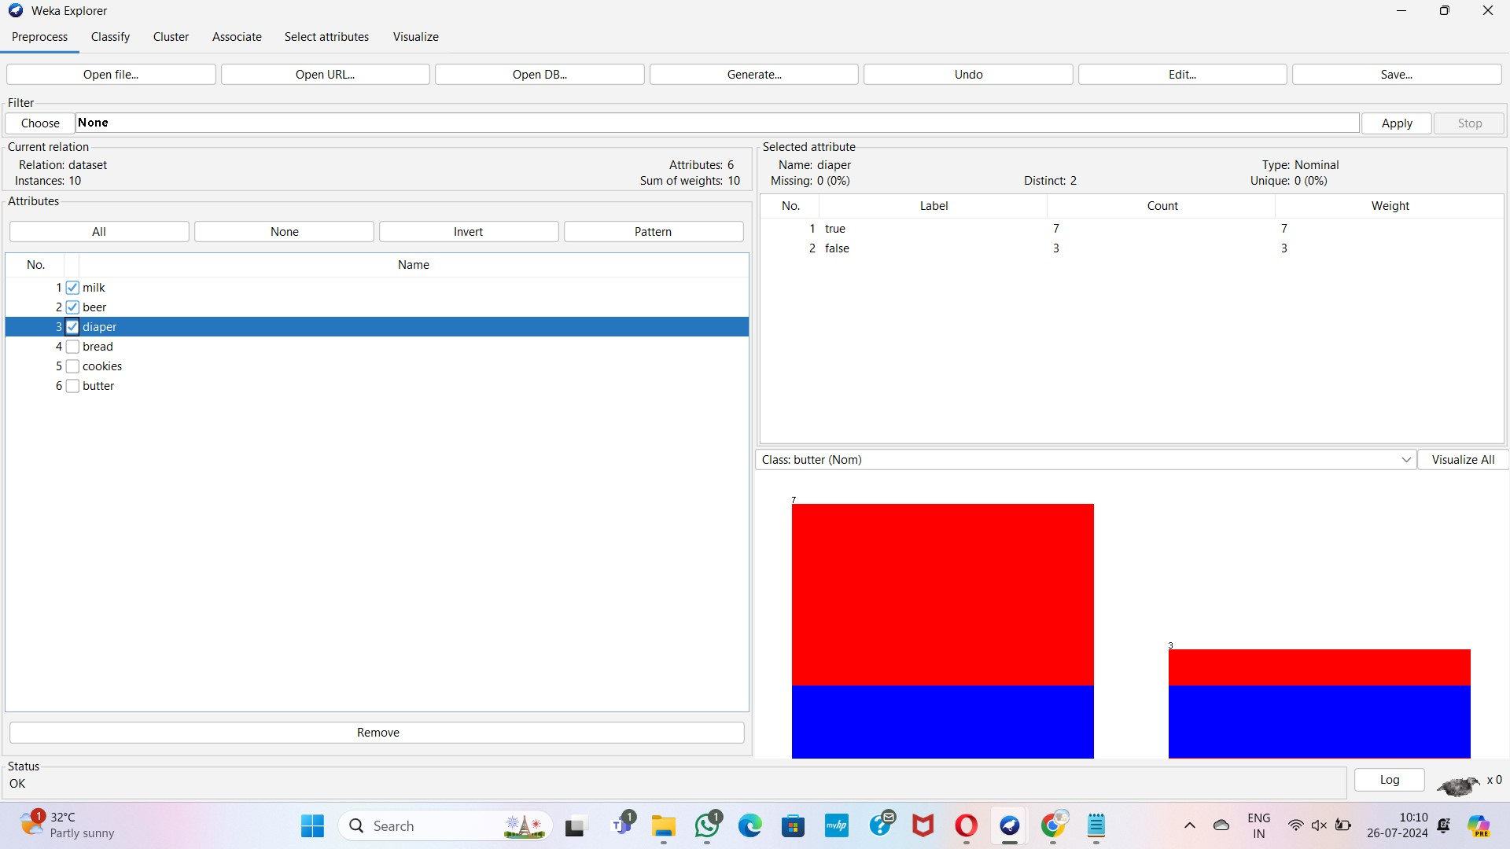

**Apriori**

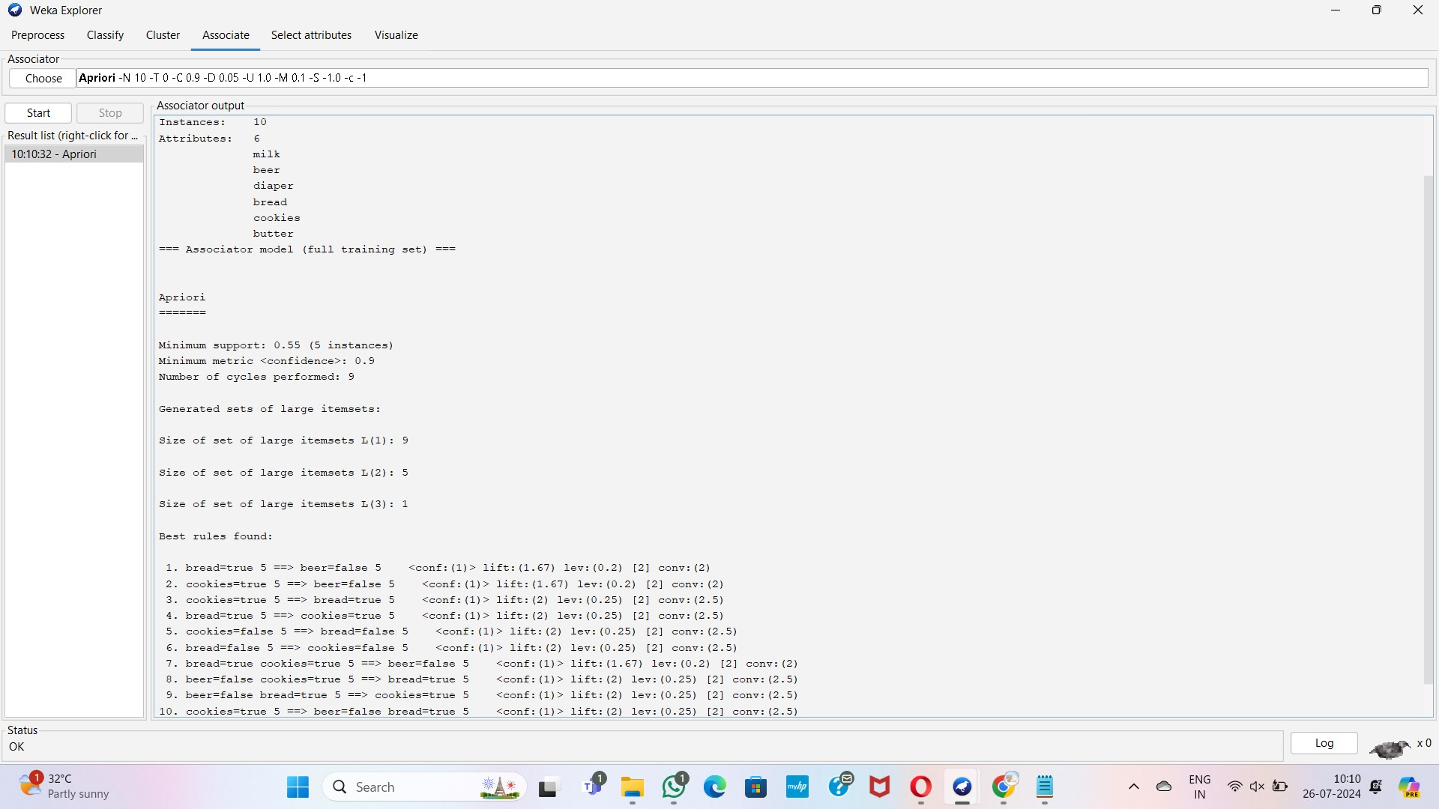

**FP growth**

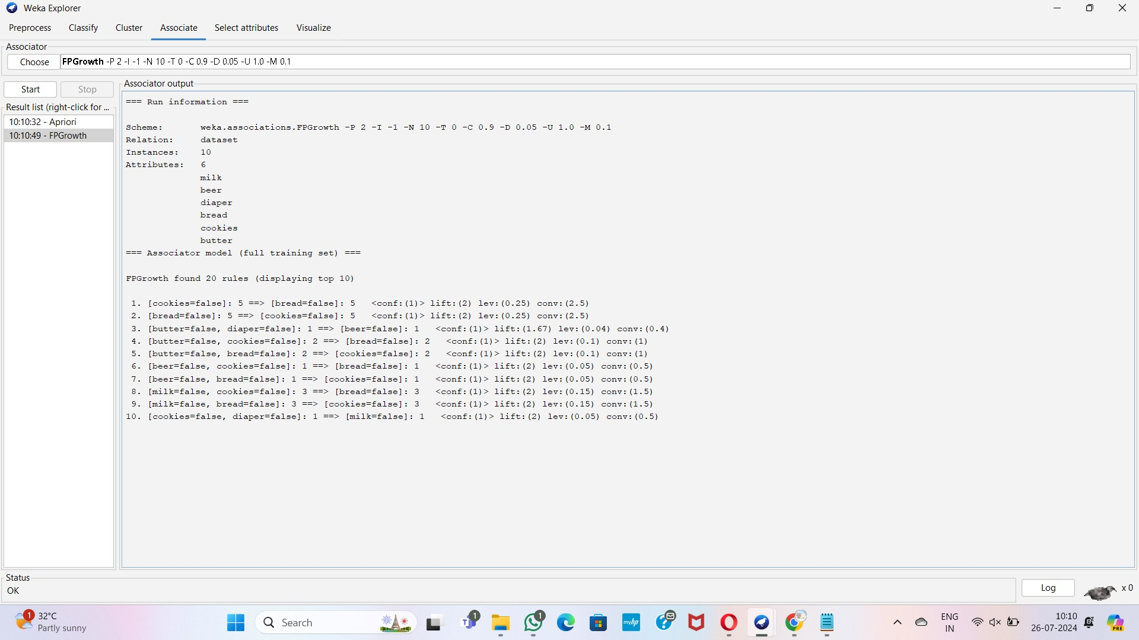

**Q3:**

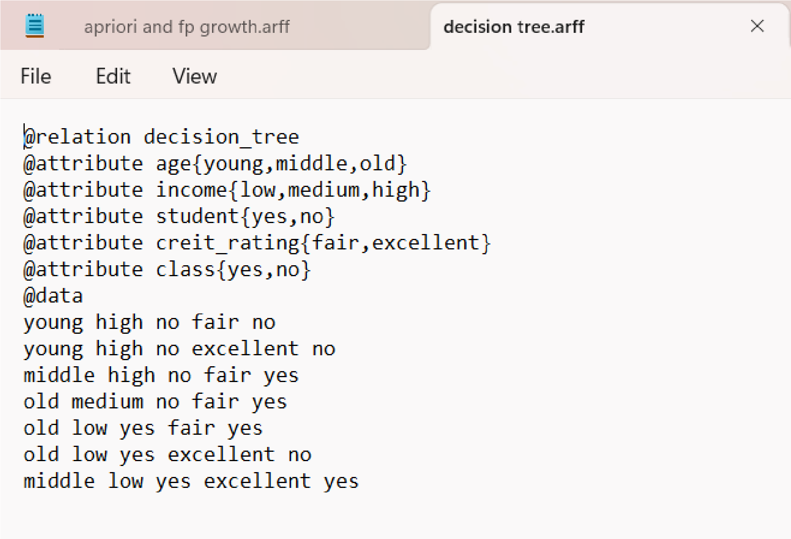

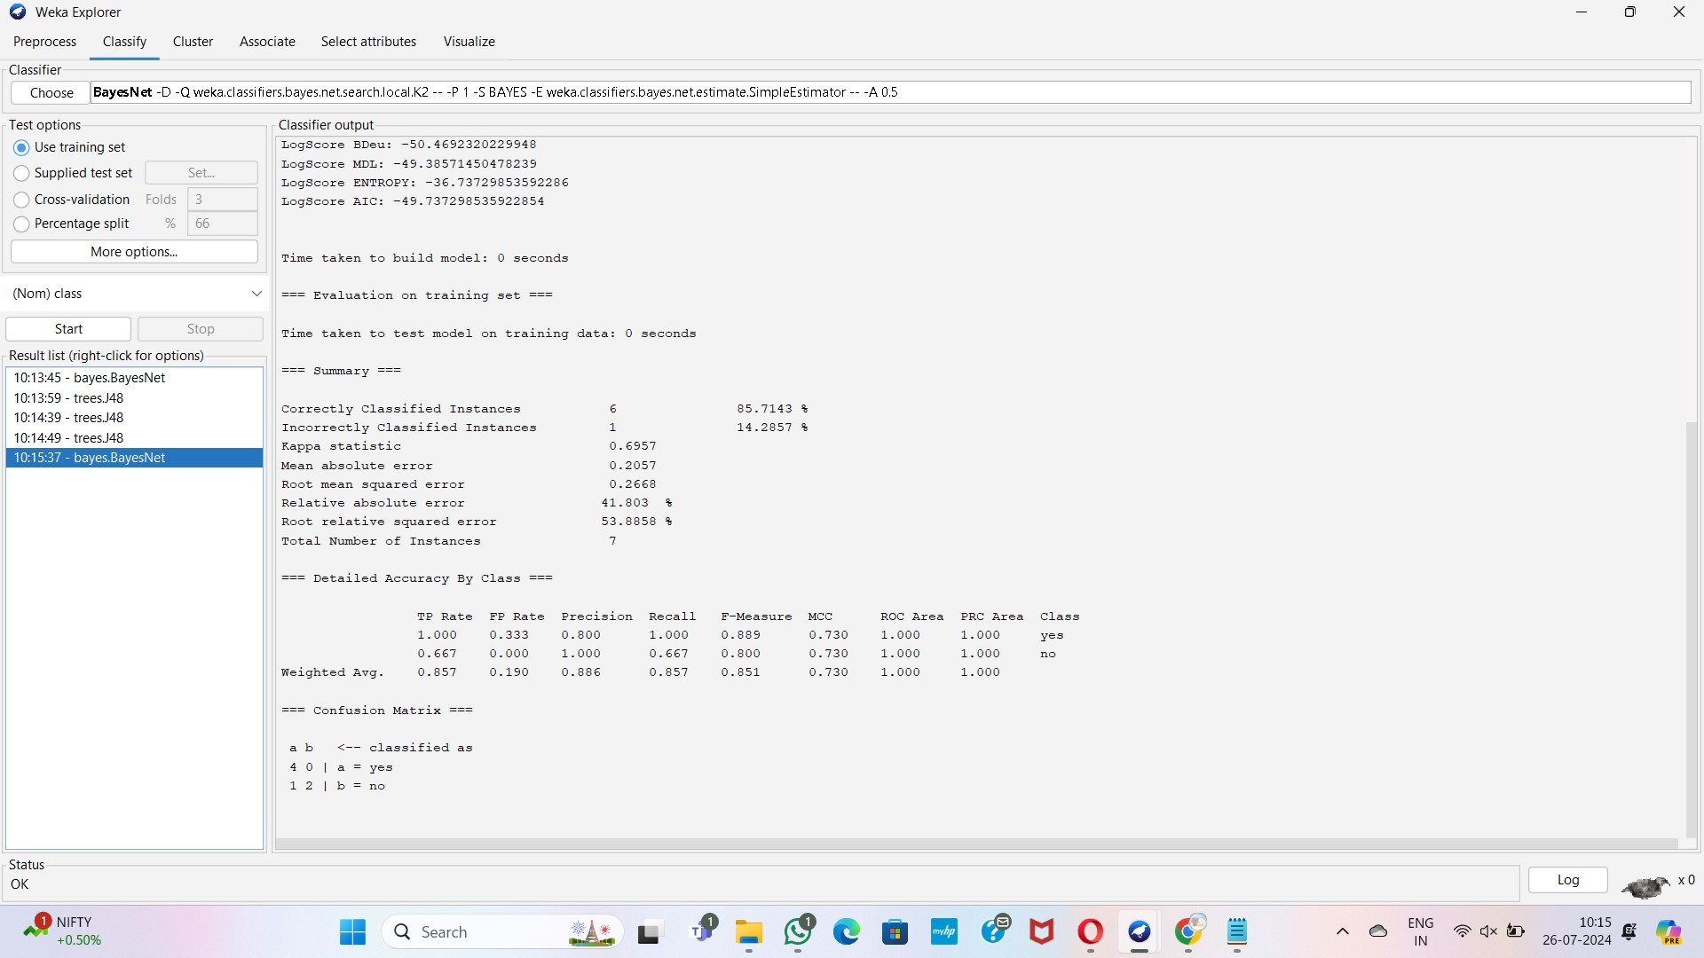

**Decision tree**

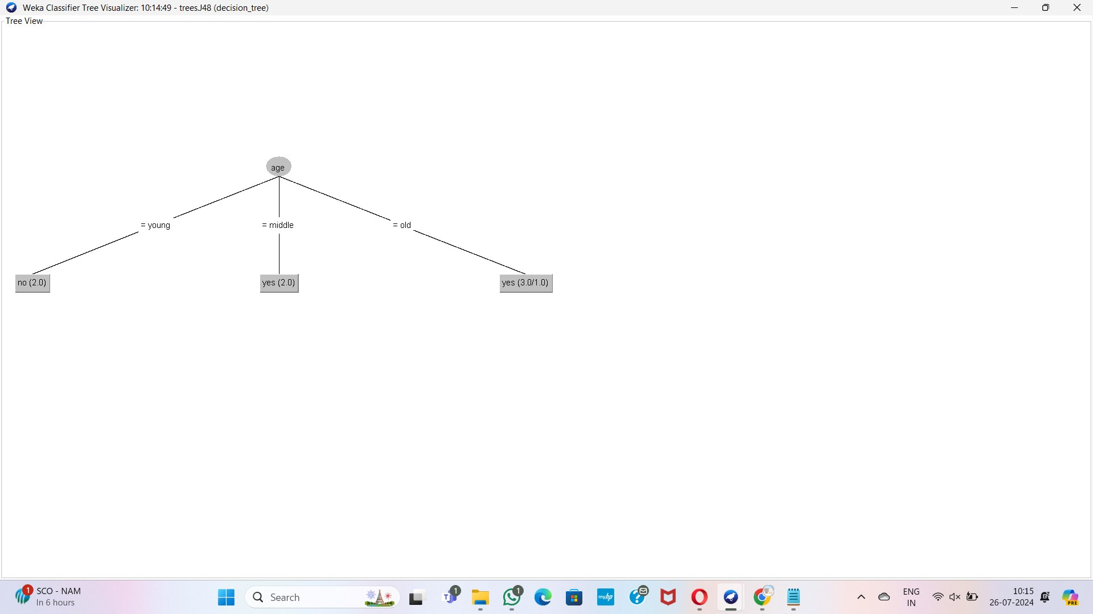

**Q4:**

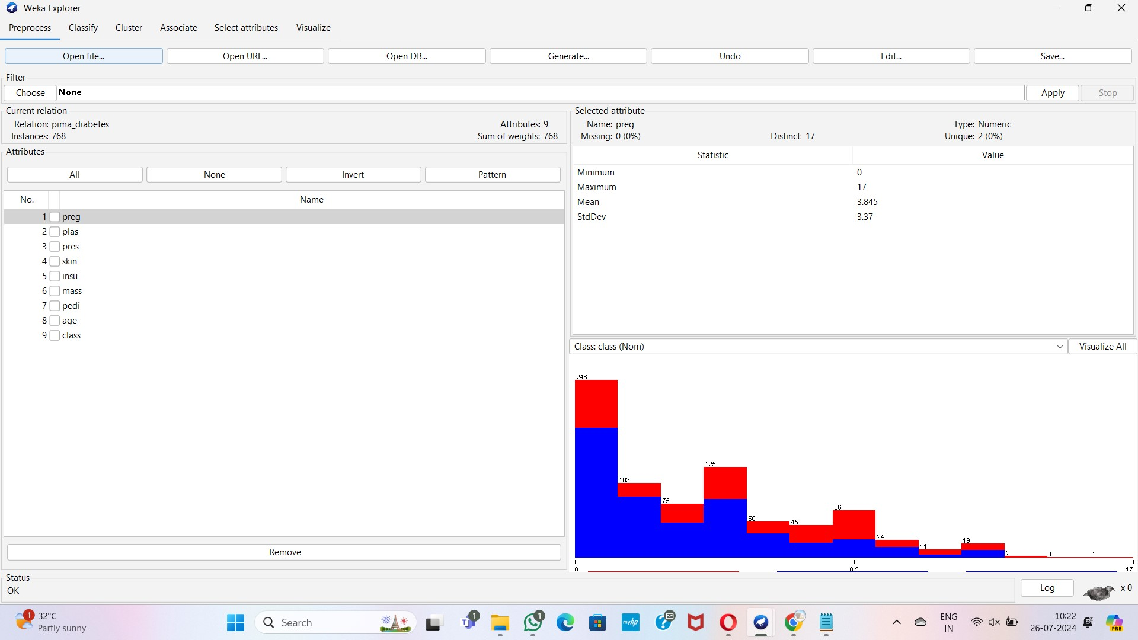

**Linear regression**

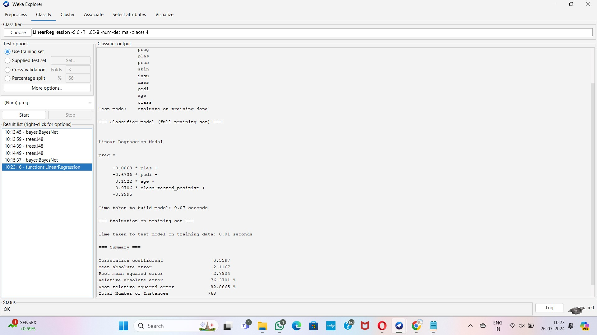

## Multiple regression

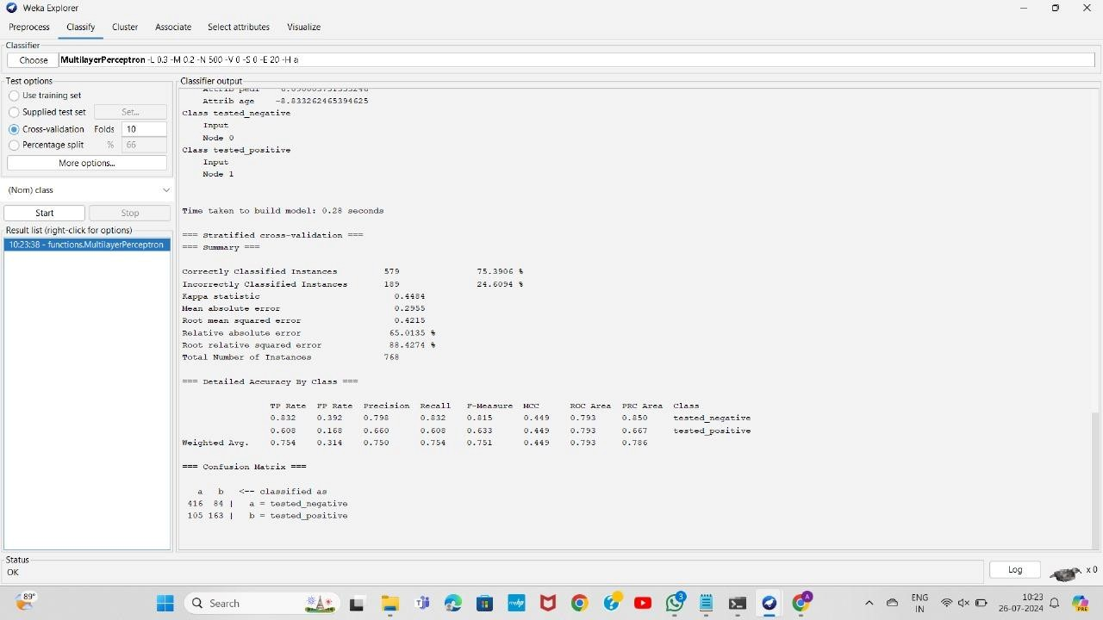

**Q5:**

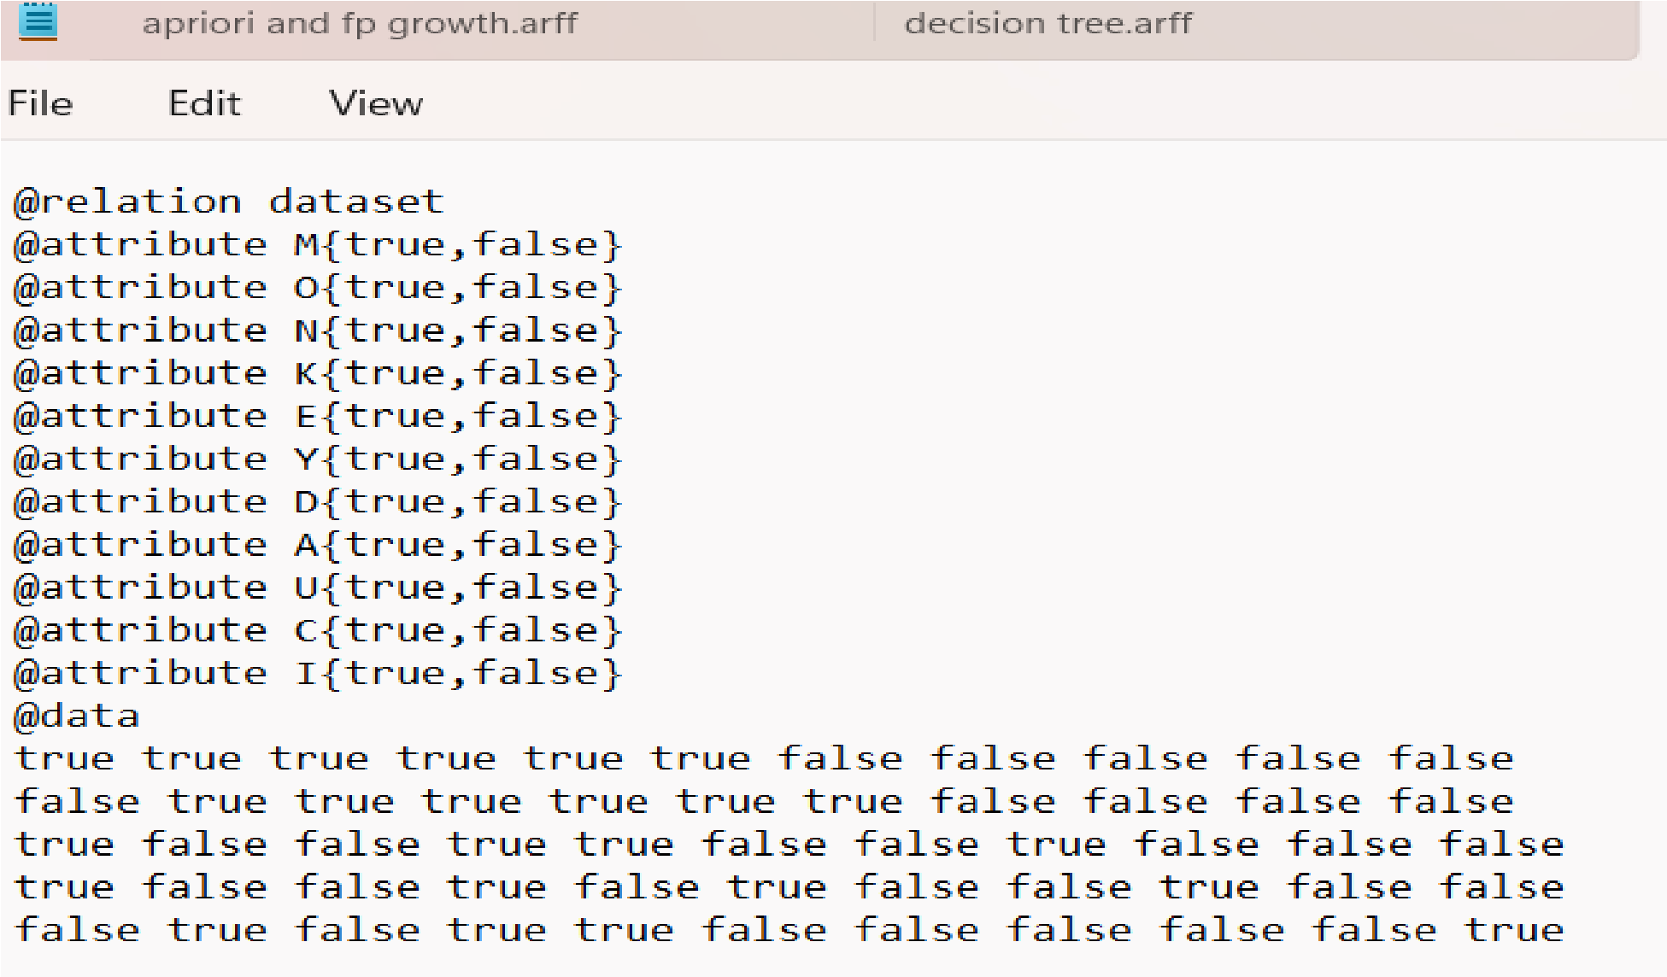

**Apriori**

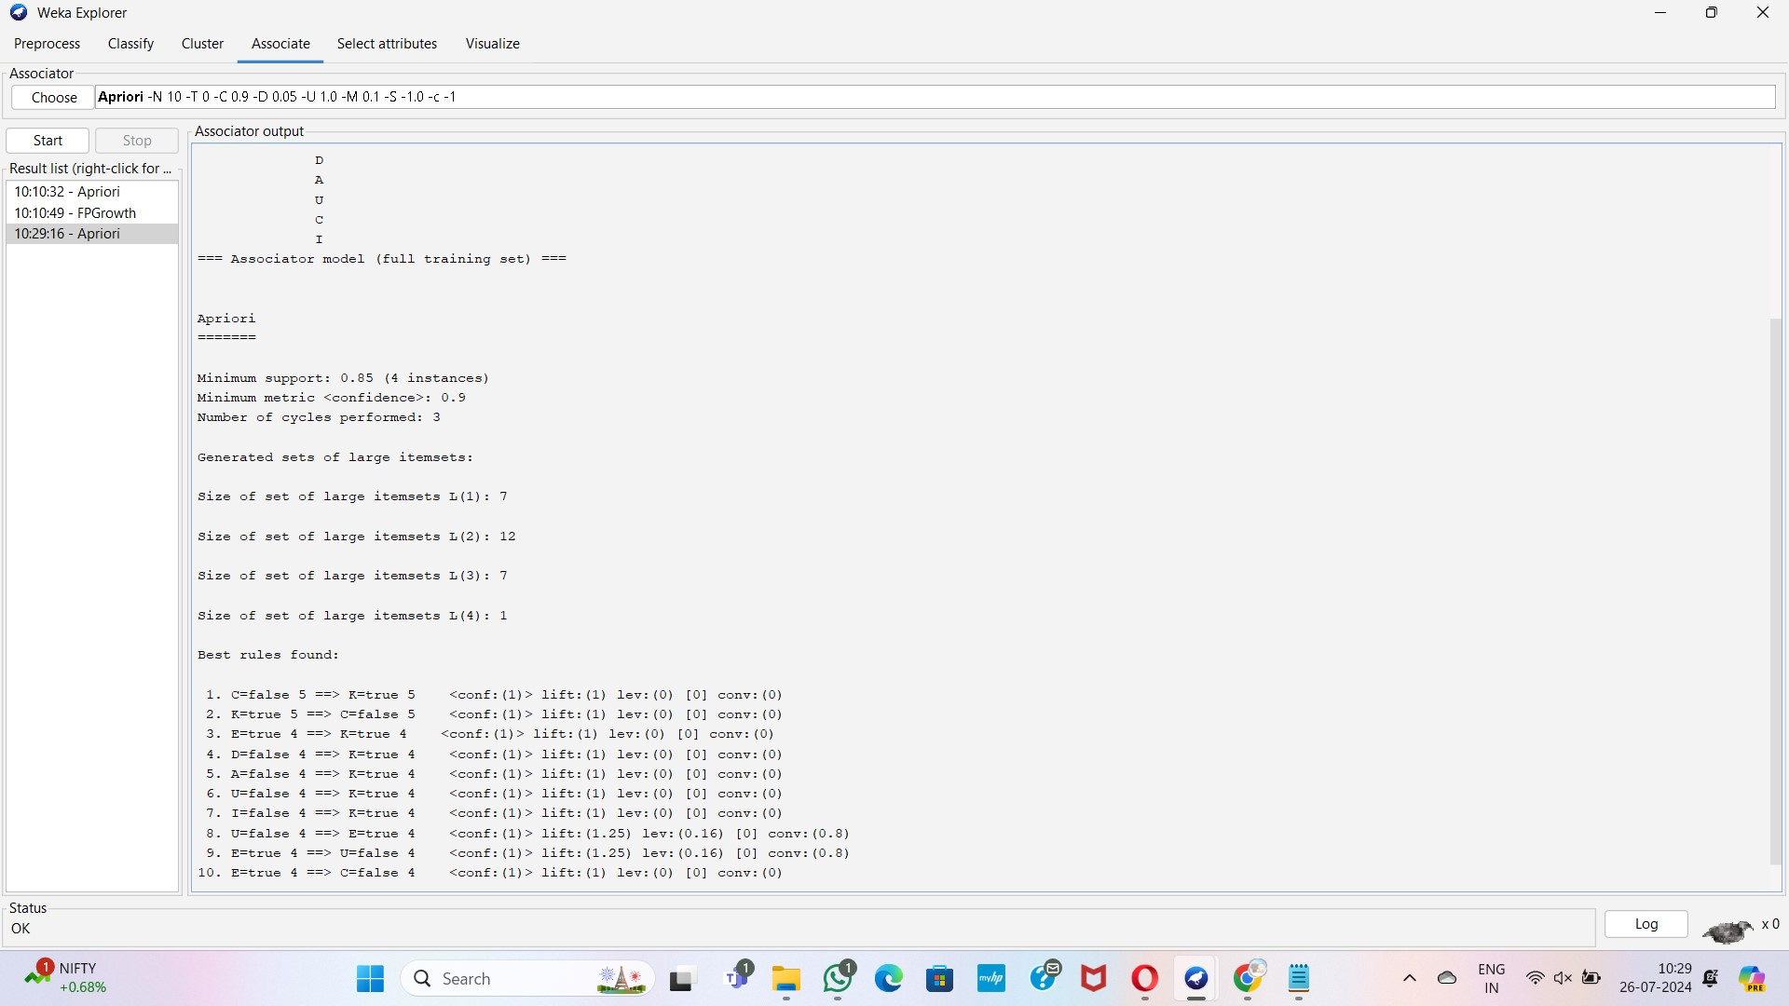

**FPgrowth**

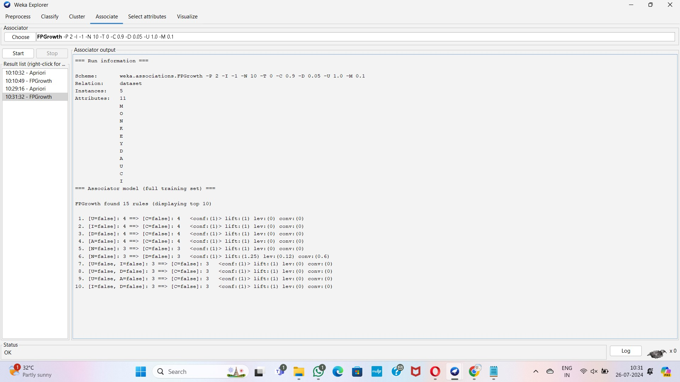

**Q6:**

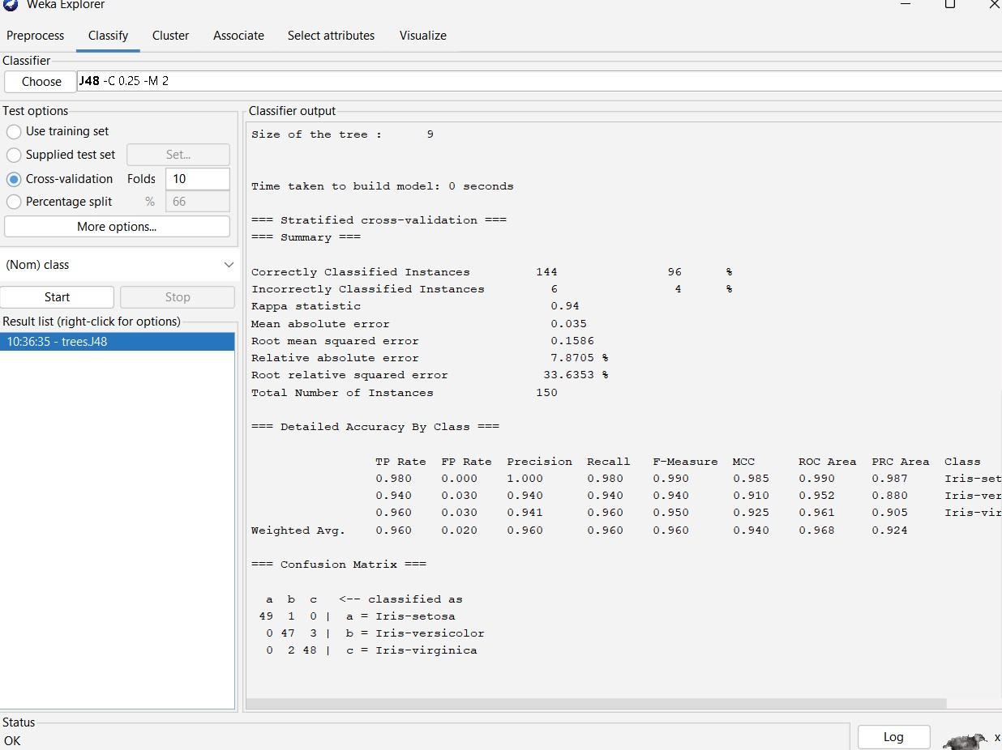

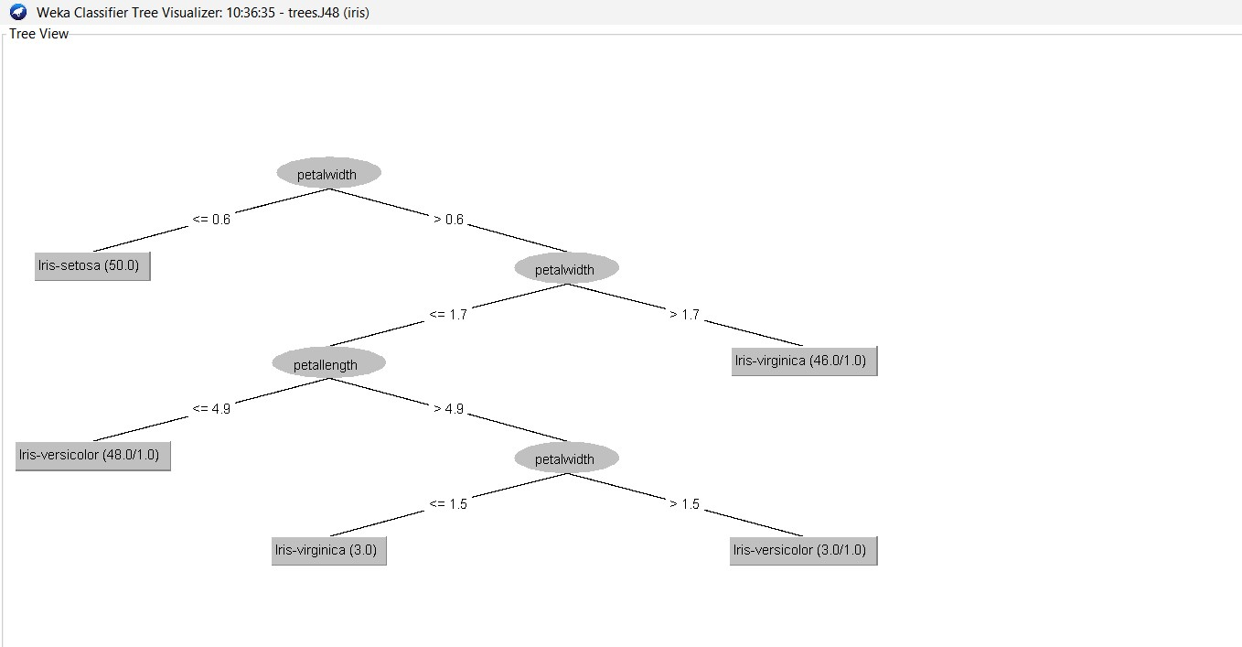

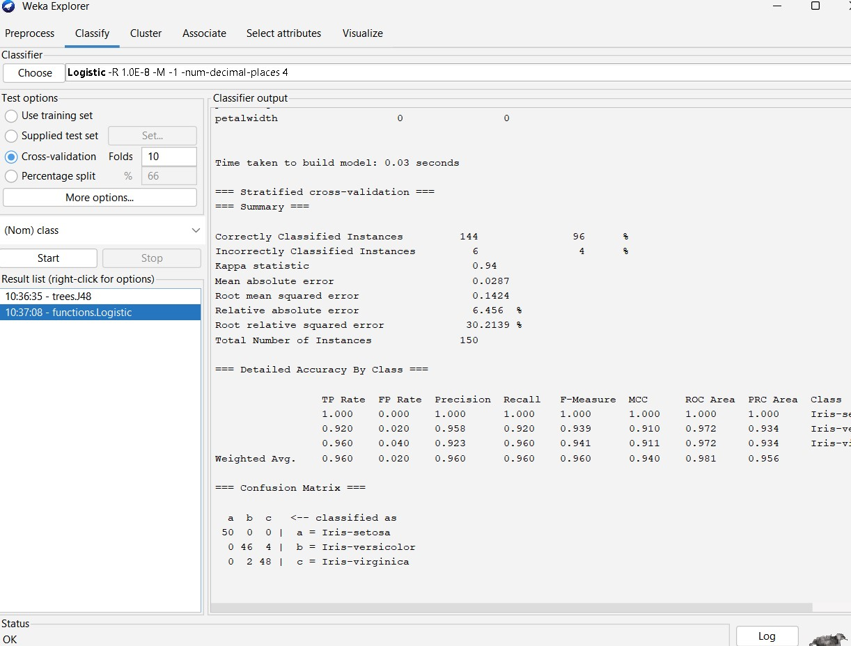

**Q7:**

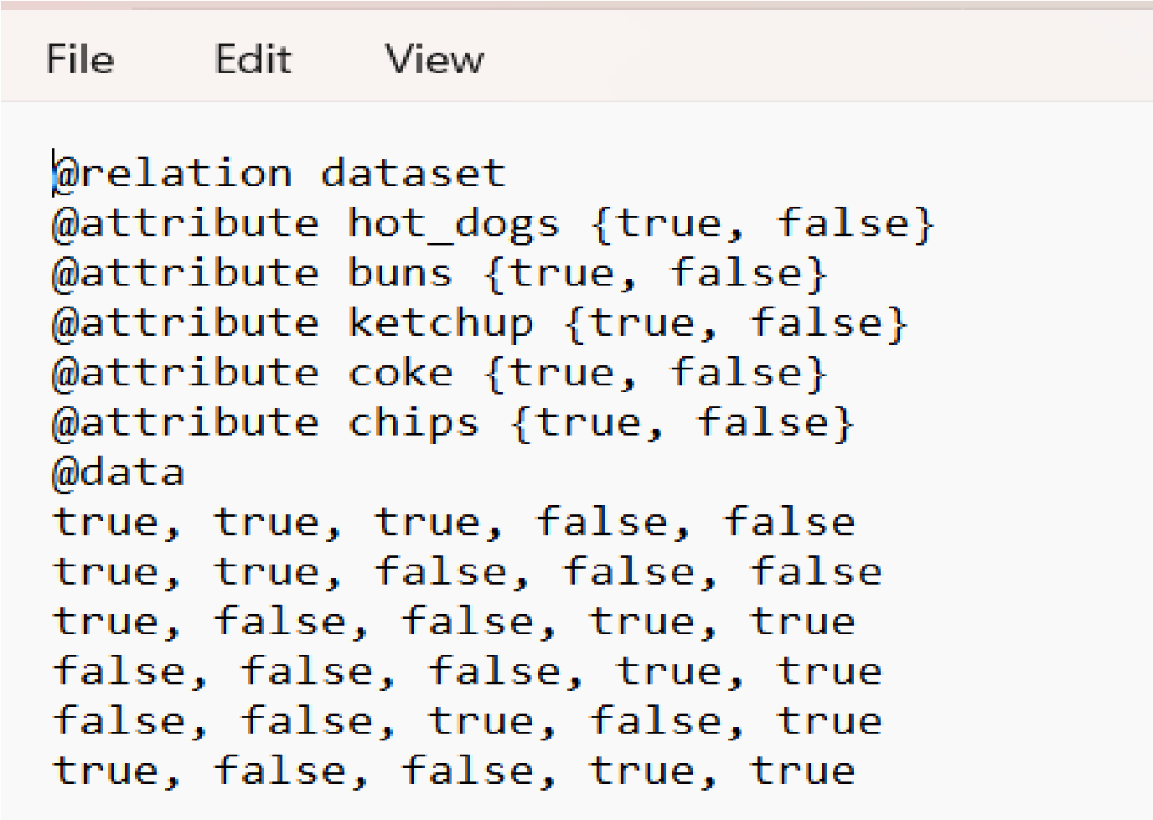

**Apriori**

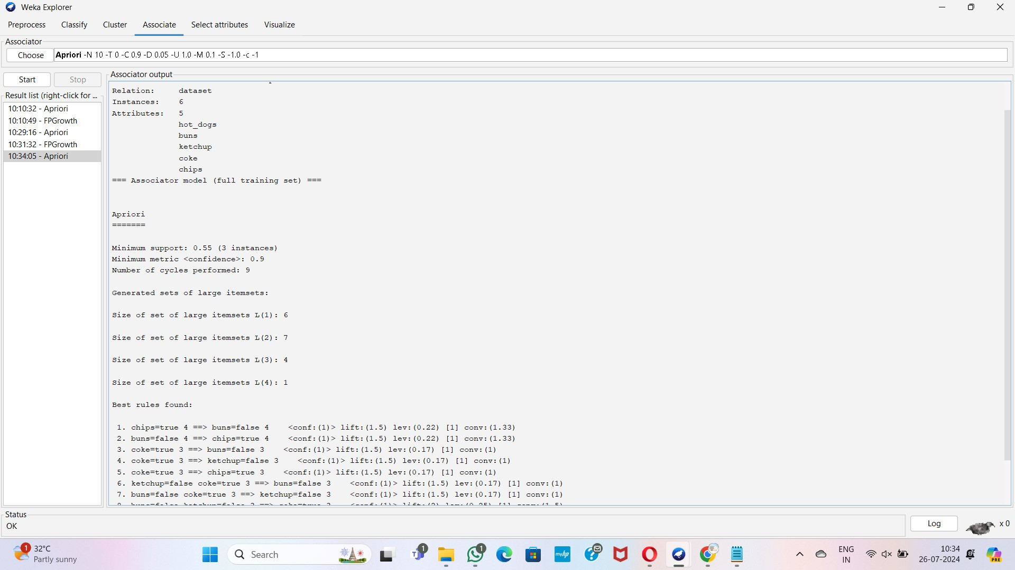

**Fp growth**

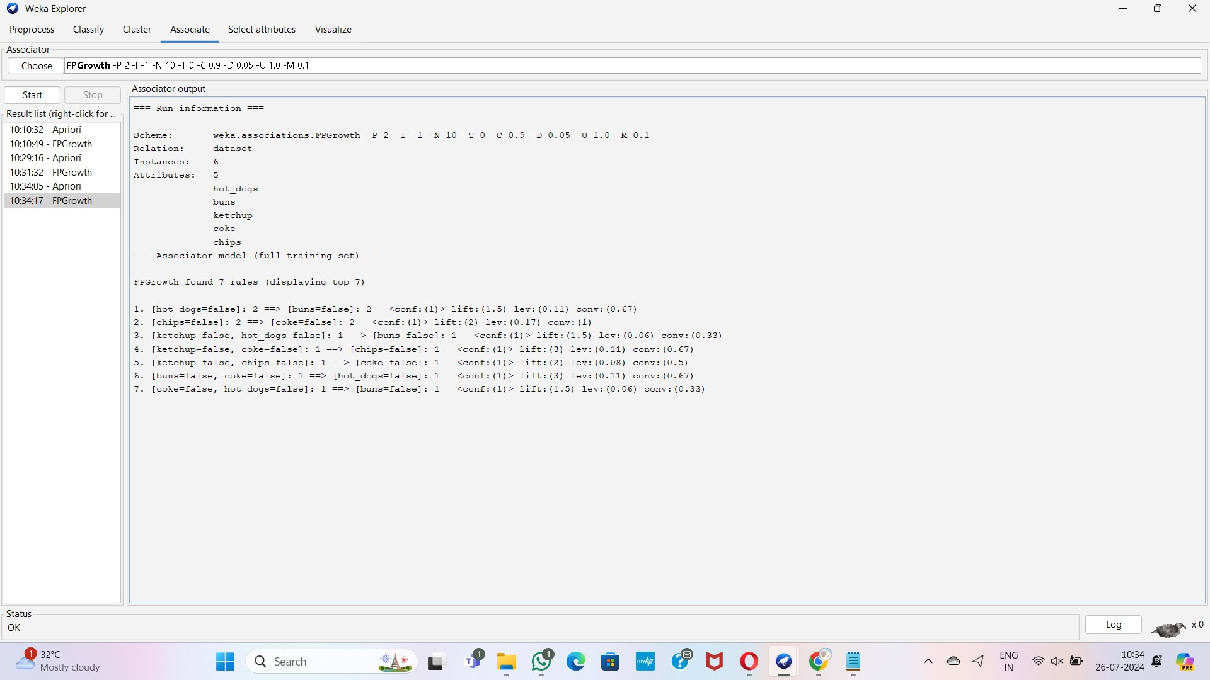

**Q8:**

**Decision tree**

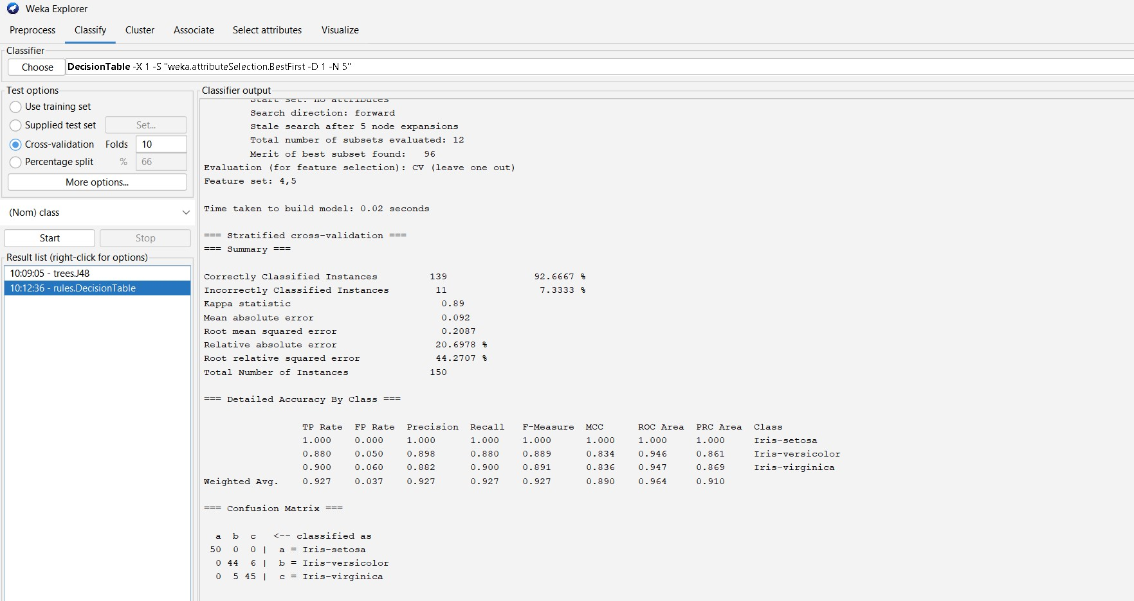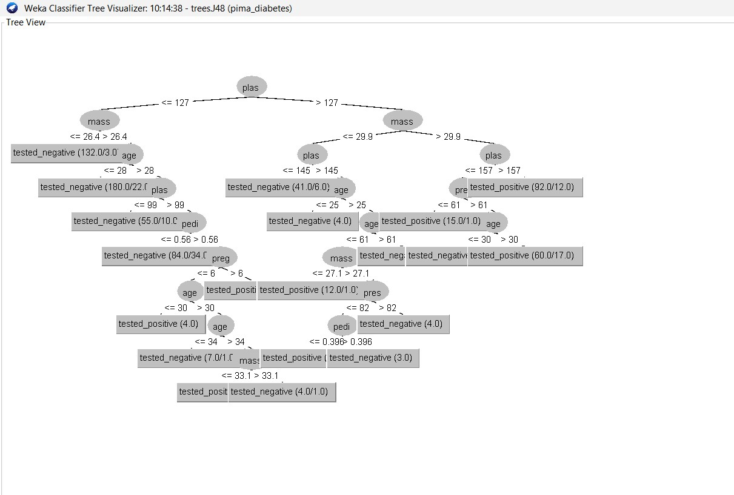

**logistic**

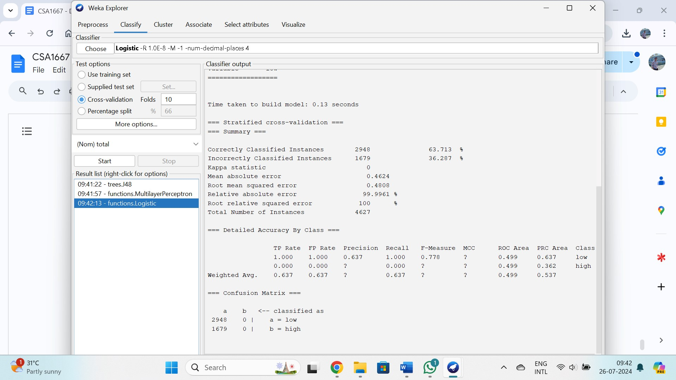

# Day-4

**Q1:**

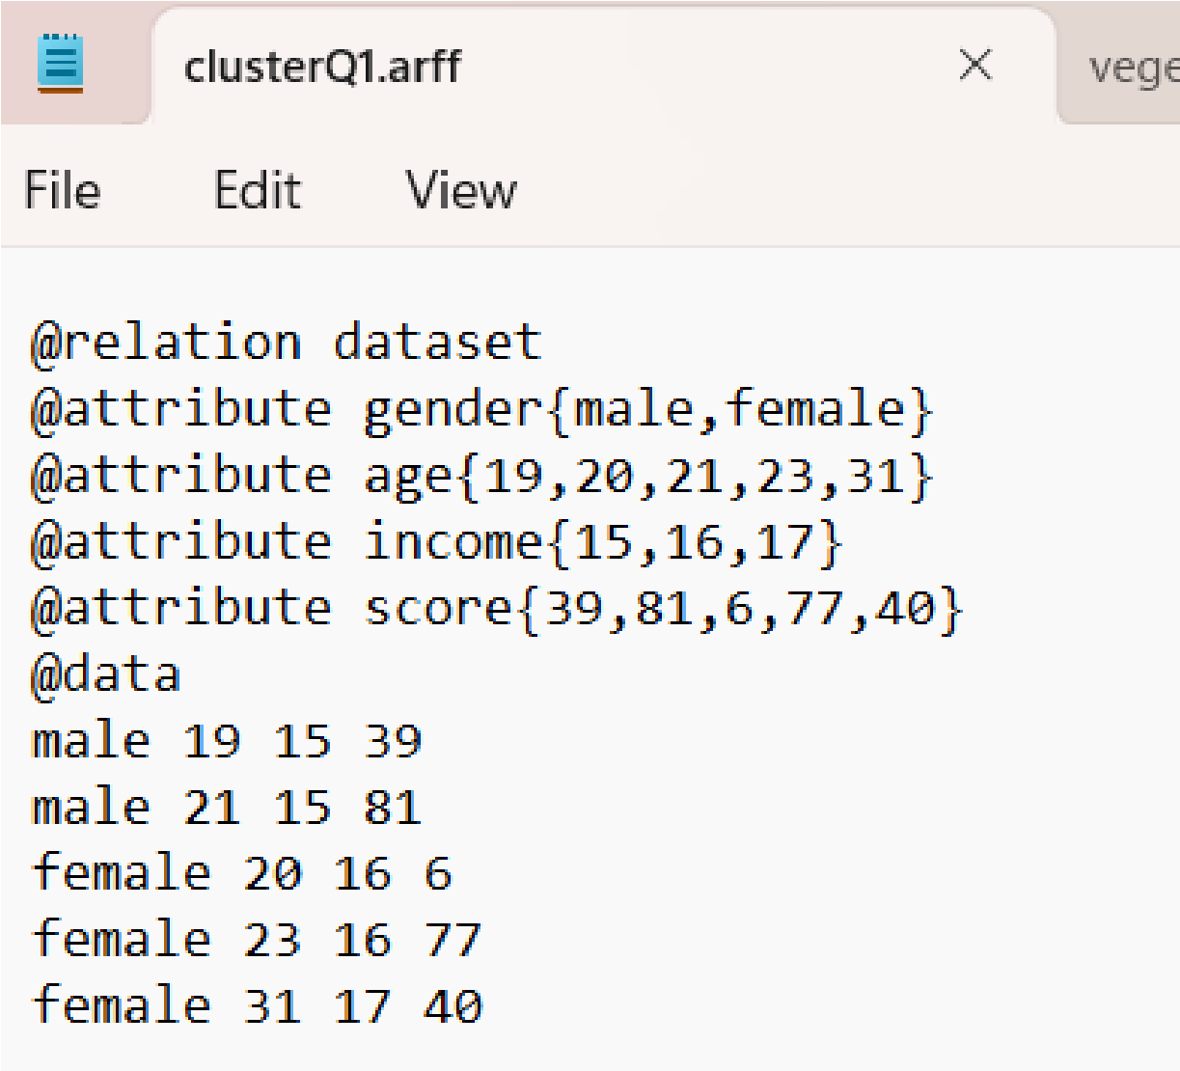

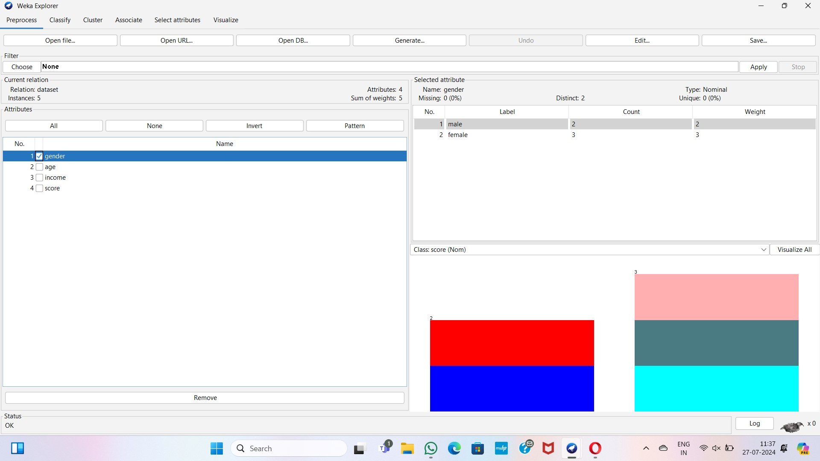

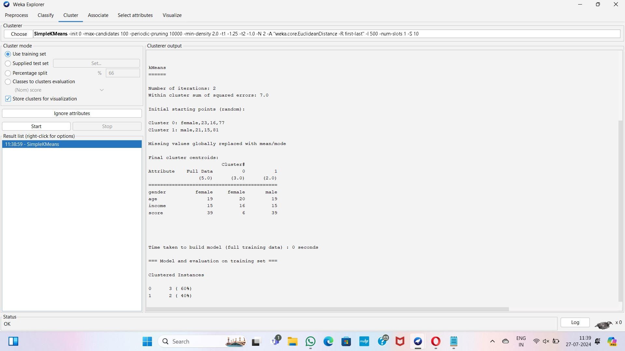

**Q2:**

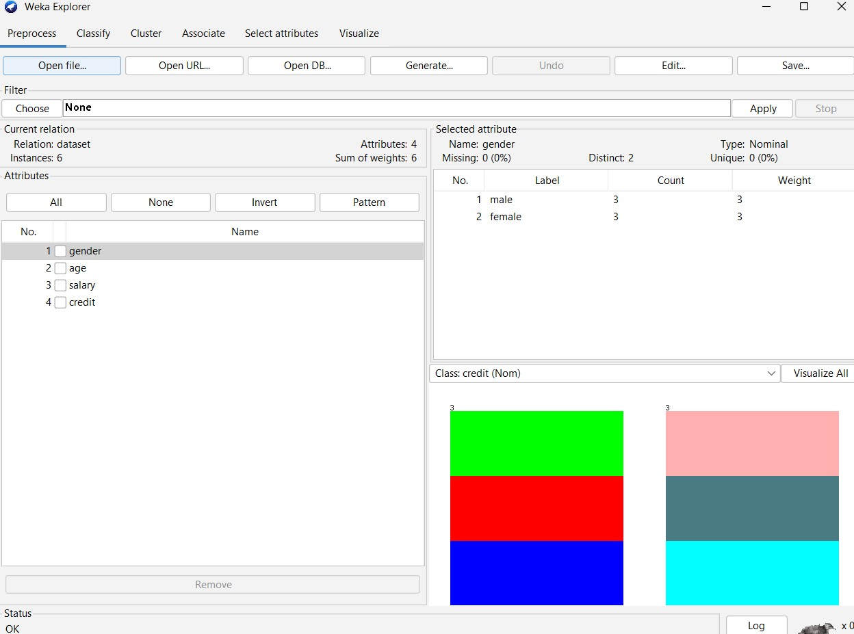

**K- Means:**

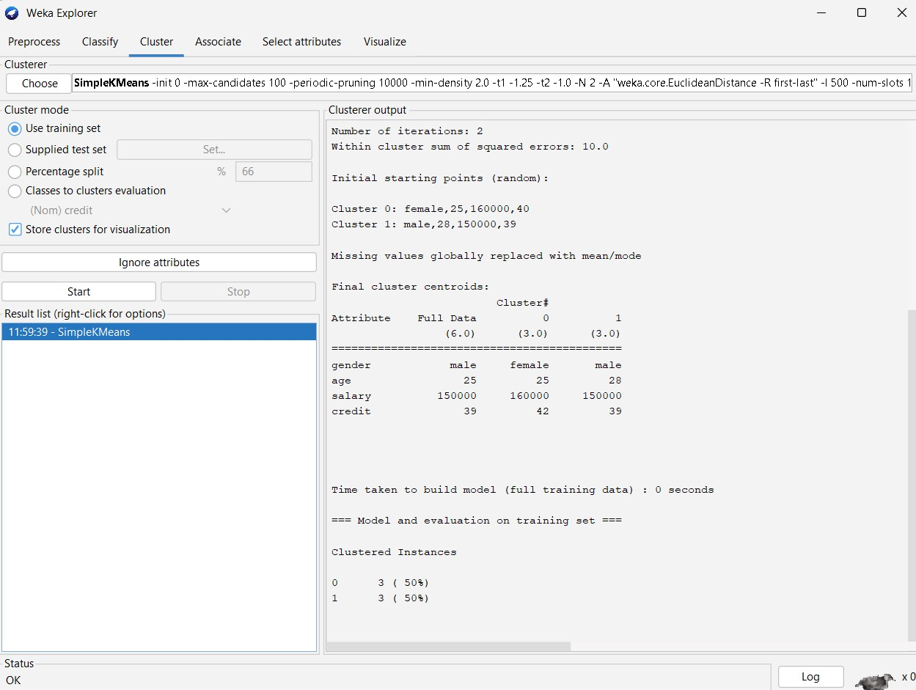

**Q3:**

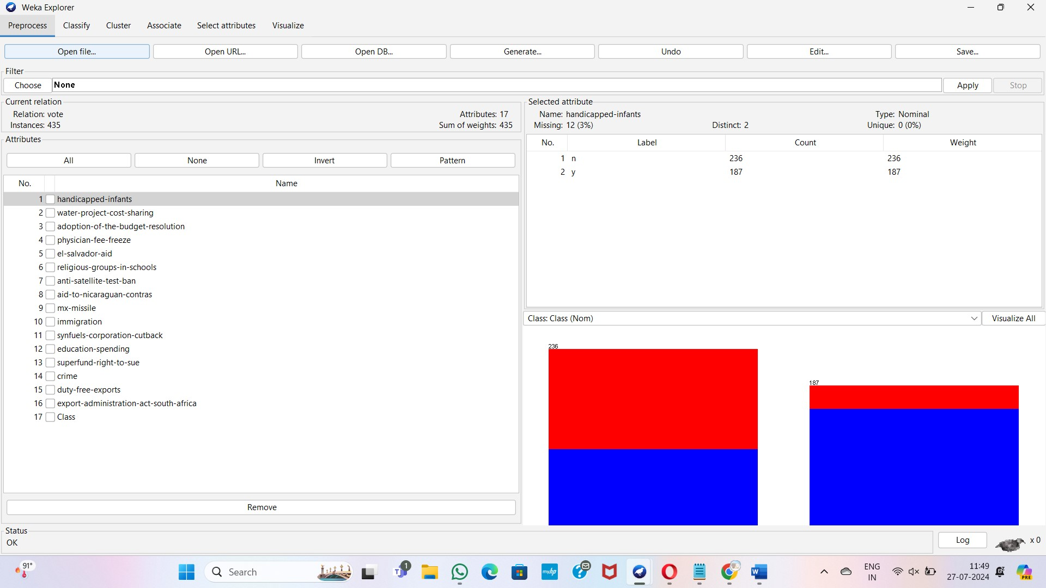

**Naïve Bayes algorithm**

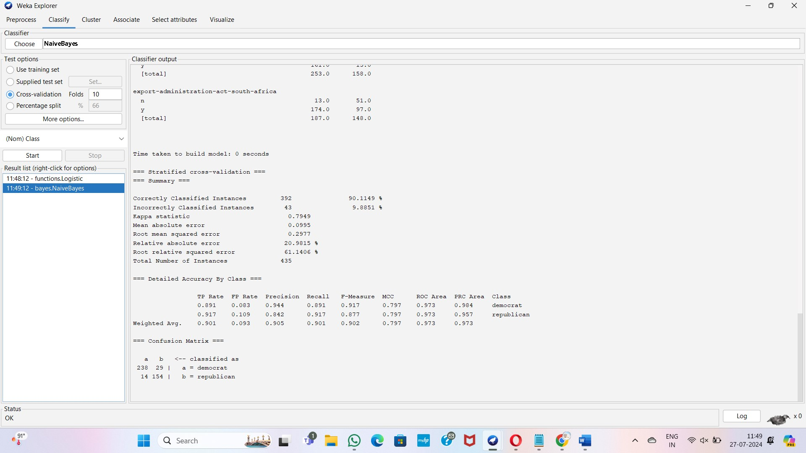

**SVM**

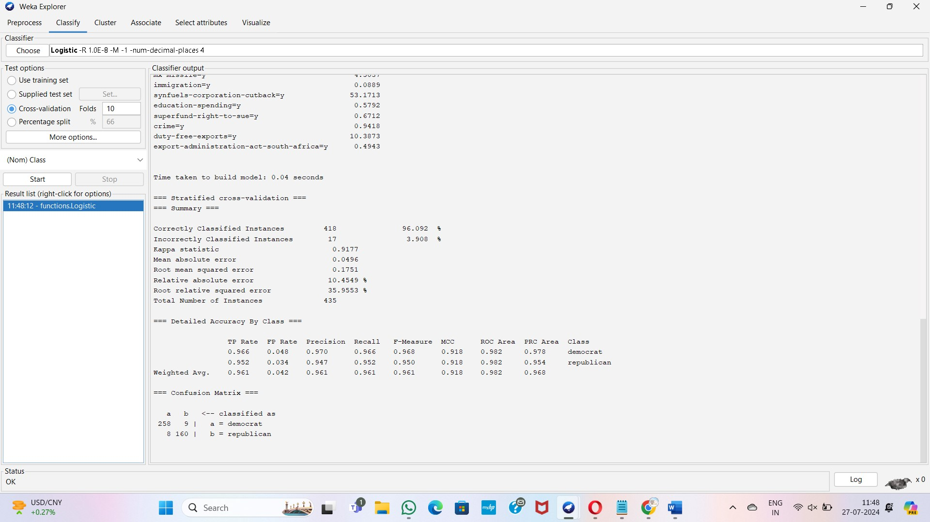

**Q4:**

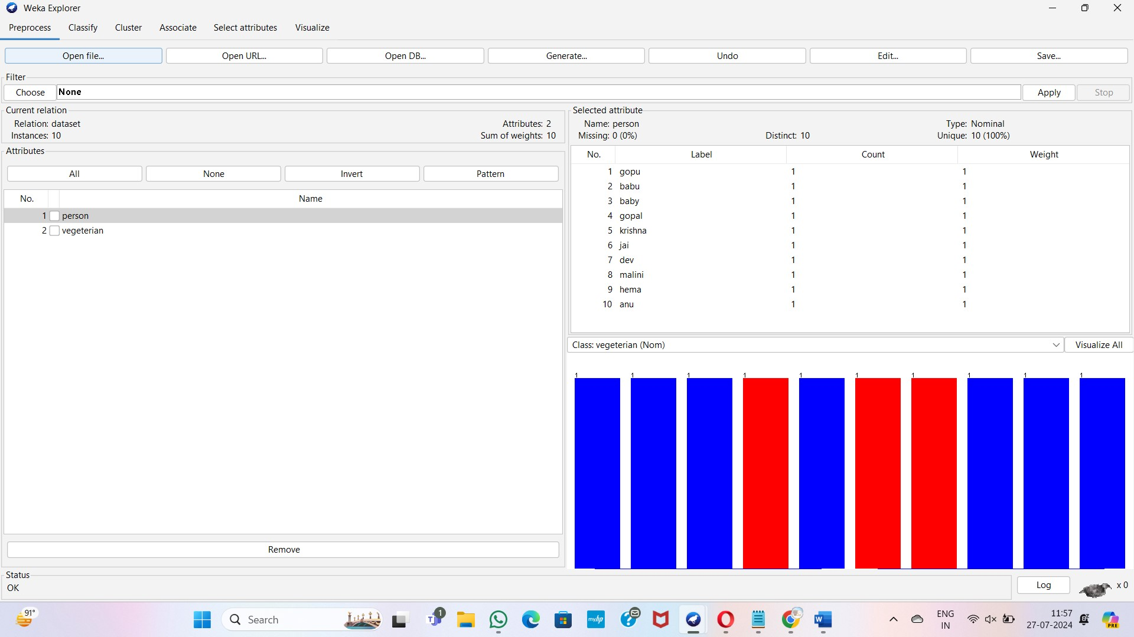

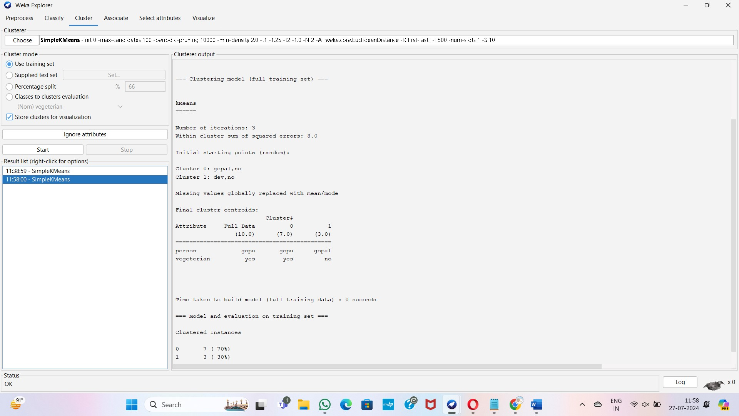

**Q5:**

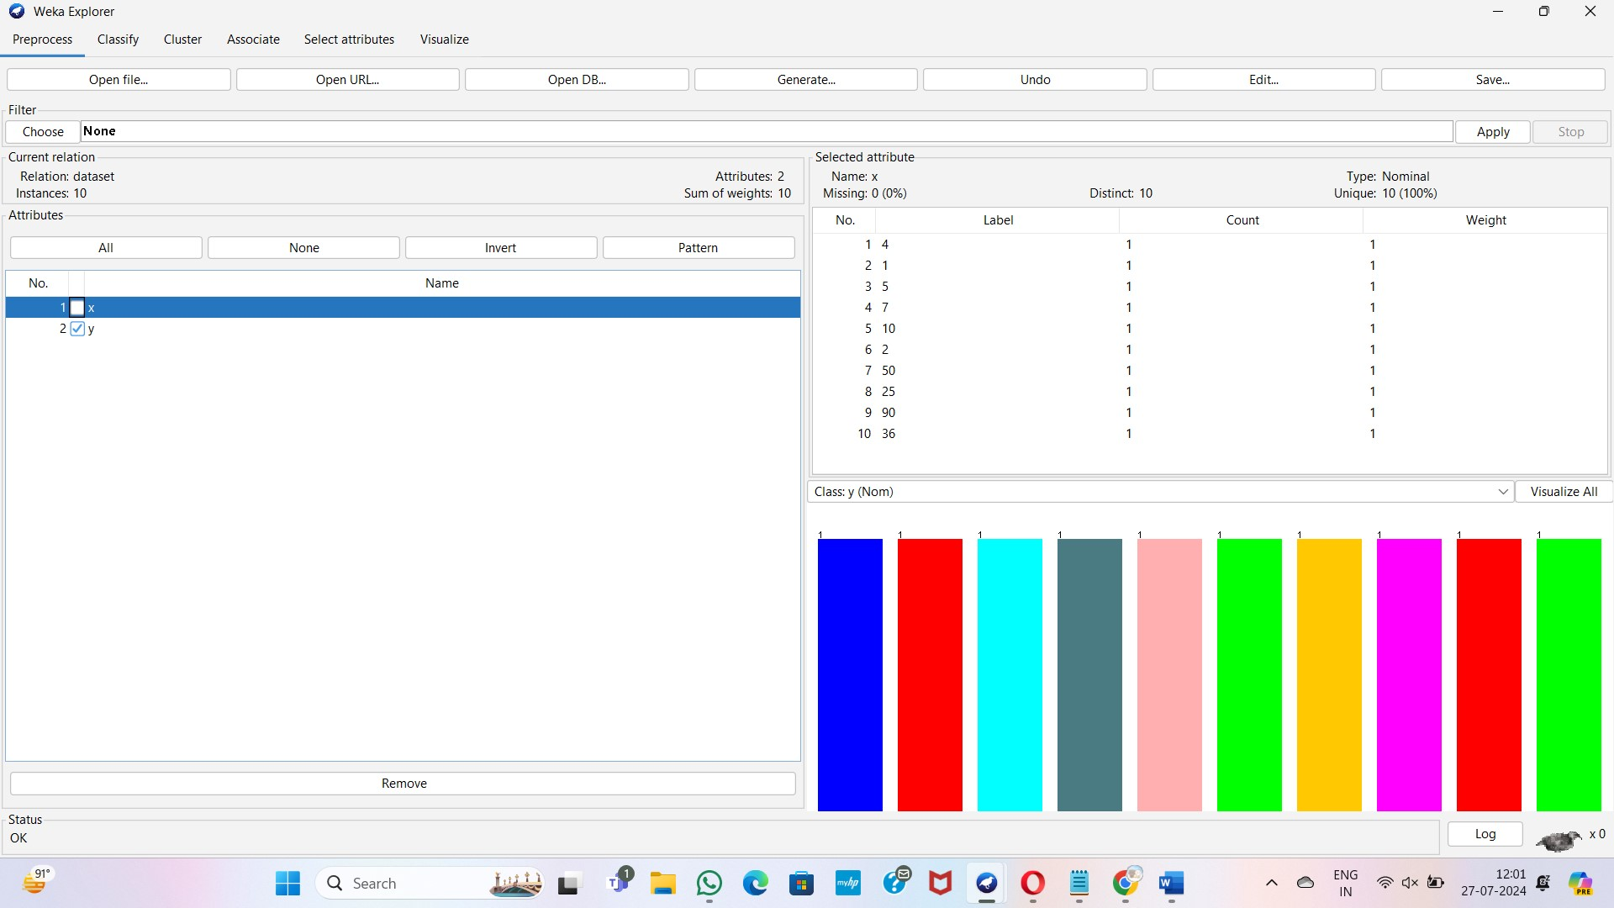

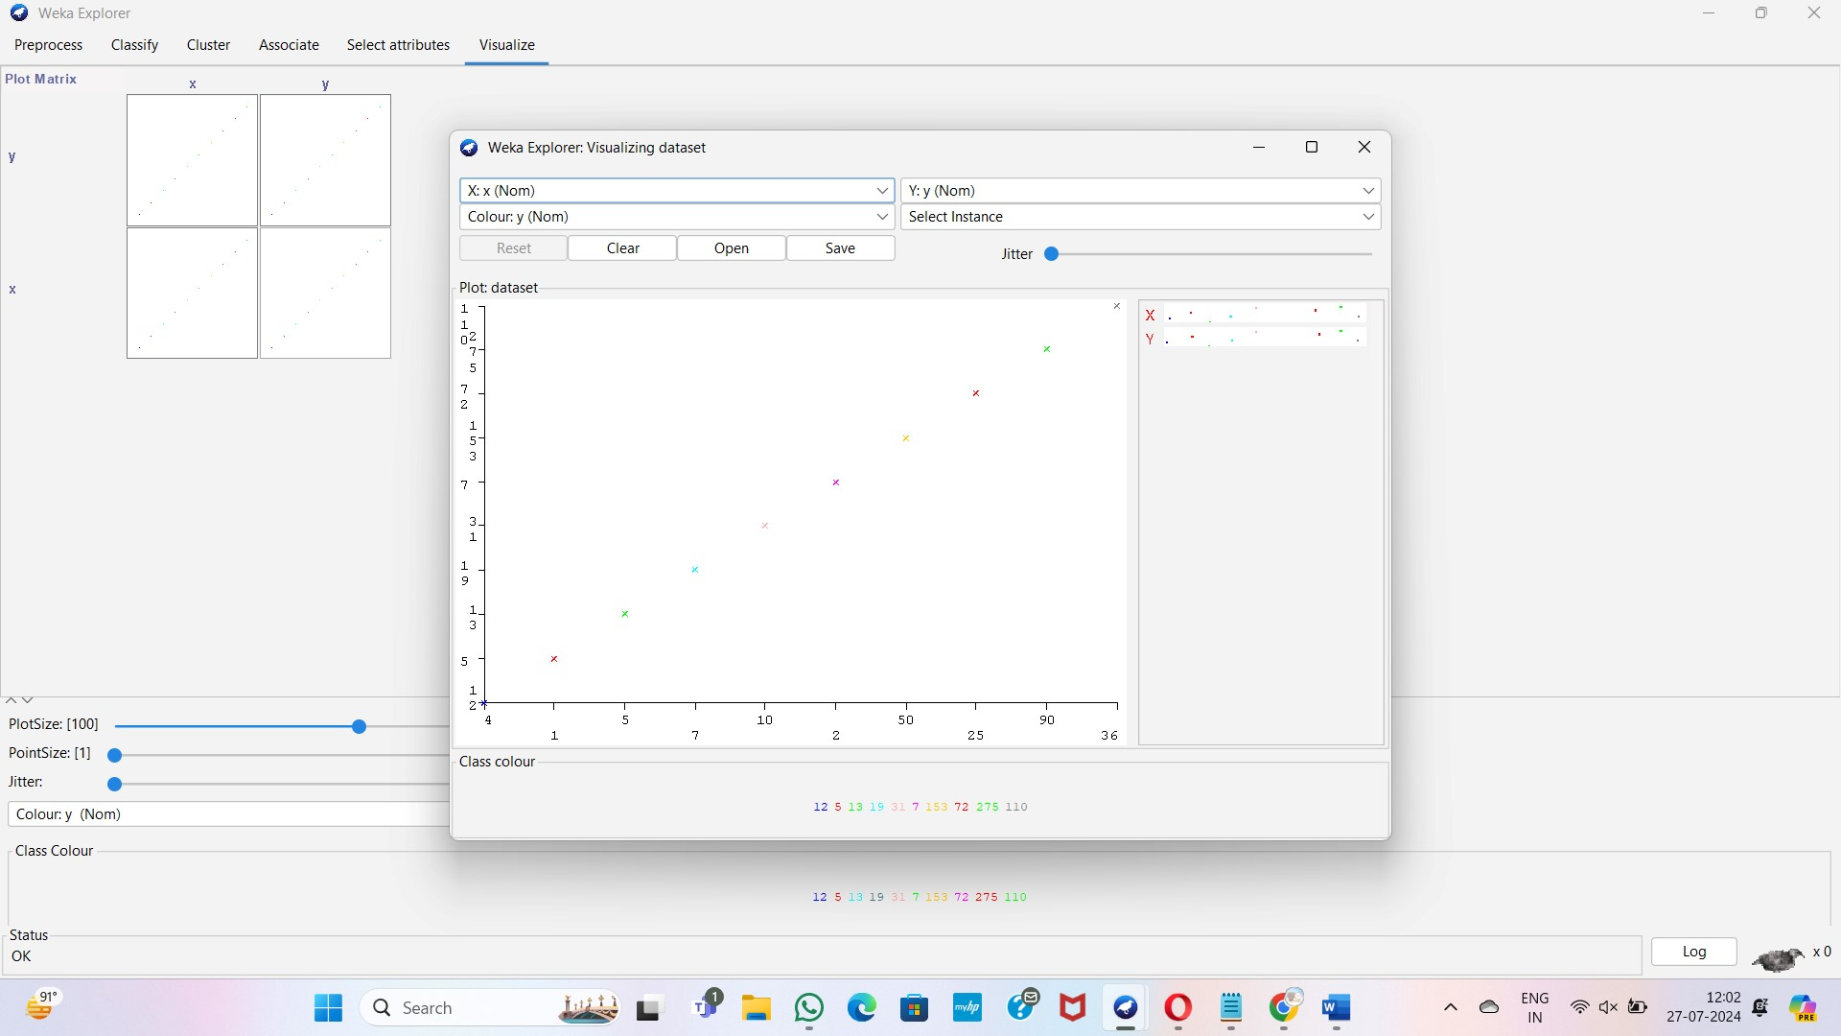

**Q6:**

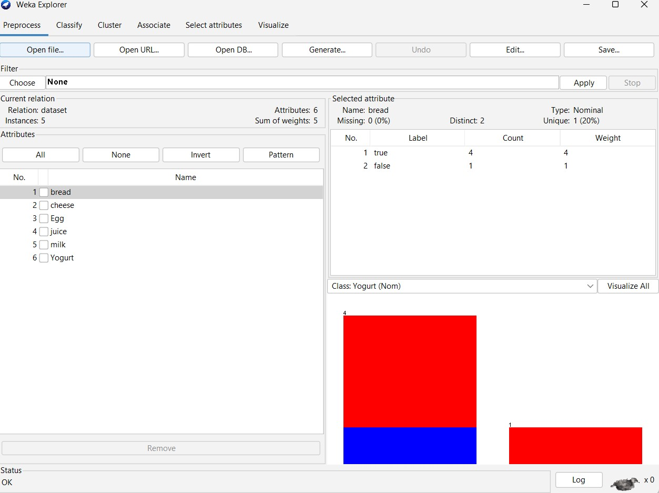

**FP growth**

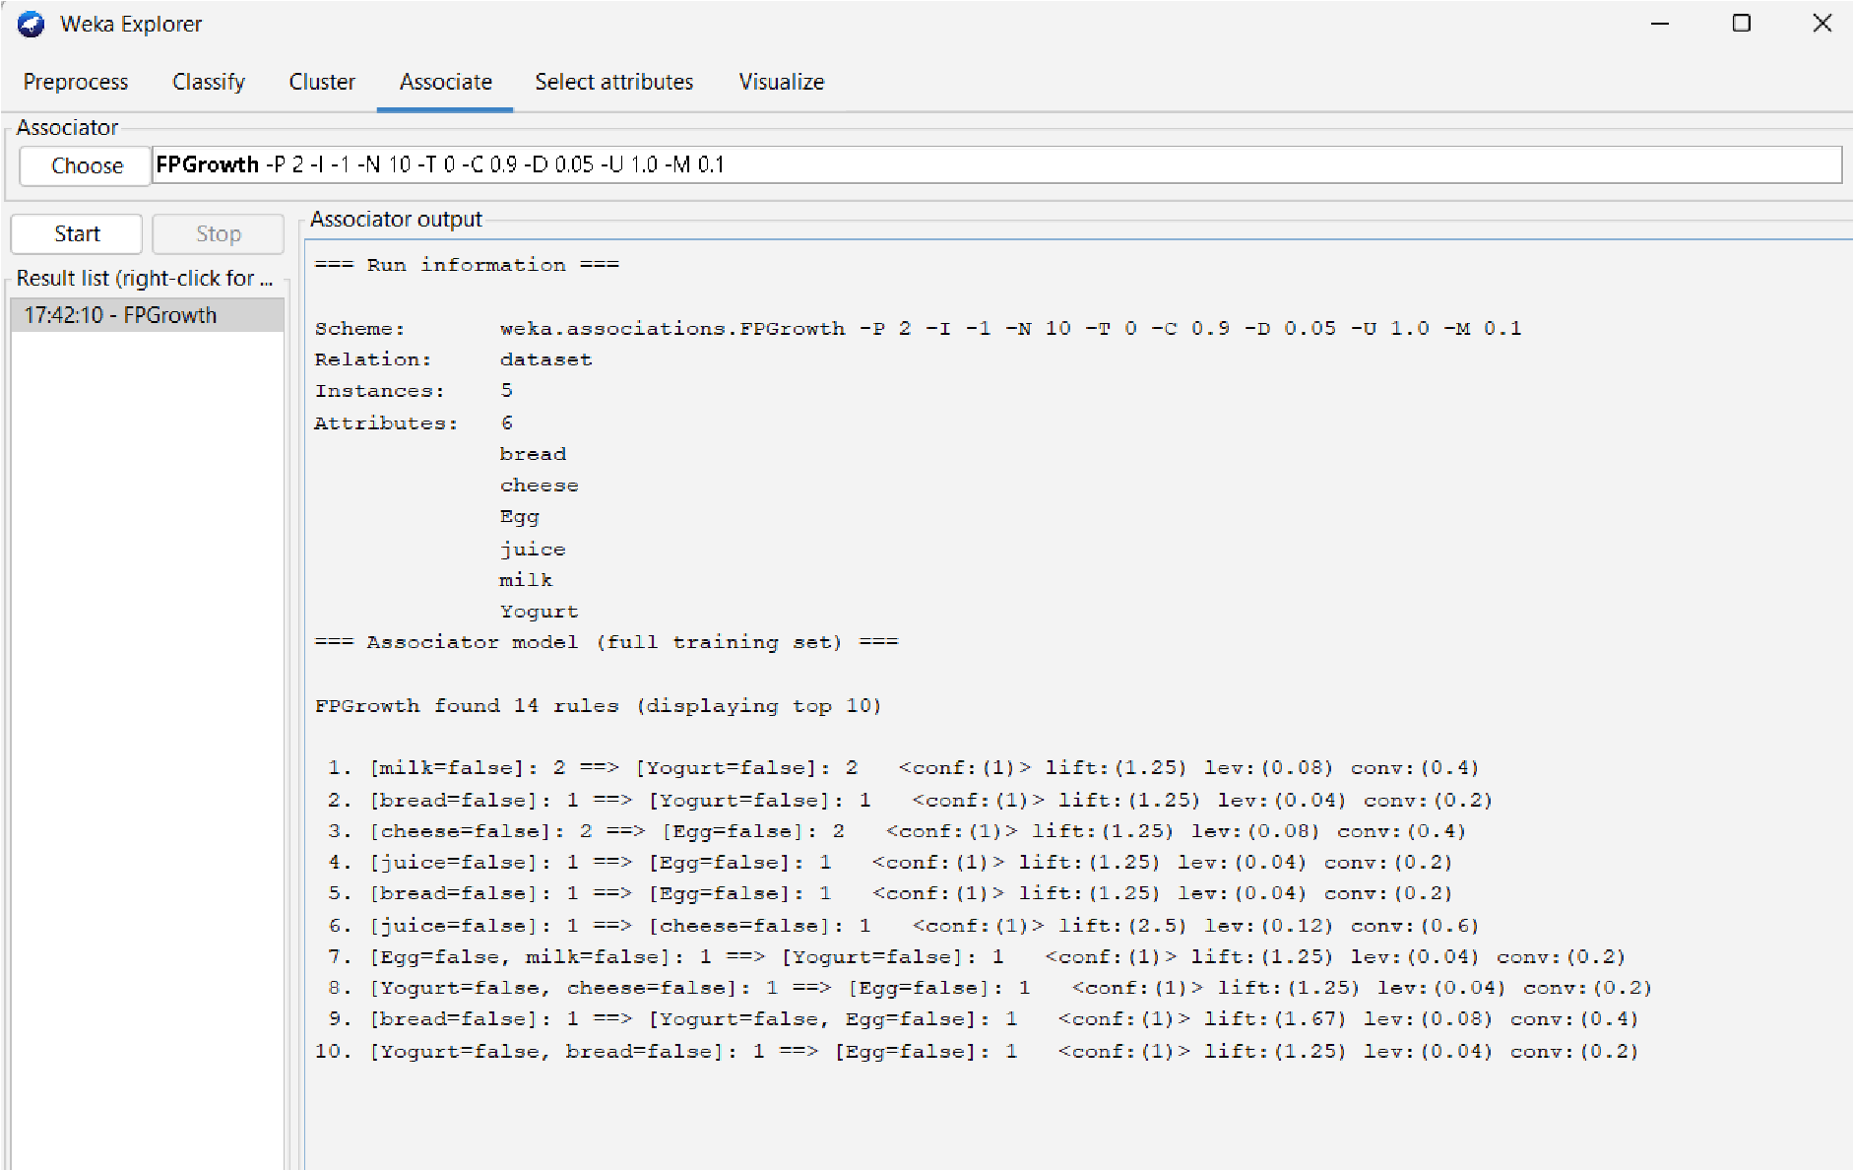

**Q7:**

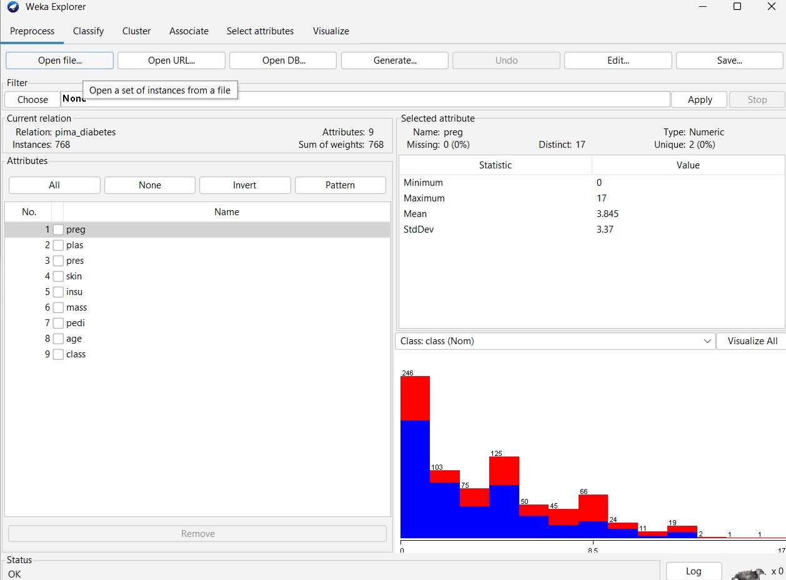

**Decision Tree Classifier:**

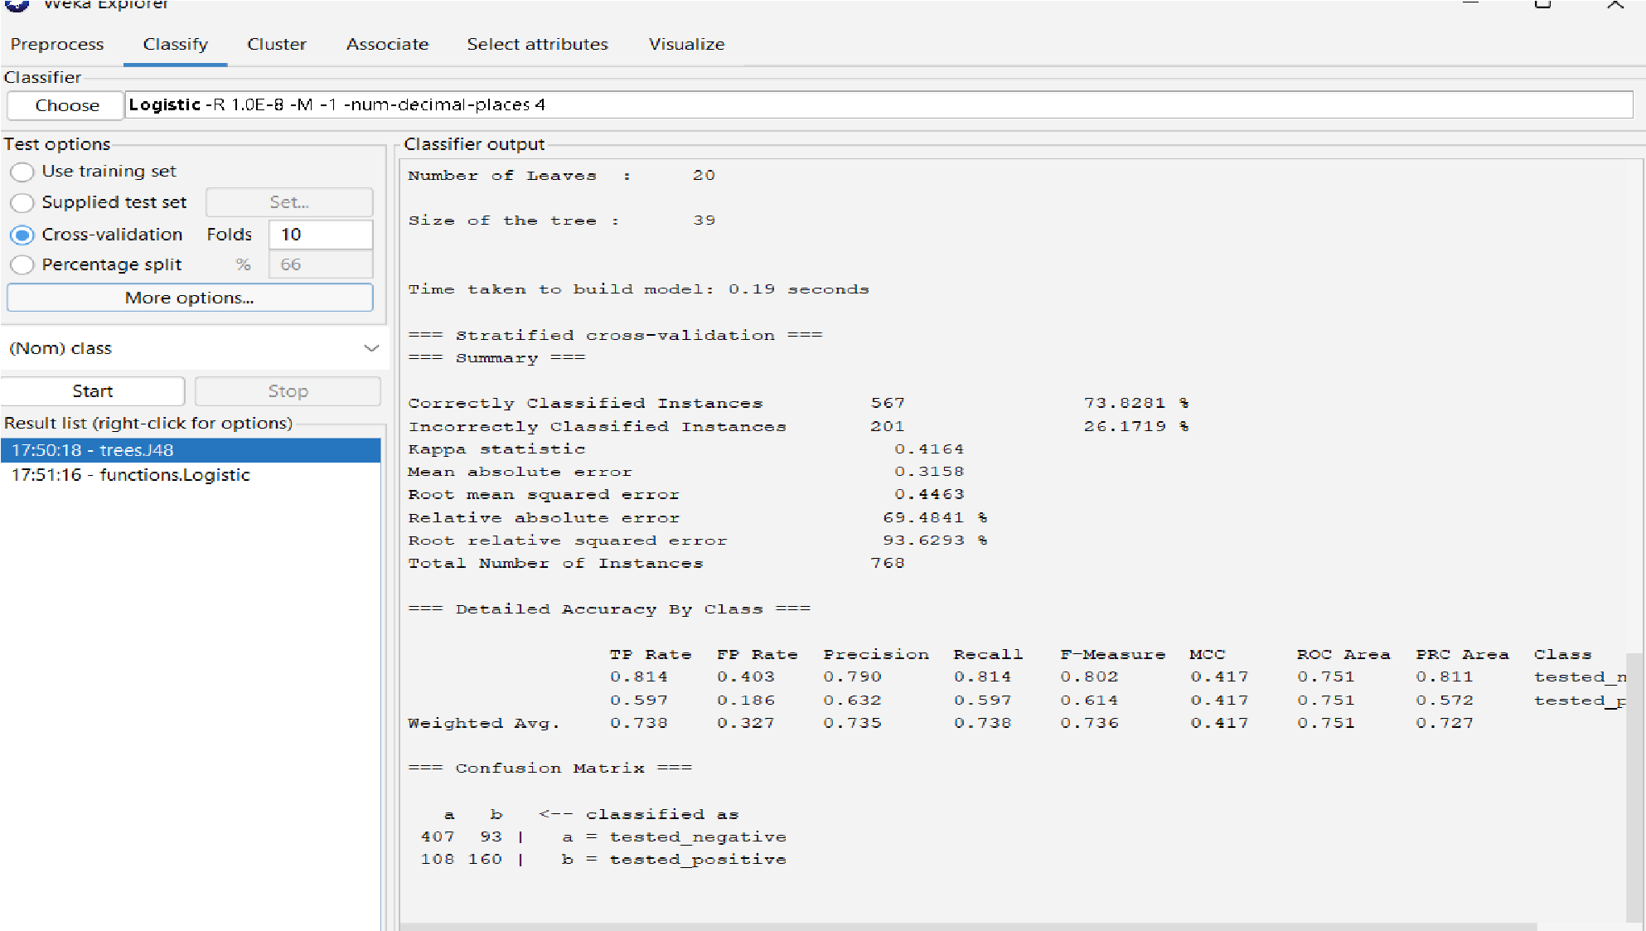

**Support Vector Machine Classifier:**

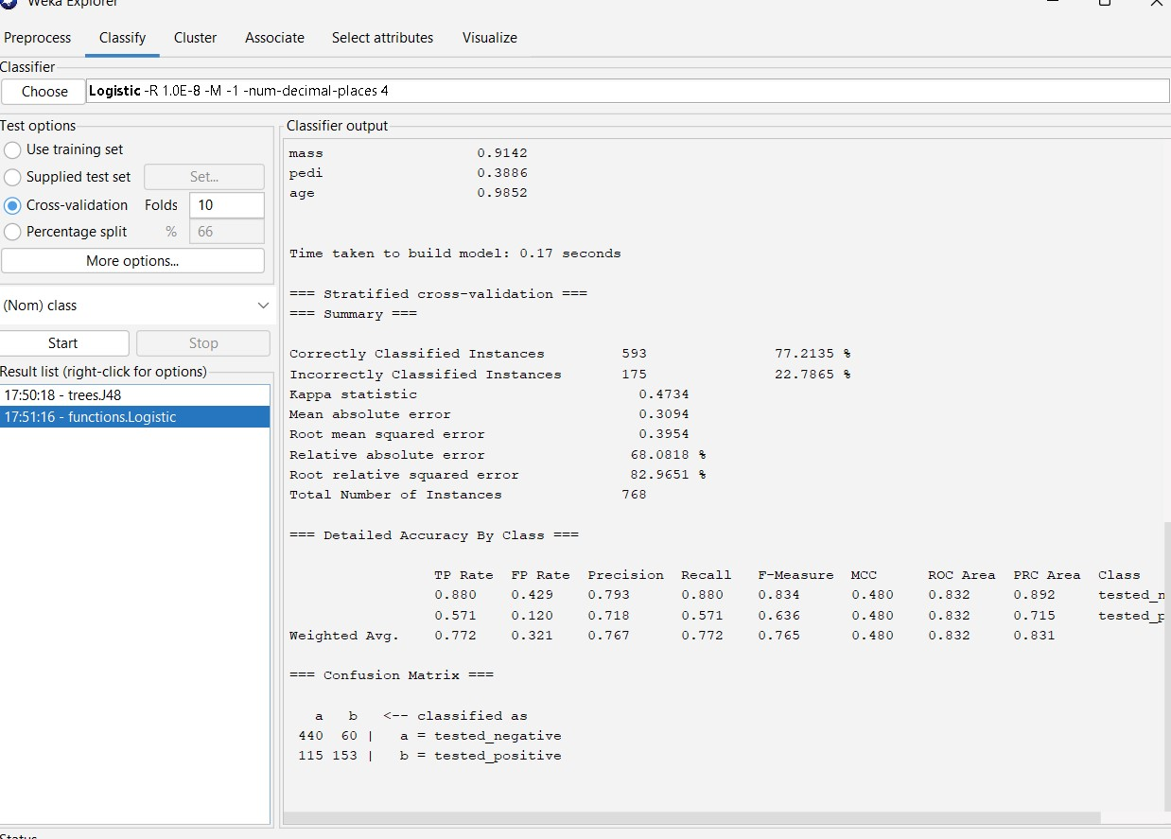

**Q8**

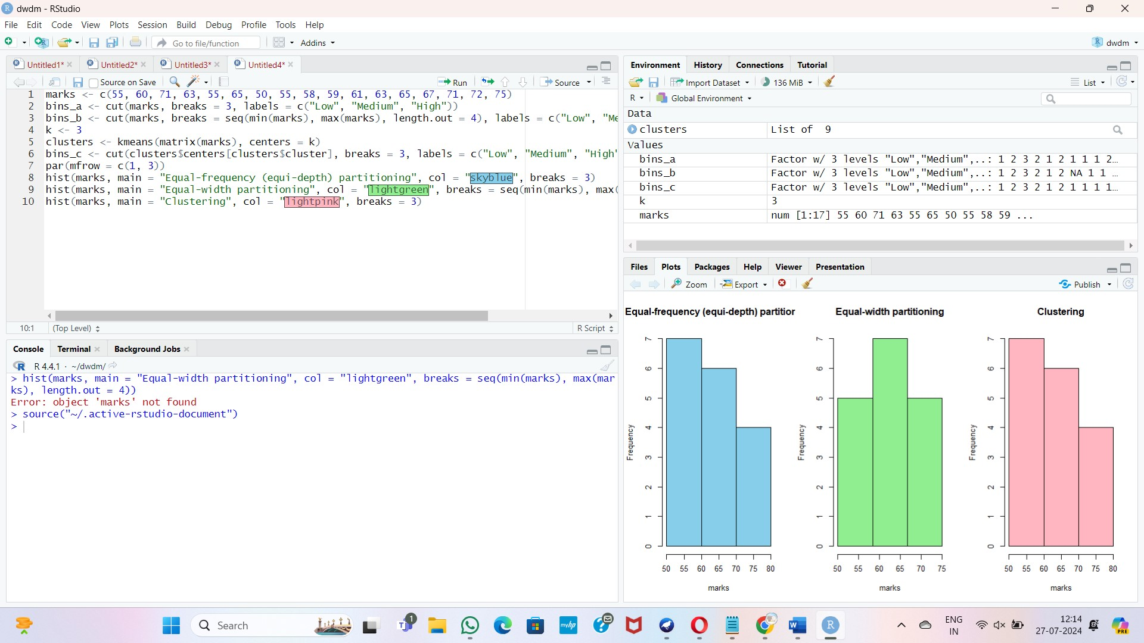

**Q9:**

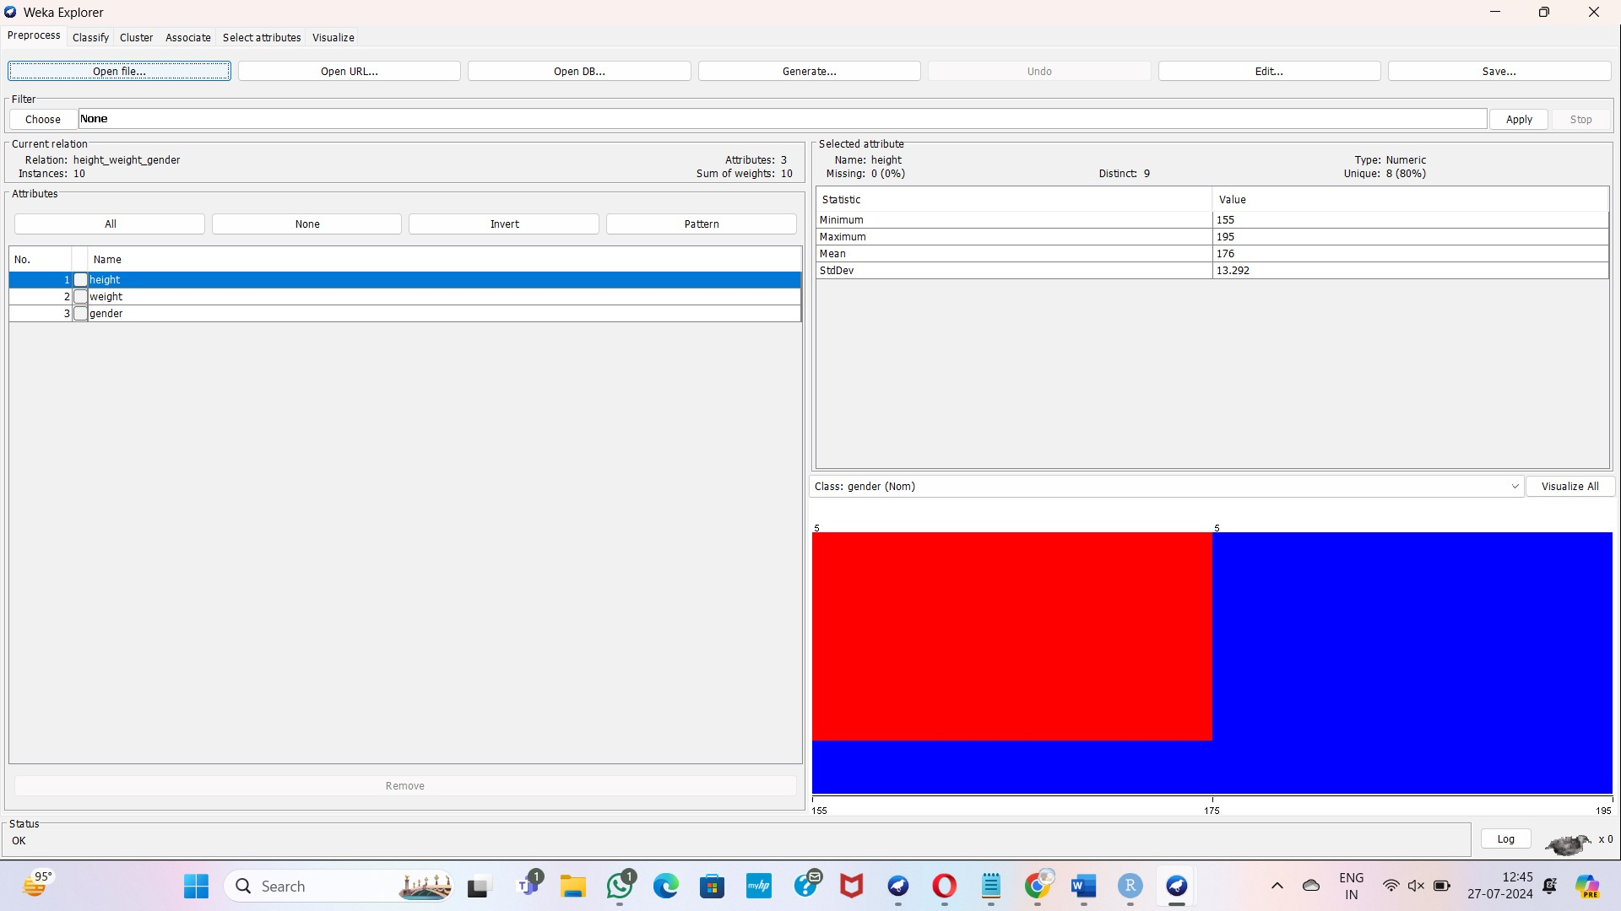

**Decision tree**

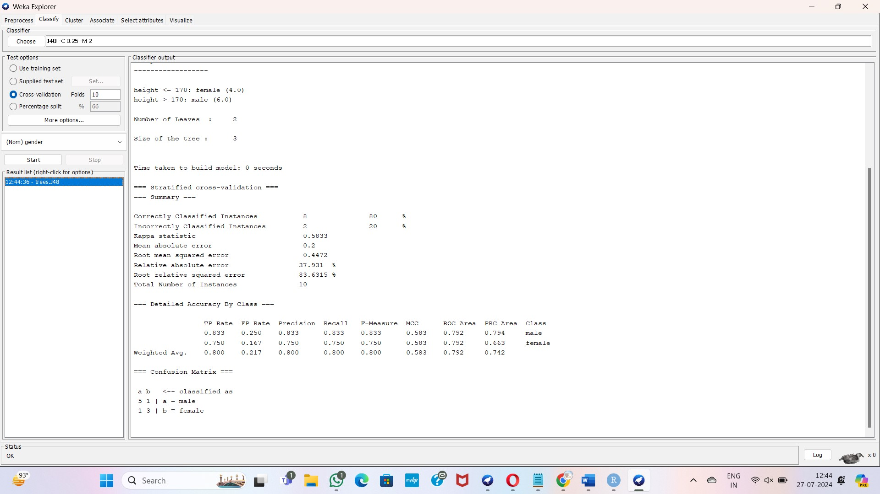

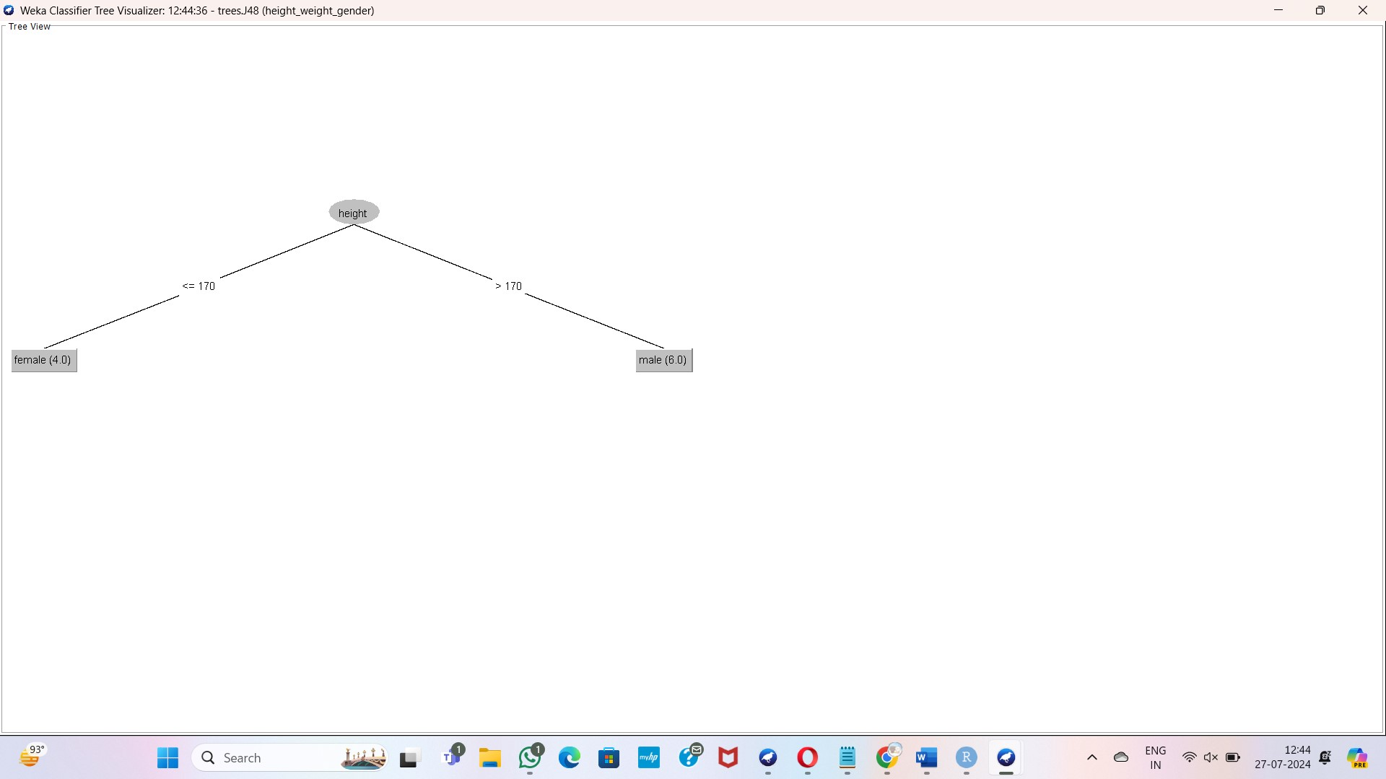

**Q10:**

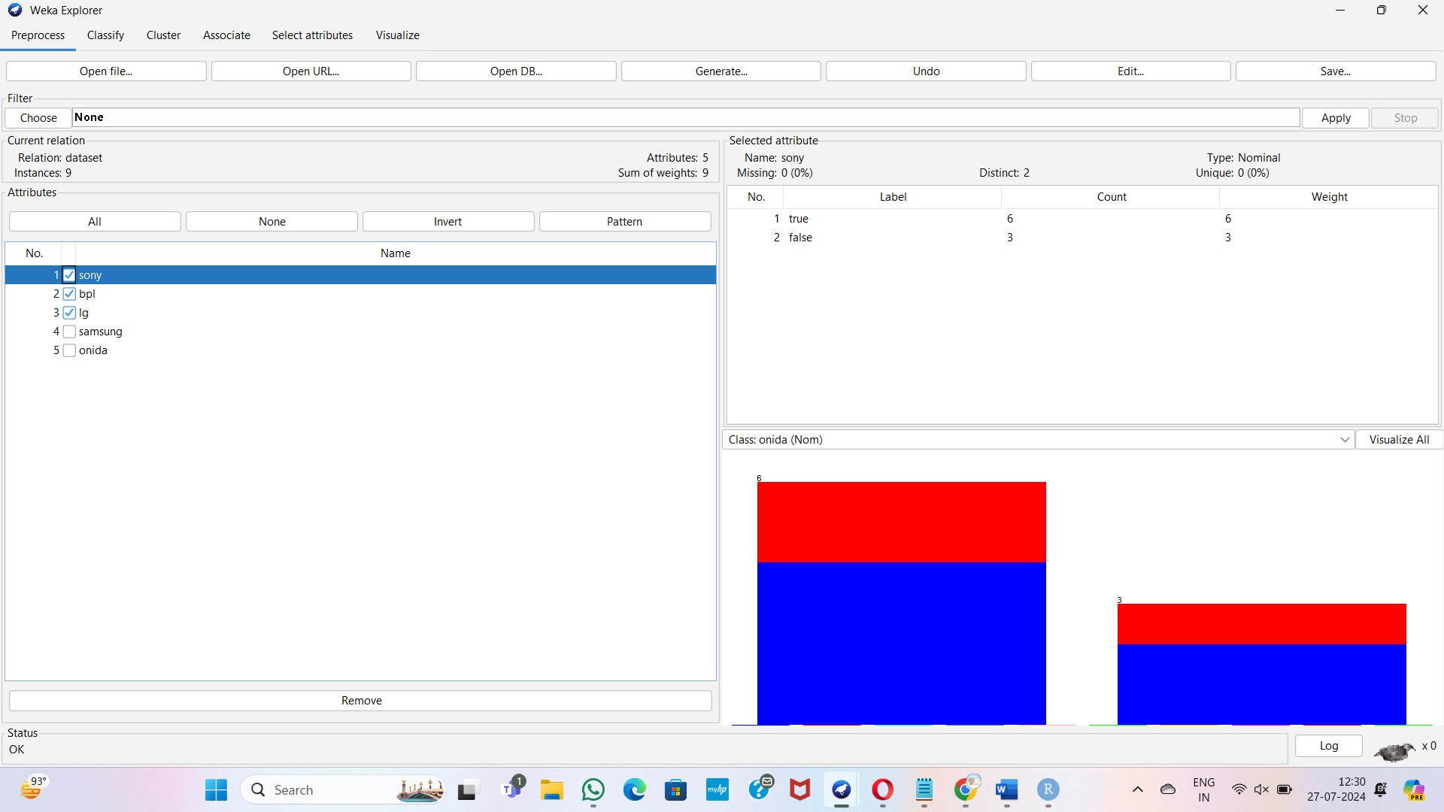

**Apriori algorithm**

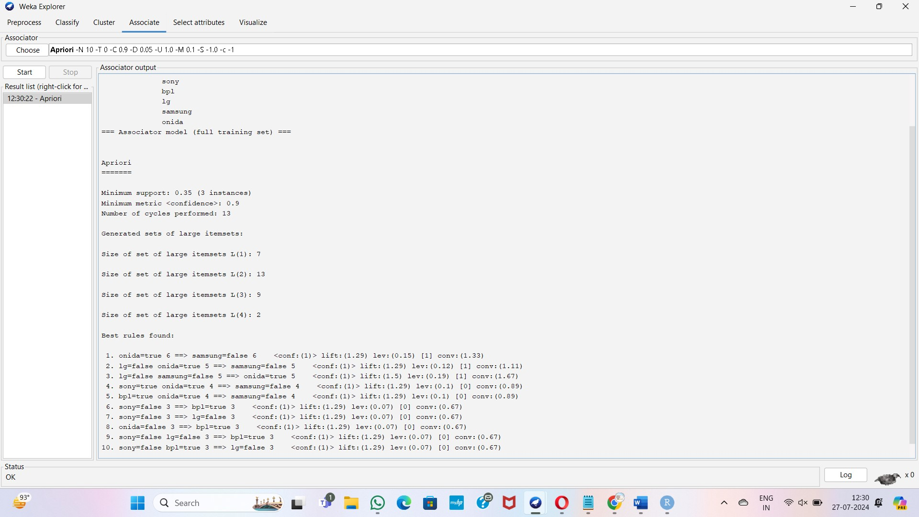

**Fp growth**

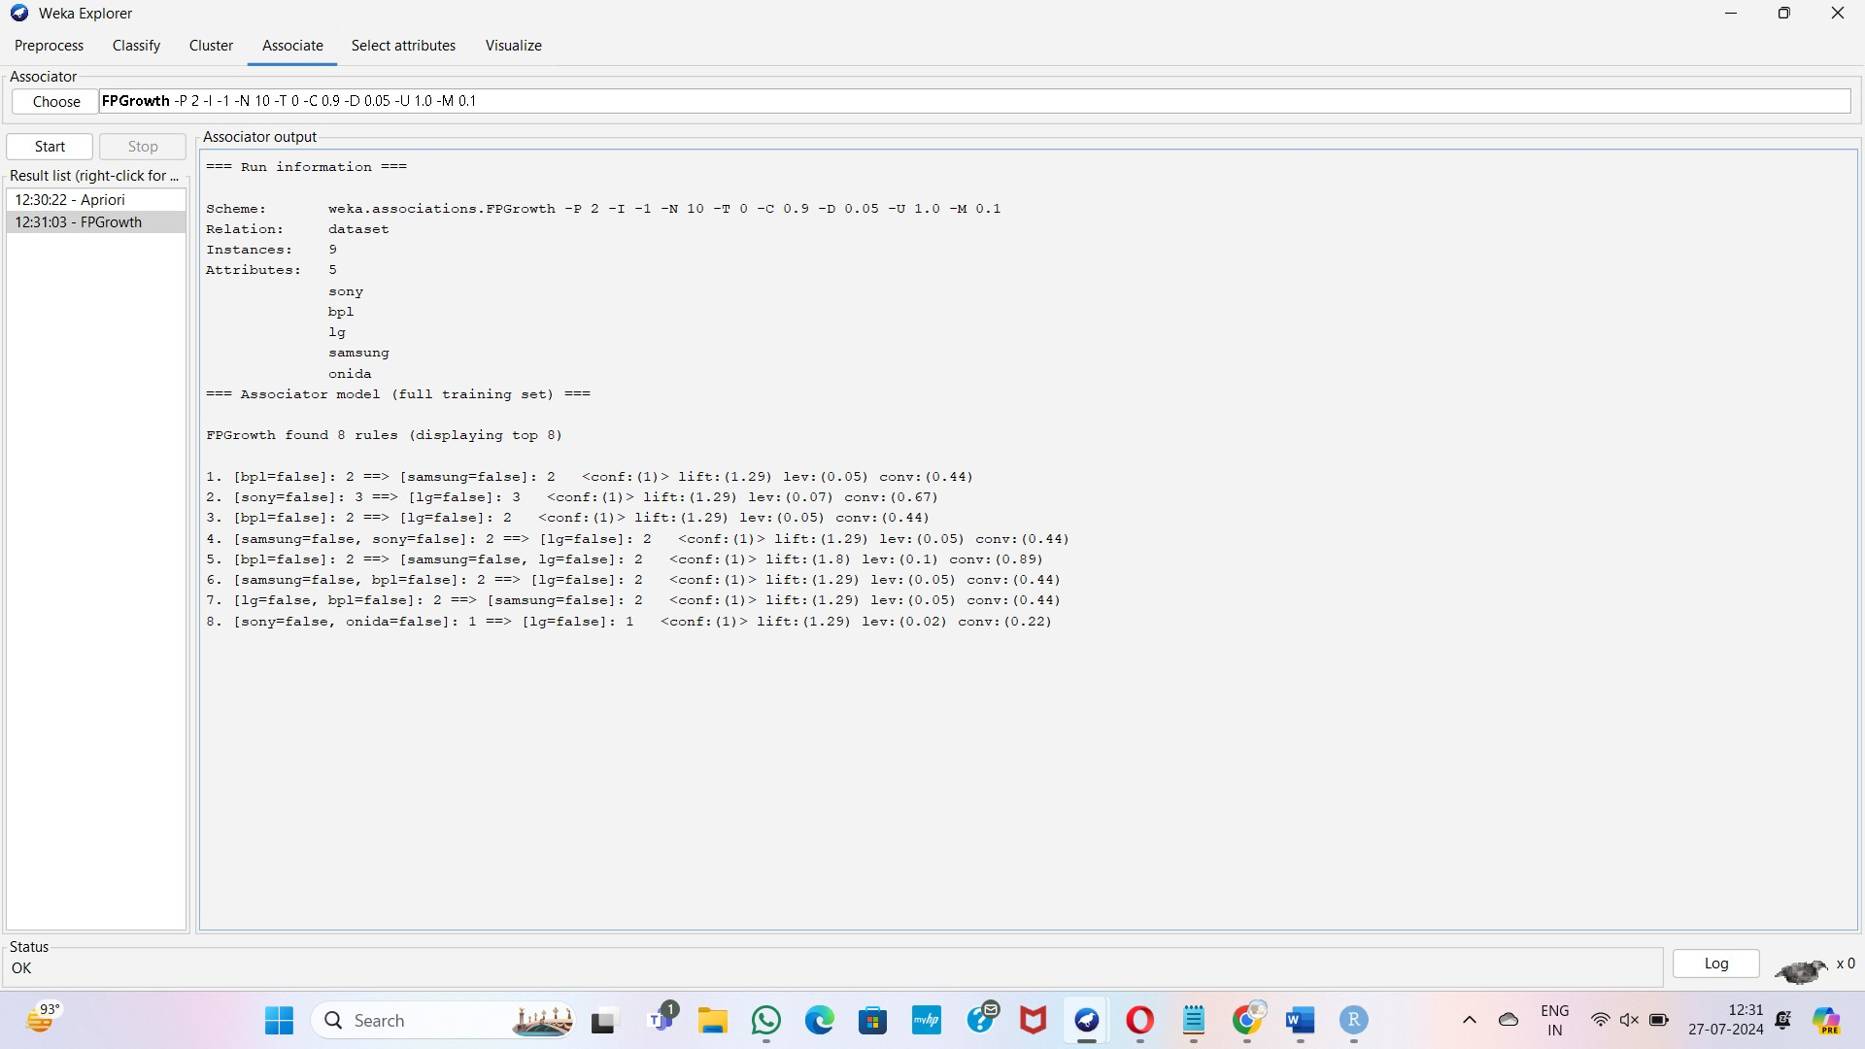

**Q11:**

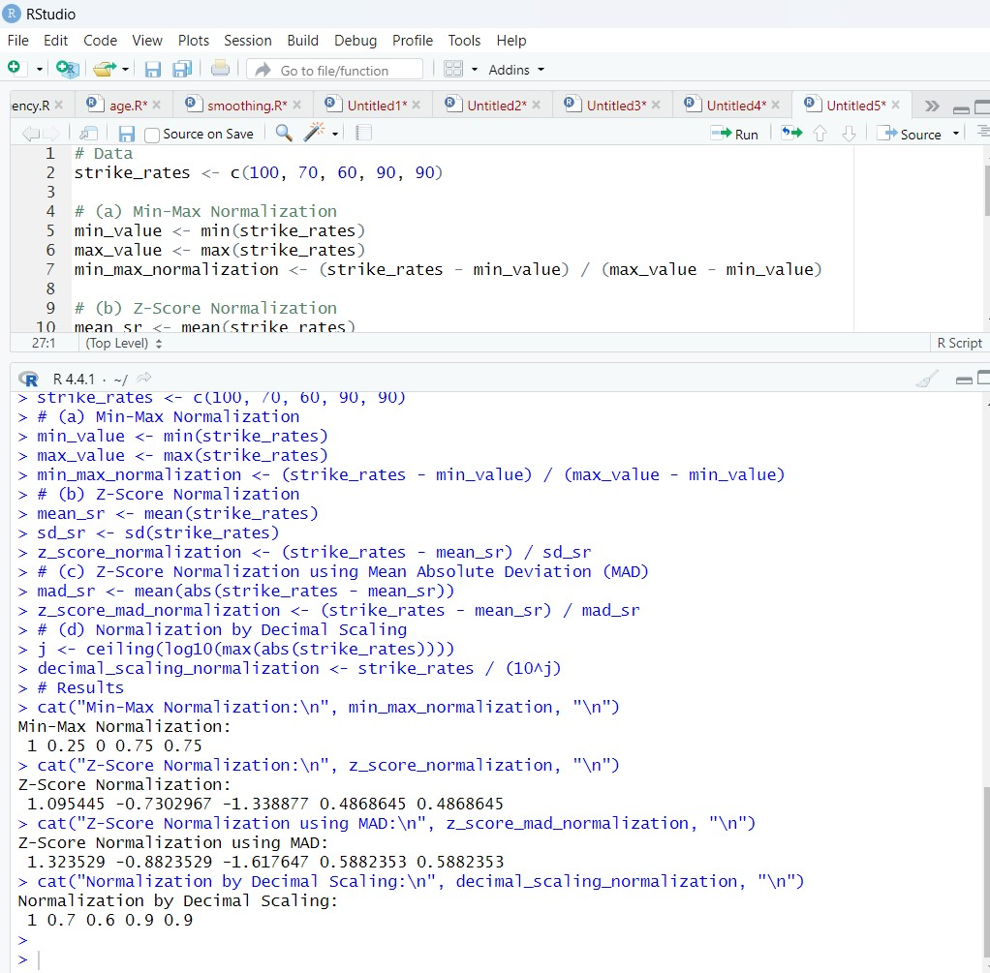

**Q12:**

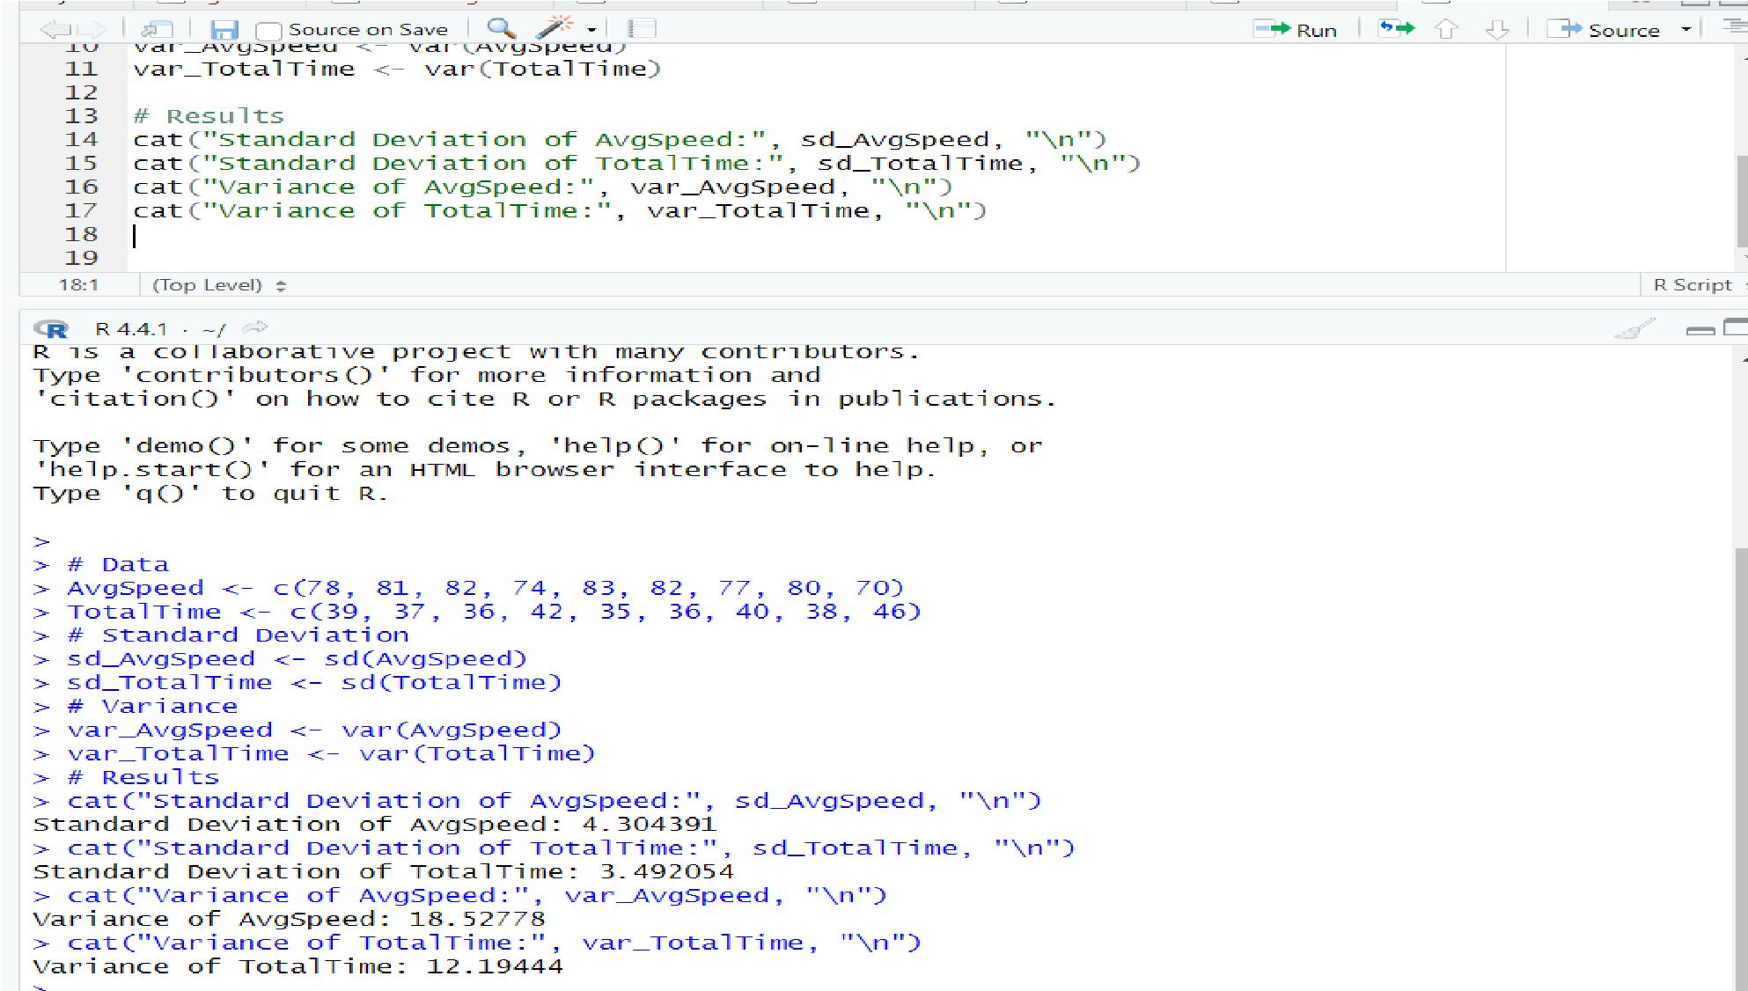

**Q13:**

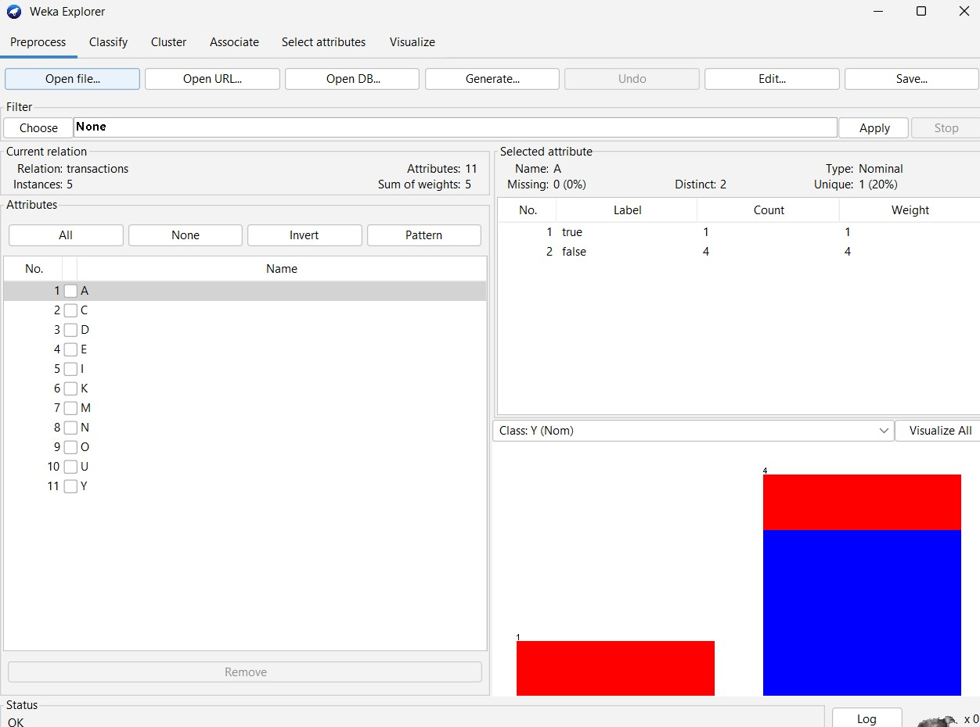

**Apriori algorithm**

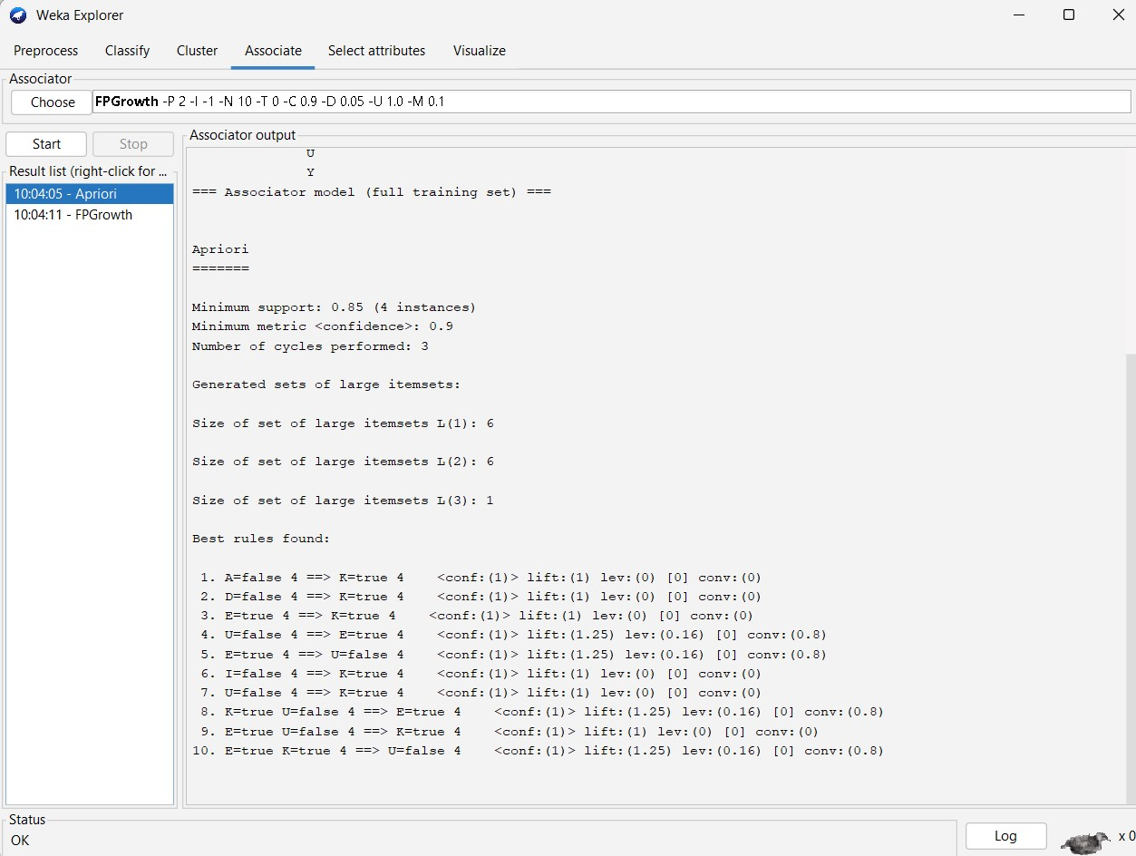

**Fp growth**

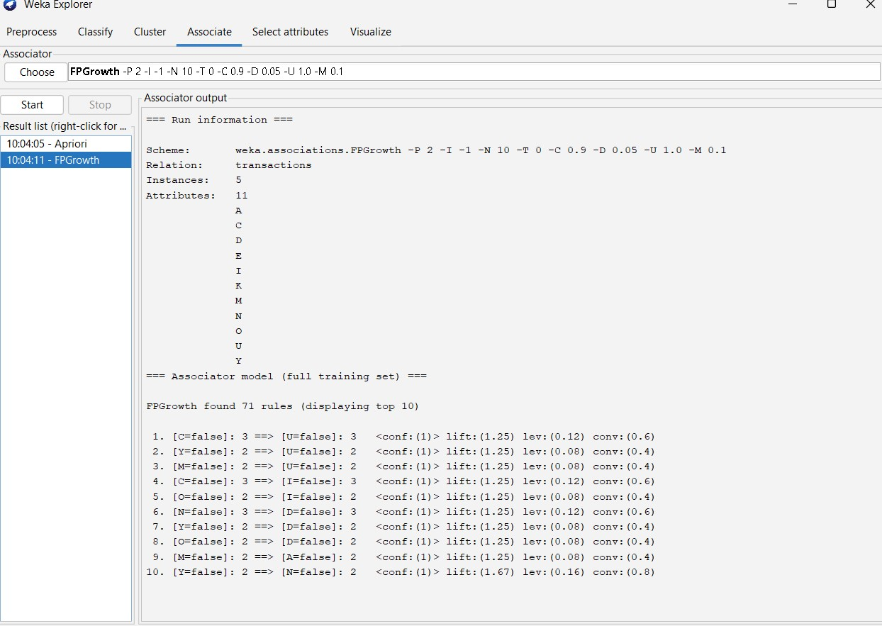

## QUESTION BANK

**Q1:**

**INPUT:**

**sales_prices <- c(5, 10, 11, 13, 15, 35, 50, 55, 72, 92, 204, 215) num_bins <- 3**

**bins_freq <- cut(sales_prices, breaks = num_bins, include.lowest = TRUE, labels = FALSE) cat("Equal-Frequency (Equi-Depth) Partitioning:\n") print(data.frame(Price = sales_prices, Bin = bins_freq)) min_price <- min(sales_prices) max_price <- max(sales_prices) num_bins <- 3 bin_width <- (max_price - min_price) / num_bins bins_width <- cut(sales_prices, breaks = seq(min_price, max_price, length.out = num_bins + 1), include.lowest = TRUE, labels = FALSE) cat("\nEqual-Width Partitioning:\n") print(data.frame(Price = sales_prices, Bin = bins_width)) num_clusters <- 3**

**kmeans_result <- kmeans(sales_prices, centers = num_clusters) cat("\nClustering:\n")**

**print(data.frame(Price = sales_prices, Cluster = kmeans_result$cluster))**

**OUTPUT:**

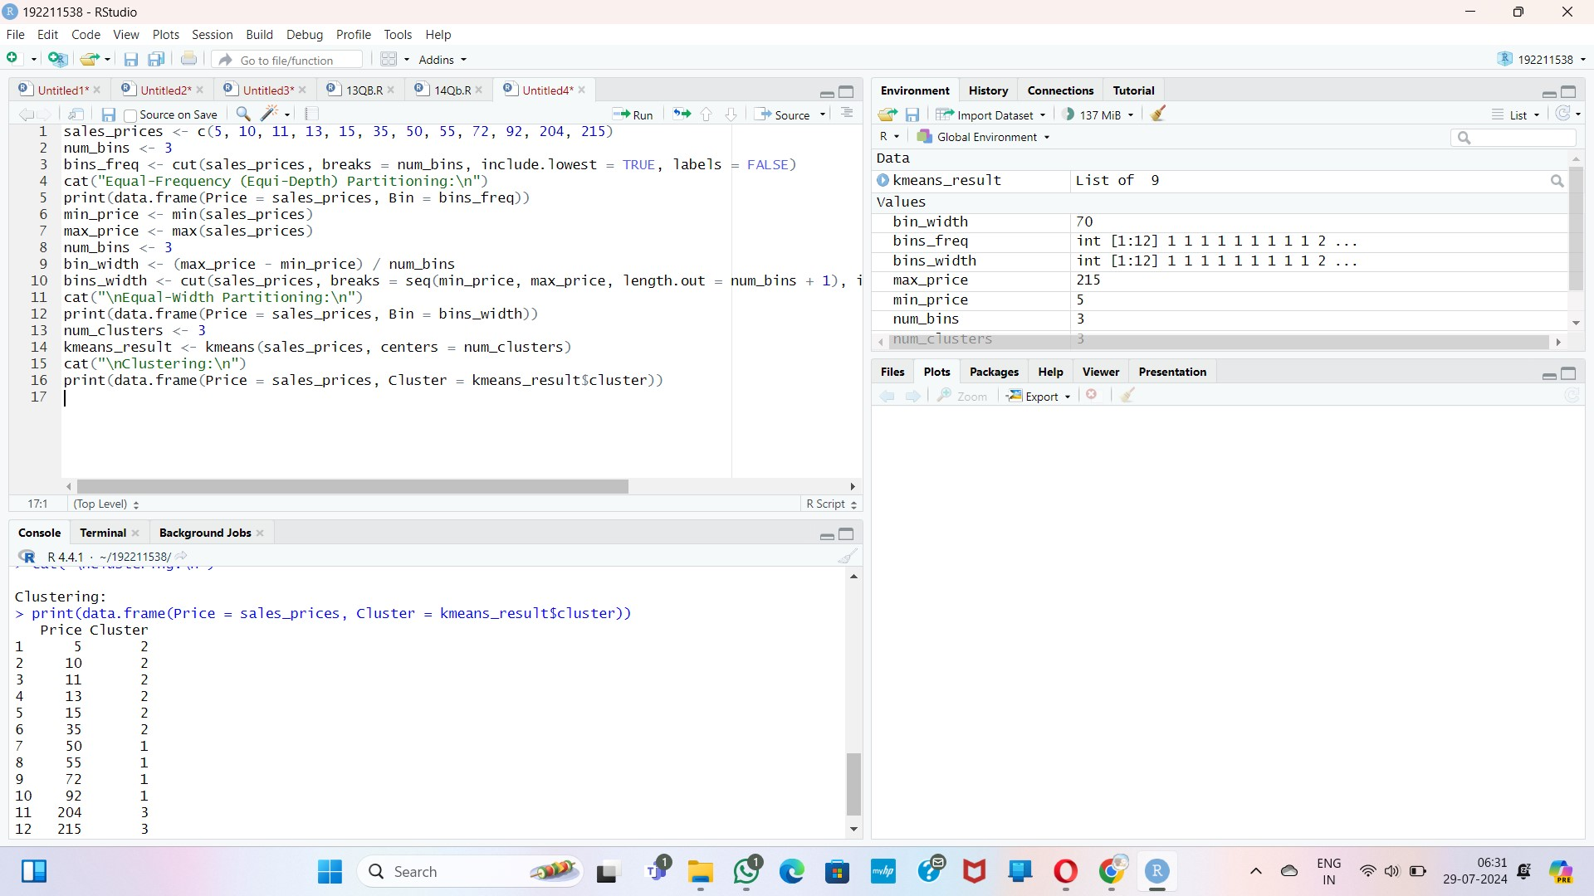

**Q2:**

**Q3:**

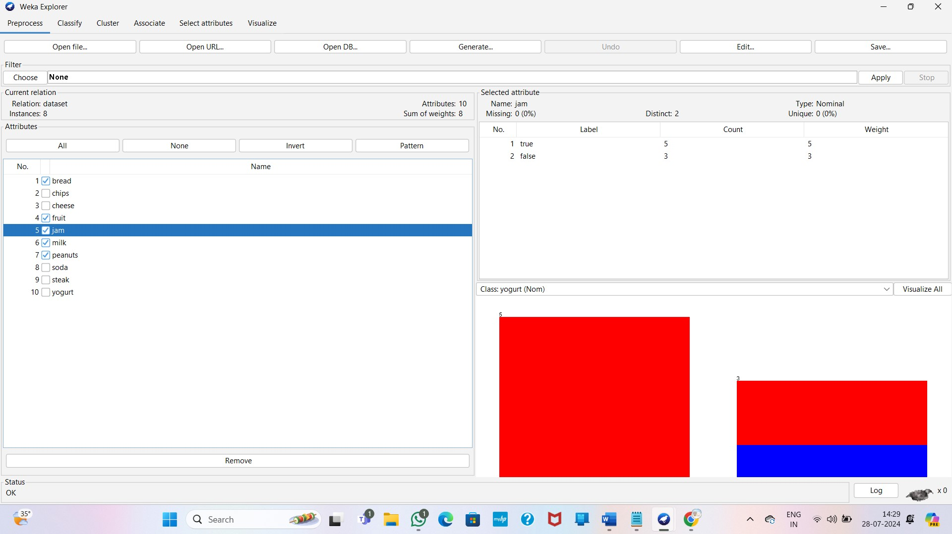

**Apriori Algorithm :**

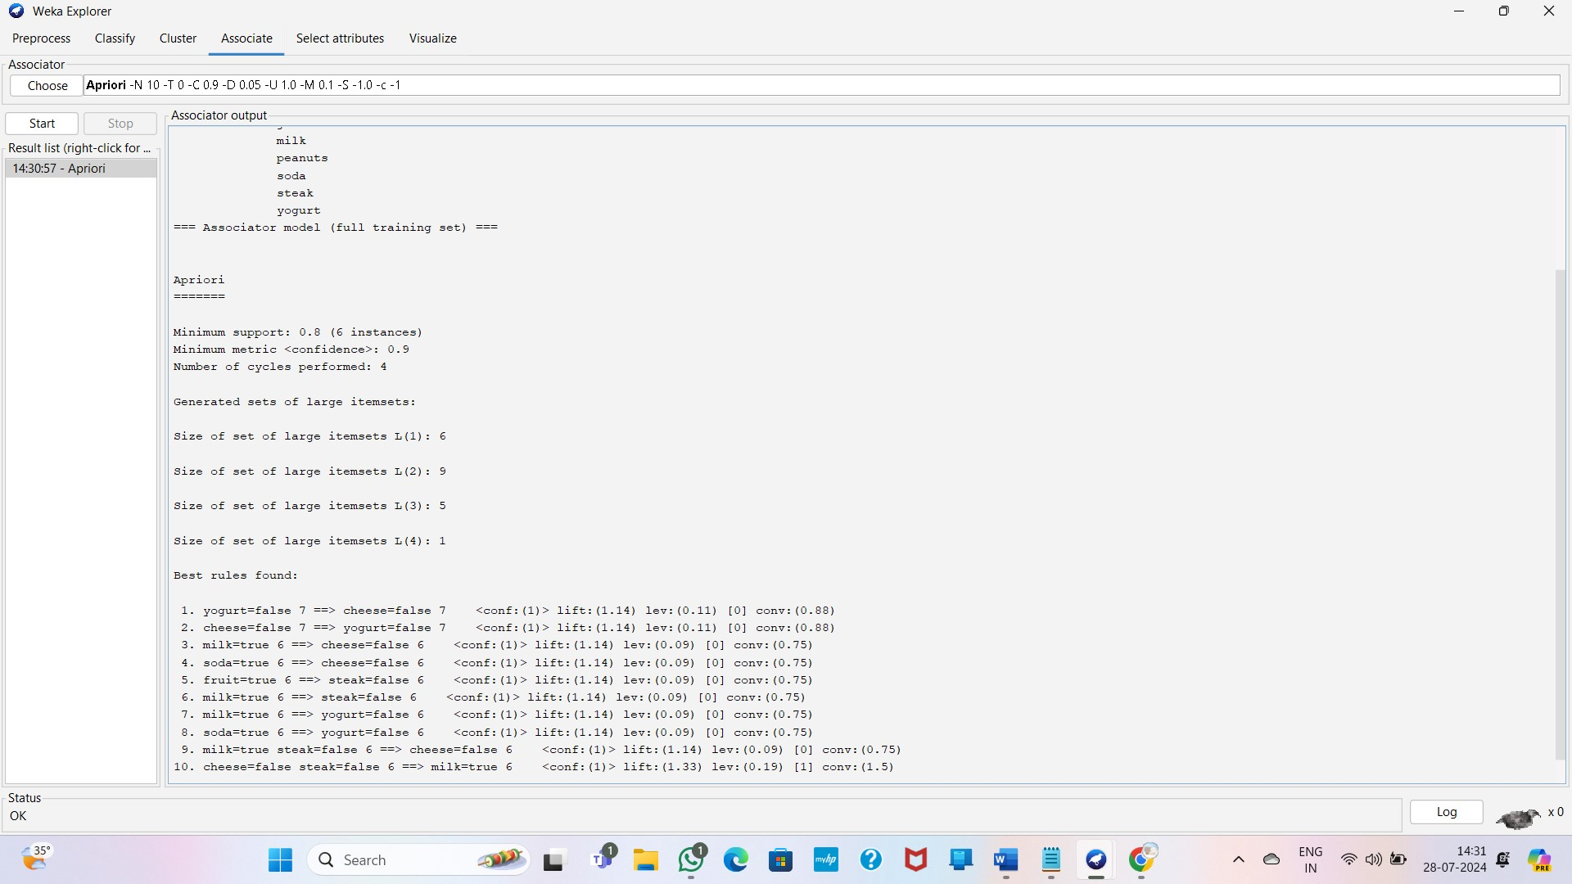

**Q4: INPUT:**

**data <- data.frame(values = c(200, 300, 400, 600, 1000)) min_value <- min(data$values) max_value <- max(data$values) data$min_max_normalized <- (data$values - min_value) / (max_value - min_value) mean_value <- mean(data$values) sd_value <- sd(data$values) data$z_score_normalized <- (data$values - mean_value) / sd_value mad_value <- mad(data$values, constant = 1) data$mad_normalized <- (data$values - mean_value) / mad_value max_abs_value <- max(abs(data$values))**

**data$decimal_scaled <- data$values / (10^ceiling(log10(max_abs_value + 1))) print(data) Output:**

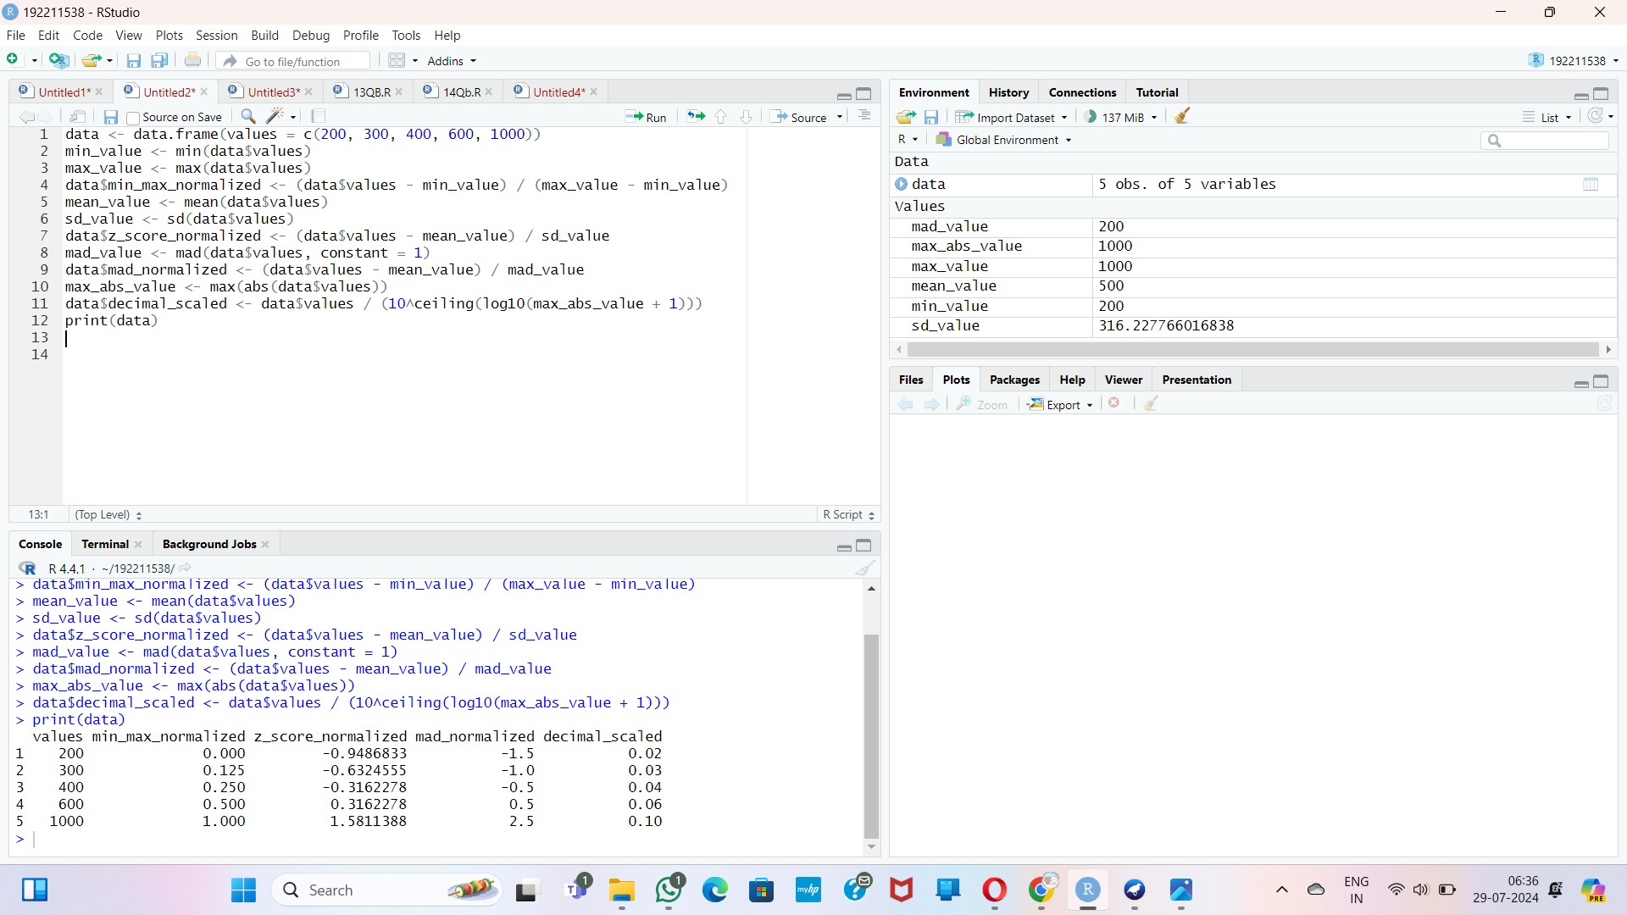

**Q5: Input:**

**library(ggplot2) library(dplyr) diabetes <- read.csv("D:/DWDM/diabetes.csv") str(diabetes)**

**ggplot(diabetes, aes(x = Age, y = BloodPressure)) + geom_point(color = "blue") + labs(title = "Scatterplot of Blood Pressure vs Age",**

**x = "Age", y = "Blood Pressure") +**

**theme_minimal()**

**diabetes <- diabetes %>%**

**mutate(AgeGroup = cut(Age, breaks = seq(0, 100, by = 10), labels = paste(seq(0, 90, by = 10), seq(10, 100, by = 10), sep = "-"), right = FALSE))**

**avg_bp_by_age_group <- diabetes %>%**

**group_by(AgeGroup) %>%**

**summarise(AverageBloodPressure = mean(BloodPressure, na.rm = TRUE))**

**ggplot(avg_bp_by_age_group, aes(x = AgeGroup, y = AverageBloodPressure, fill =**

**AgeGroup)) + geom_bar(stat = "identity") + labs(title = "Average Blood Pressure by Age Group",**

**x = "Age Group", y = "Average Blood Pressure") +**

**theme_minimal() +**

**theme(axis.text.x = element_text(angle = 45, hjust = 1))**

**OUTPUT:**



**Q6:**

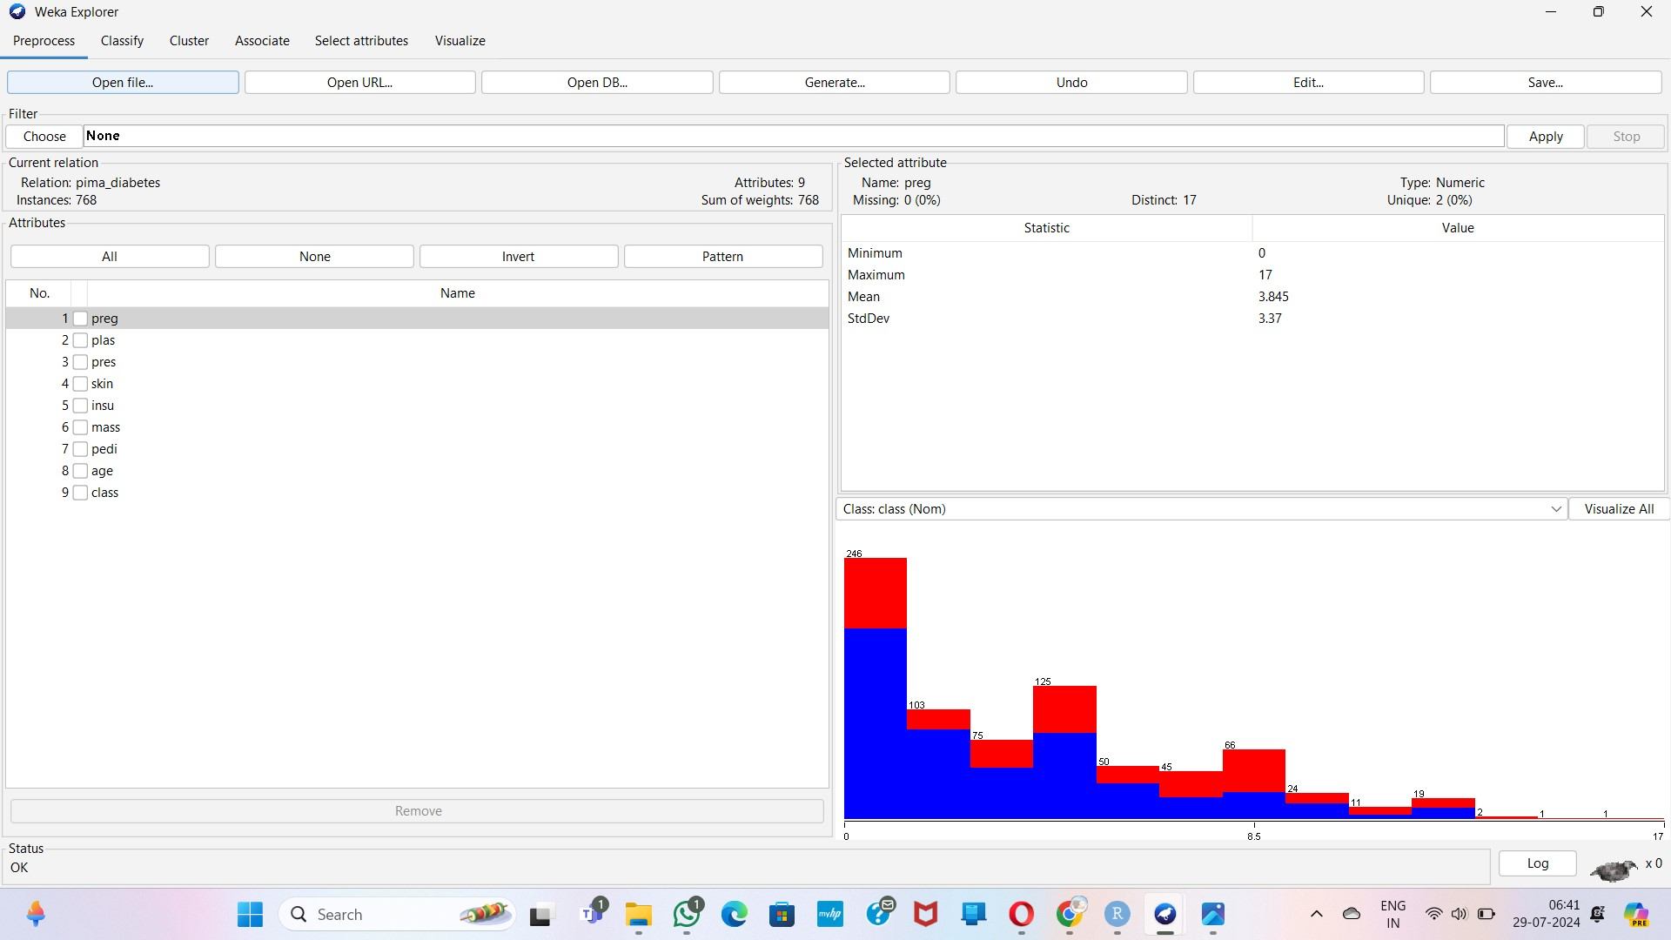

**Linear regression:**

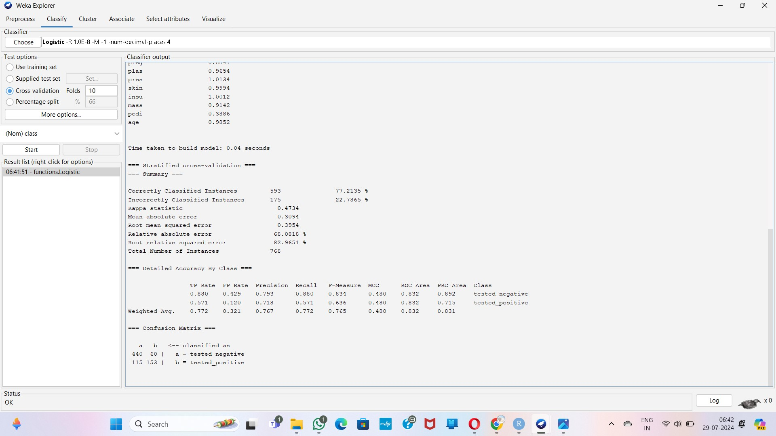

**Multiple regression:**

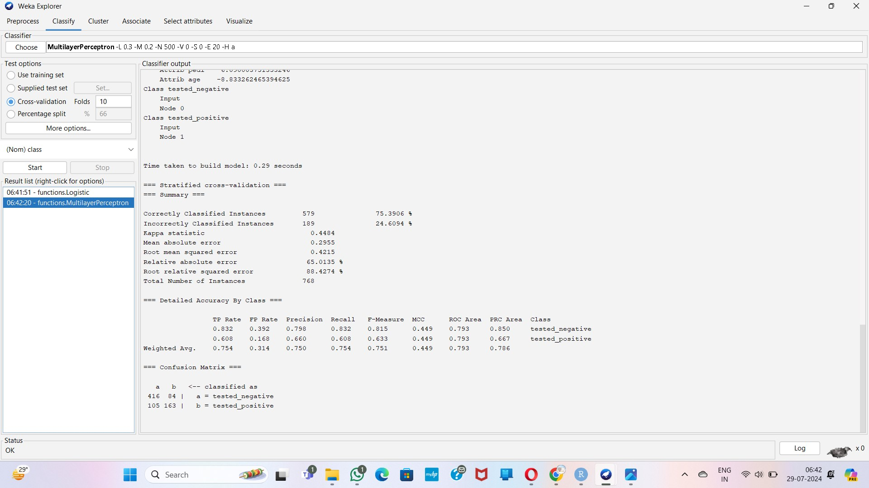

**Q7:**

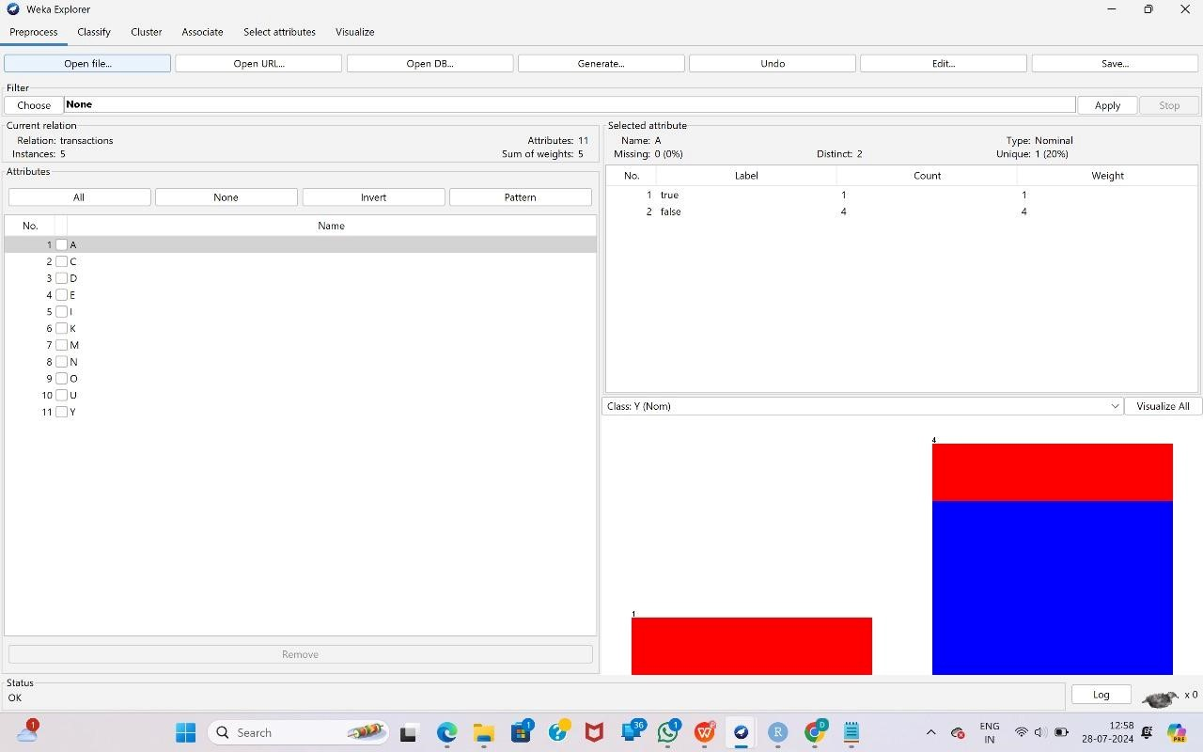

**Apriori Algorithm:**

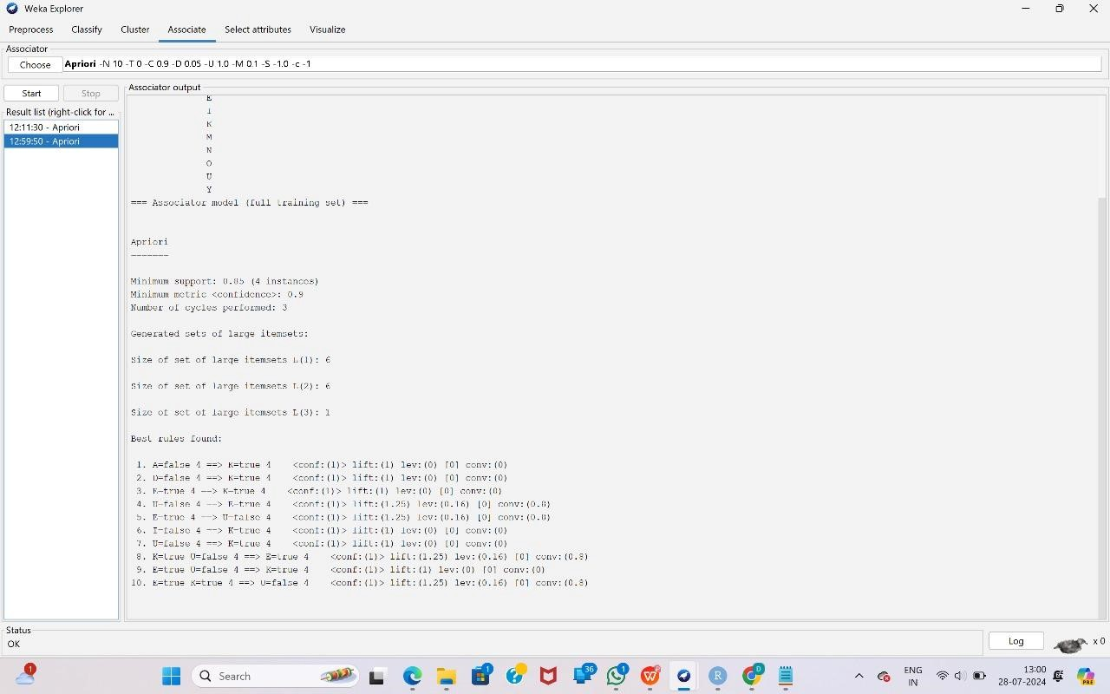

**FP Growth:**

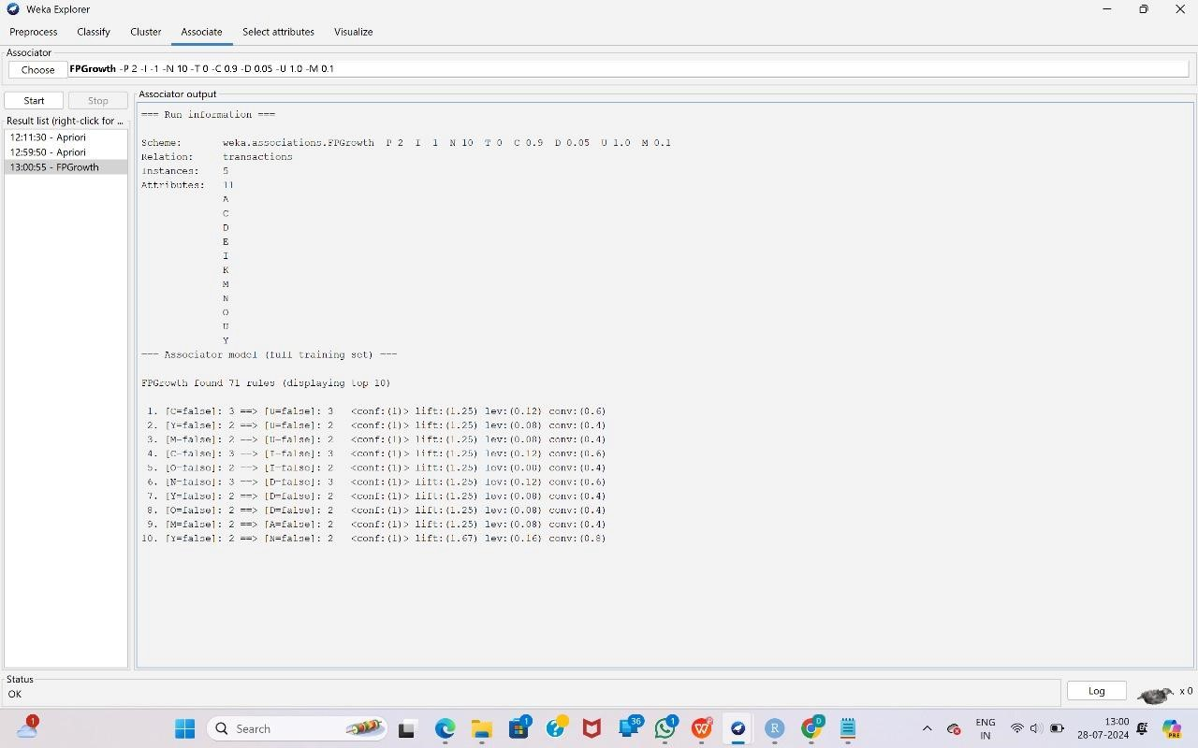

**Q8:**

**TREE:**



**PREPROCESS:**



**Q9:**

**INPUT:**

**#Q1, Q2**

**age<-c(13,15,16,16,19,20,20,21,22,22,25,25,25,25,30,33,33,35,35,35,35,36,40,45,46,52,70) quantile(age,.25) quantile(age,.75) Output:**

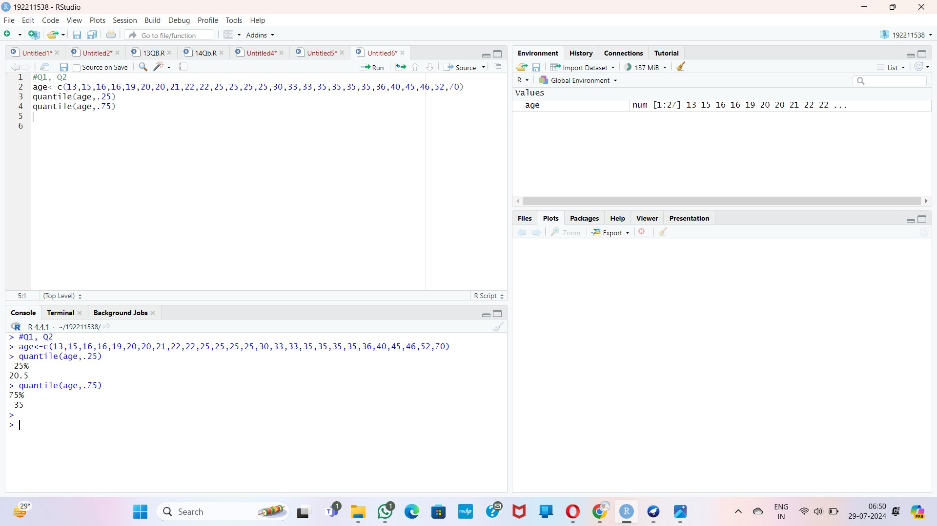

**Q10:**

**INPUT:**

**data(water, package="datasets")**

**plot(water$hardness, water$mortality, main="Scatterplot of Mortality vs Hardness", xlab="Hardness", ylab="Mortality") model <- lm(mortality ~ hardness, data=water) abline(model, col="red")**

**predicted_mortality <- predict(model, newdata=data.frame(hardness=88)) predicted_mortality**

**OUTPUT:**

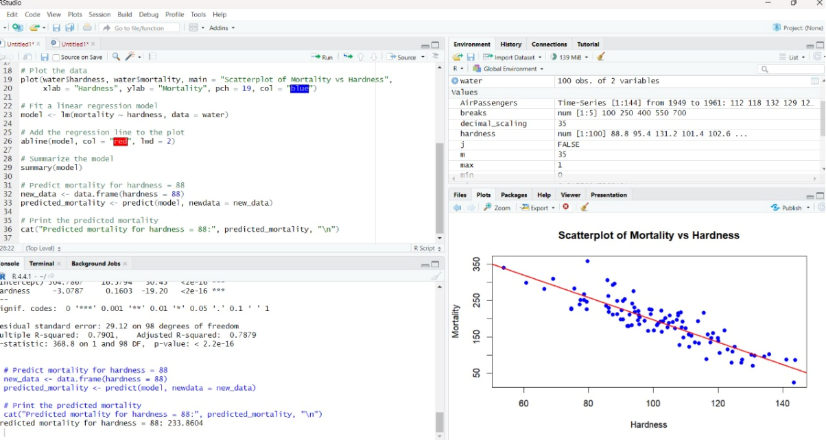

**Q11:**

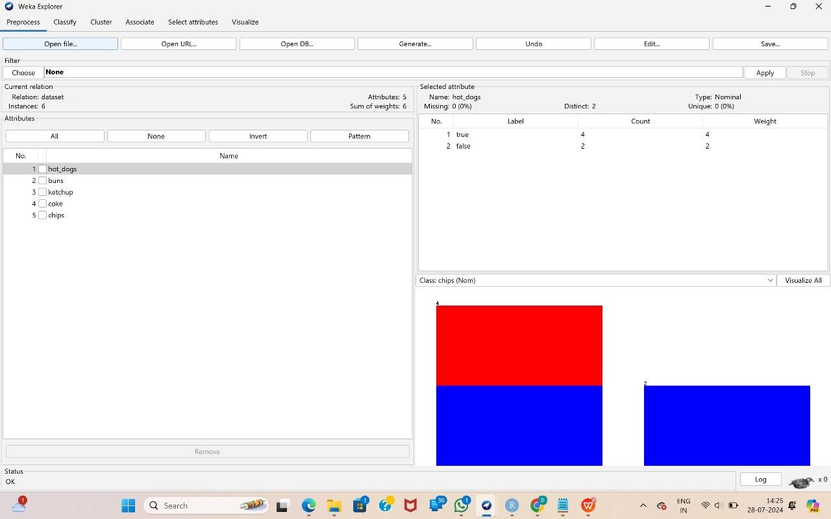

**Apriori Algorithm:**

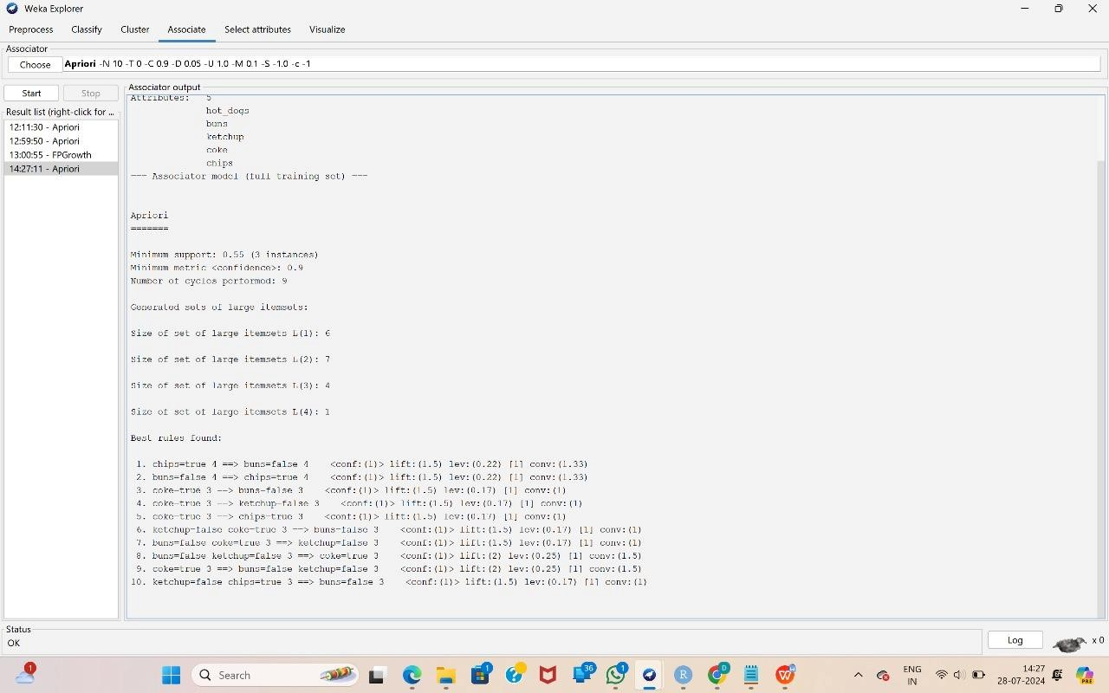

**FP Growth:**

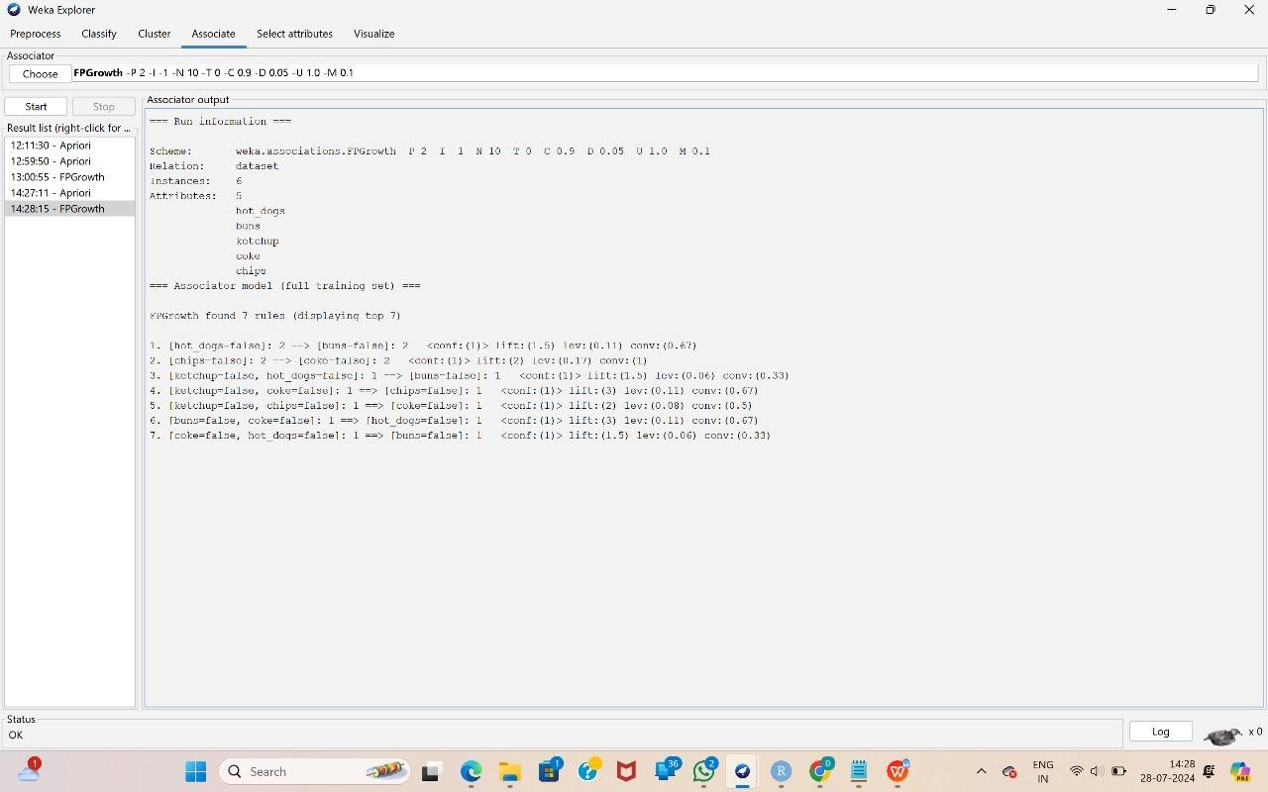

**Q12: Tree:**



**Decision Tree:**



**Logistic:**



**Q13:**

**INPUT:**

**prices <- c(1, 1, 5, 5, 5, 5, 5, 8, 8, 10, 10, 10, 10, 12, 14, 14, 14, 15, 15, 15, 15, 15, 15, 18,**

**18, 18, 18, 18, 18, 18, 18, 20, 20, 20, 20, 20, 20, 20, 21, 21, 21, 21, 25, 25, 25, 25, 25, 28,**

**28, 30, 30, 30) library(dplyr)**

**num_bins <- 3 bin_size <- length(prices) / num_bins bins <- split(prices, ceiling(seq_along(prices) / bin_size)) print("Equal-frequency bins:") print(bins) bin_means <- lapply(bins, mean)**

**print("Smoothing by bin means:") print(bin_means) bin_boundaries <- lapply(bins, function(bin) { min_val <- min(bin) max_val <- max(bin) sapply(bin, function(x) { if (x - min_val < max_val - x) min_val else max_val**

**})**

**})**

**print("Smoothing by bin boundaries:") print(bin_boundaries) bins_unlisted <- unlist(bins)**

**hist(bins_unlisted, breaks=num_bins, main="Histogram of Prices with Equal-Frequency Bins", xlab="Price", ylab="Frequency", col="lightblue", border="black") abline(v = unlist(bin_means), col = "red", lwd = 2, lty = 2) # bin means**

**abline(v = unlist(lapply(bin_boundaries, range)), col = "blue", lwd = 2, lty = 3) # bin boundaries**

**legend("topright", legend=c("Bin Means", "Bin Boundaries"), col=c("red",**

**"blue"), lwd=2, lty=c(2, 3))**

**OUTPUT:**

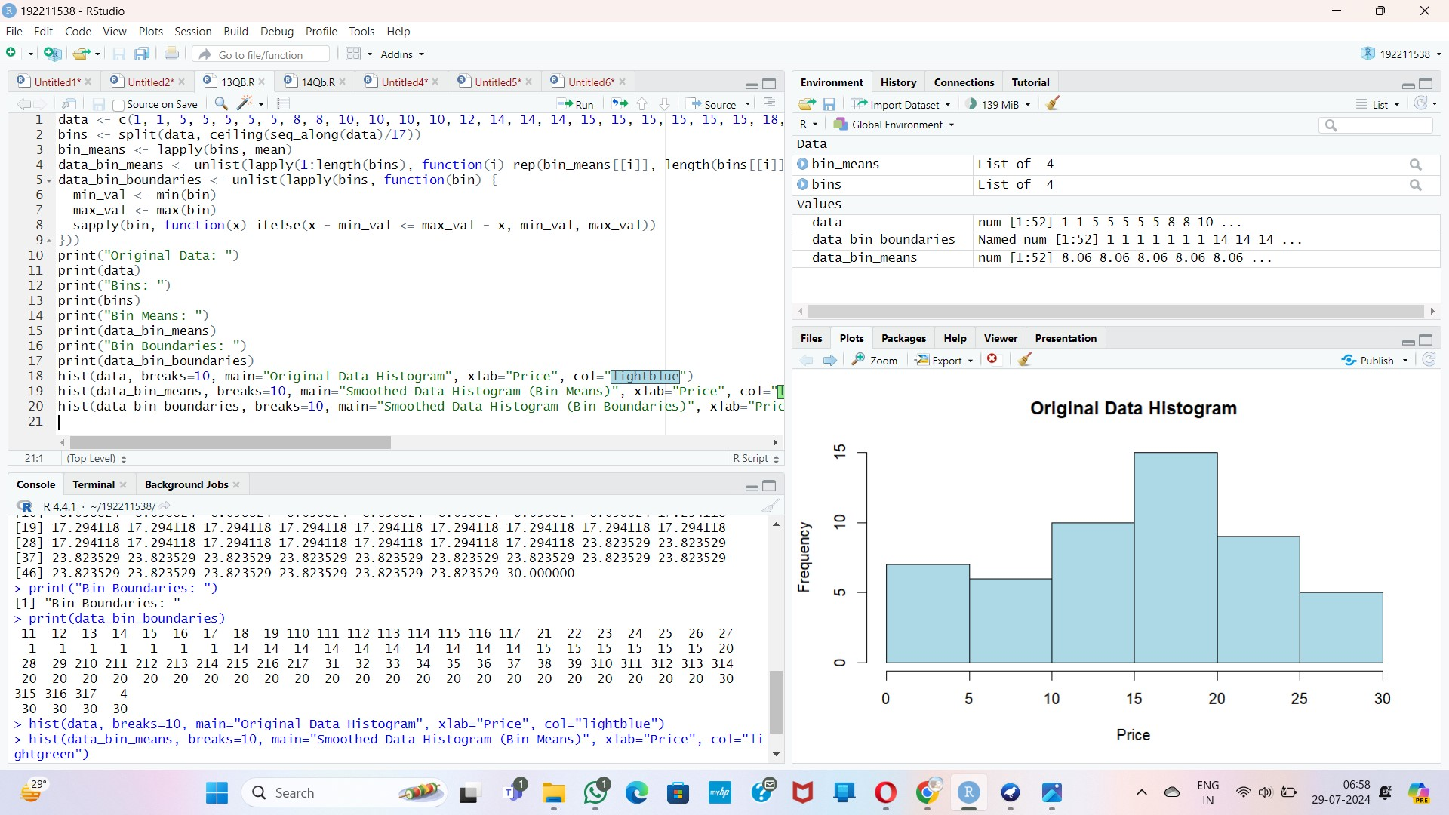

**Q14: INPUT:**

**class_A <- c(76, 35, 47, 64, 95, 66, 89, 36, 84) class_B <- c(51, 56, 84, 60, 59, 70, 63, 66, 50) mean_A <- mean(class_A) mean_B <- mean(class_B) median_A <- median(class_A) median_B <- median(class_B) range_A <- range(class_A) range_B <- range(class_B) range_A_diff <- diff(range_A) range_B_diff <- diff(range_B)**

**cat("Class A - Mean:", mean_A, " Median:", median_A, " Range:", range_A_diff, "\n") cat("Class B - Mean:", mean_B, " Median:", median_B, " Range:", range_B_diff, "\n")**

**boxplot(class_A, class_B, names=c("Class A", "Class B"), main="Comparison of Class A and Class B Performance", ylab="Scores", col=c("lightblue", "lightgreen")) abline(h=mean_A, col="blue", lty=2) abline(h=mean_B, col="green", lty=2) abline(h=median_A, col="blue", lty=3) abline(h=median_B, col="green", lty=3)**

**legend("topright", legend=c("Mean A", "Mean B", "Median A", "Median B"), col=c("blue", "green", "blue", "green"), lty=c(2, 2, 3, 3))**

**OUTPUT:**

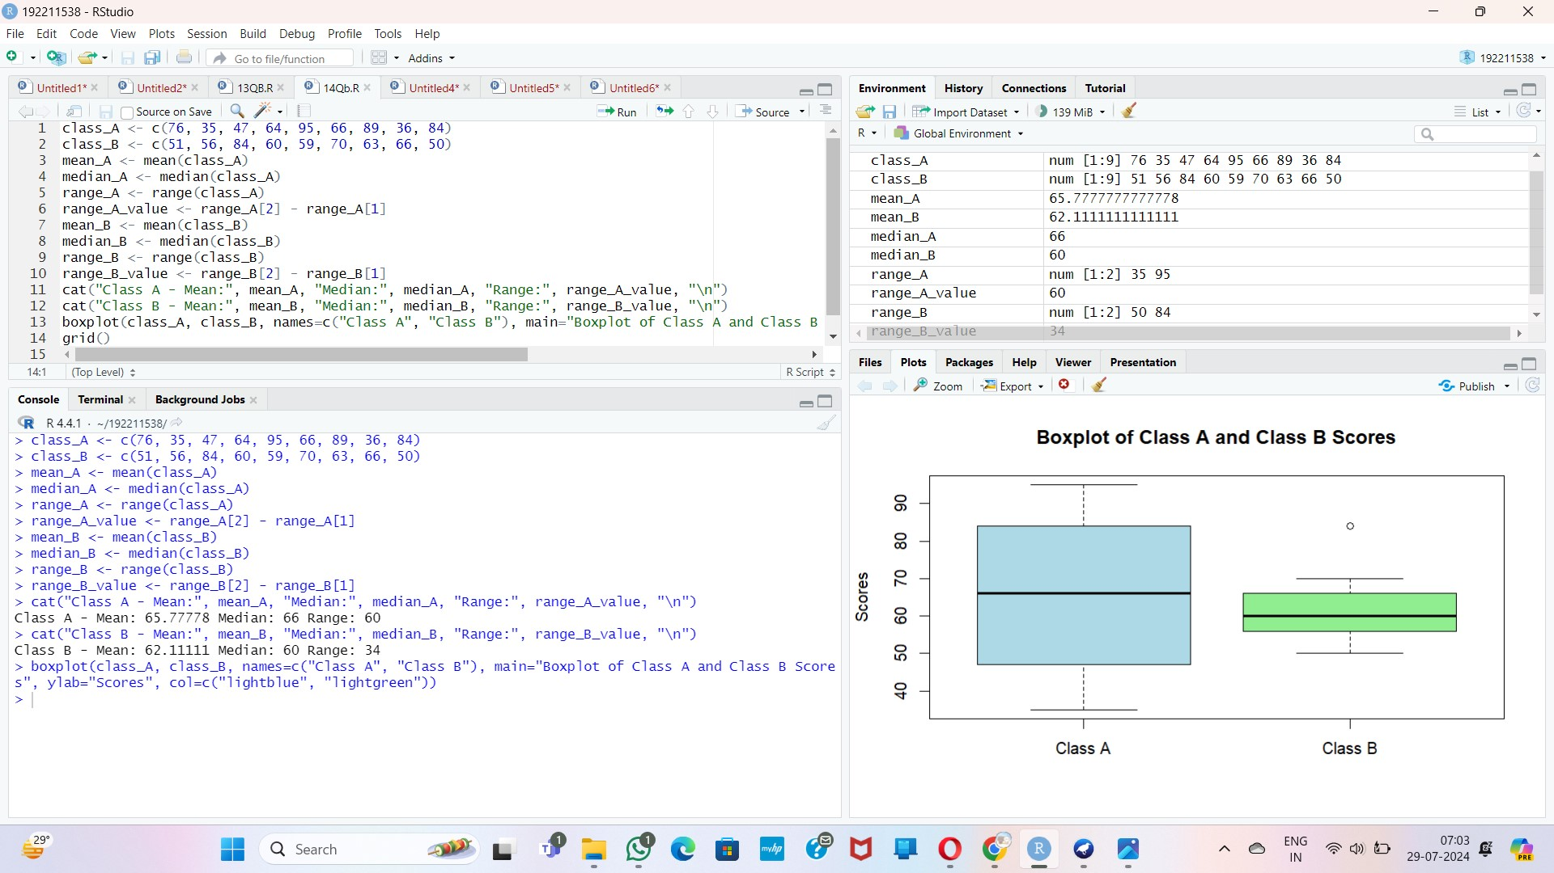

**Q15:**

**Q16: Q16:**

**library(cluster) # For clustering algorithms library(factoextra) # For clustering visualization library(datasets) # For sample datasets set.seed(123) customer_data <- data.frame( percentage_opened = runif(100, 0, 100), # Percentage of emails opened clicks_per_email = runif(100, 0, 10), # Number of clicks per email time_spent_viewing = runif(100, 0, 5) # Time spent viewing email (in minutes)**

**)**

**customer_data_scaled <- scale(customer_data) set.seed(123) kmeans_result <- kmeans(customer_data_scaled, centers = 3, nstart = 25) distances <- dist(customer_data_scaled) hclust_result <- hclust(distances, method = "ward.D2") cutree_result <- cutree(hclust_result, k = 3) silhouette_kmeans <- silhouette(kmeans_result$cluster, distances) silhouette_hclust <- silhouette(cutree_result, distances) avg_silhouette_kmeans <- mean(silhouette_kmeans[, 3]) avg_silhouette_hclust <- mean(silhouette_hclust[, 3]) cat("Average Silhouette Score for k-means: ", avg_silhouette_kmeans, "\n") cat("Average Silhouette Score for Hierarchical Clustering: ", avg_silhouette_hclust, "\n")**

**fviz_cluster(kmeans_result, data = customer_data_scaled, geom = "point", stand = FALSE, main = "K-means Clustering")**

**fviz_dend(hclust_result, k = 3, rect = TRUE, main = "Hierarchical Clustering Dendrogram") if (avg_silhouette_kmeans > avg_silhouette_hclust) { cat("K-means clustering performed better based on the silhouette score.\n")**

**} else { cat("Hierarchical clustering performed better based on the silhouette score.\n") }**

**OUTPUT:**

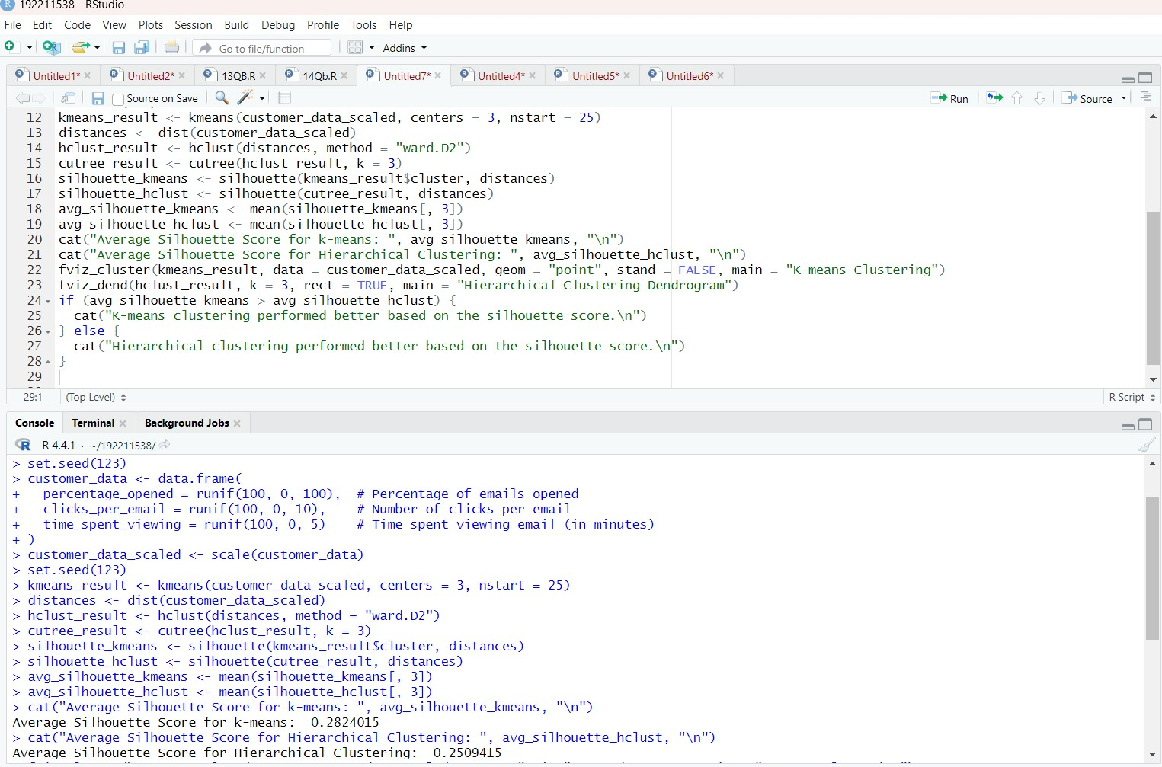

**Q17:INPUT:**

**age<-c(23,23,27,27,39,41,47,49,50,52,54,54,56,57,58,58,60,61) fat<-c(9.5,26.5,7.8,17.8,31.4,25.9,27.4,27.2,31.2,34.6,42.5,28.8,33.4,30.2,34.1,32.9,41.2,35.7) mean(age) median(age) sd(age) mean(fat) median(fat) sd(fat) boxplot(age,fat) scatter.smooth(age,fat) plotqqplot(age,fat)**

**Output:**

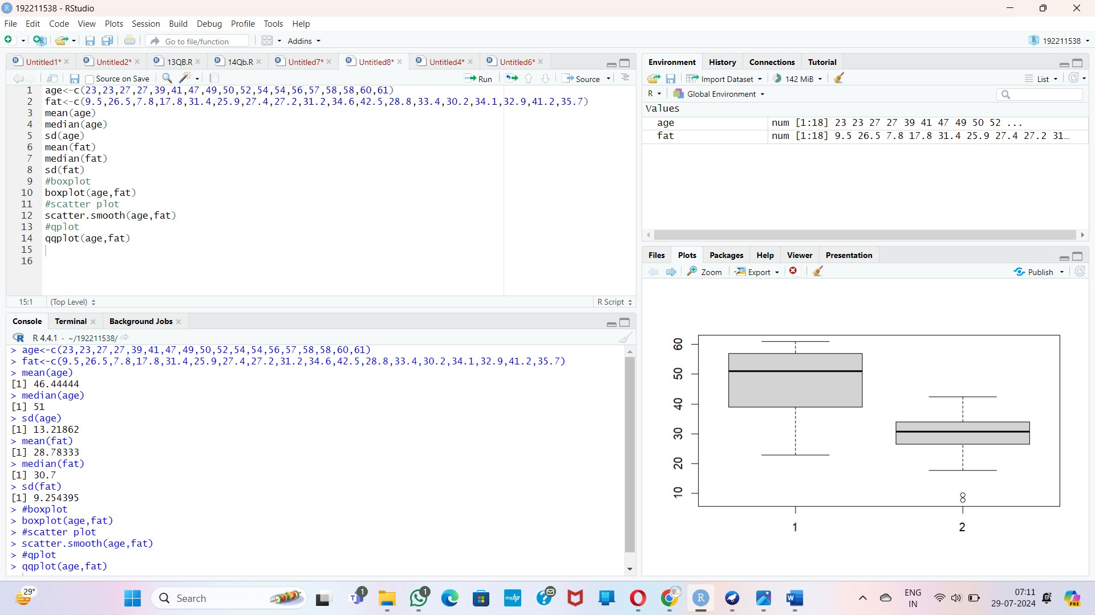

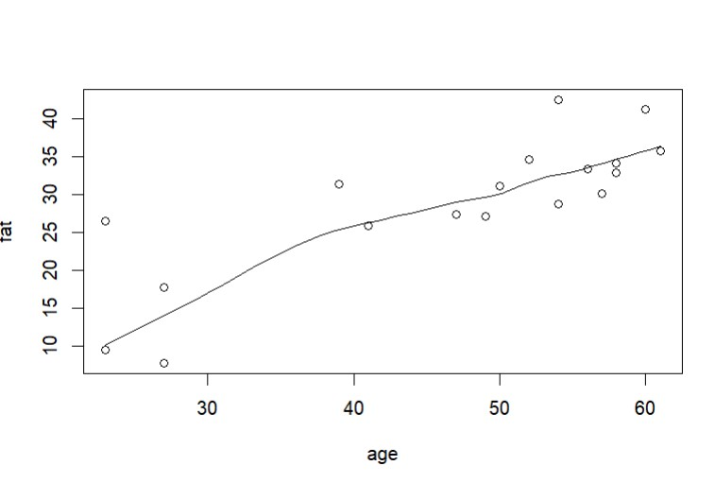

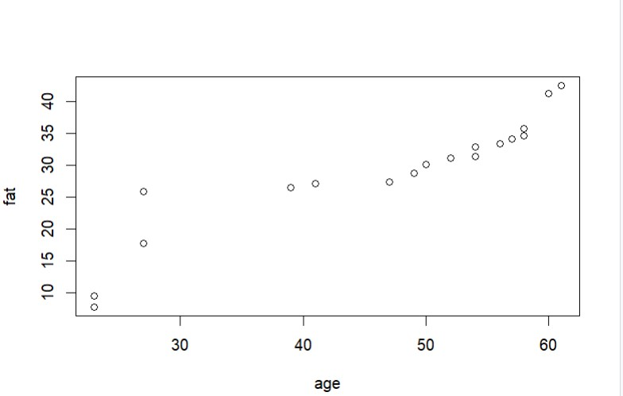

**Q18: INPUT: v<-c(23,23,27,27,39,41,47,49,50,52,54,54,56,57,58,58,60,61) min<-0 max<-1 #min_max**

**min_max=((35-min(v))/(max(v)-min(v))) print(min_max) #z-score m=mean(v) s<-12.94 z_score=(35-m)/s print(z_score) #decimal scaling m<-35 j=max(m)<1 decimal_scaling=m/10^j print(decimal_scaling)**

**Output:**

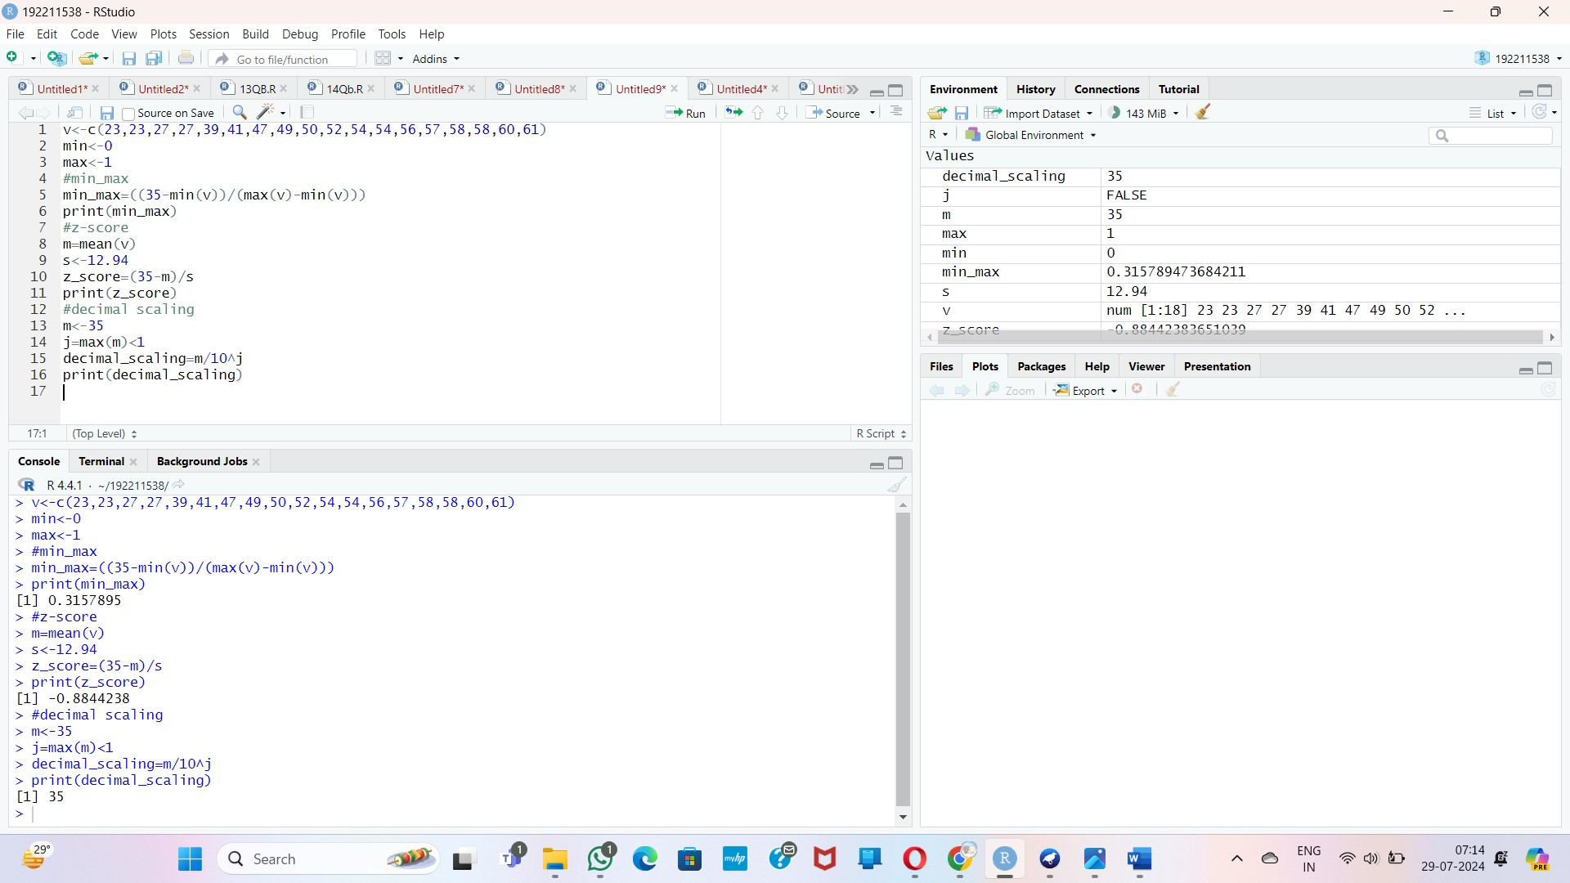

**Q19:**

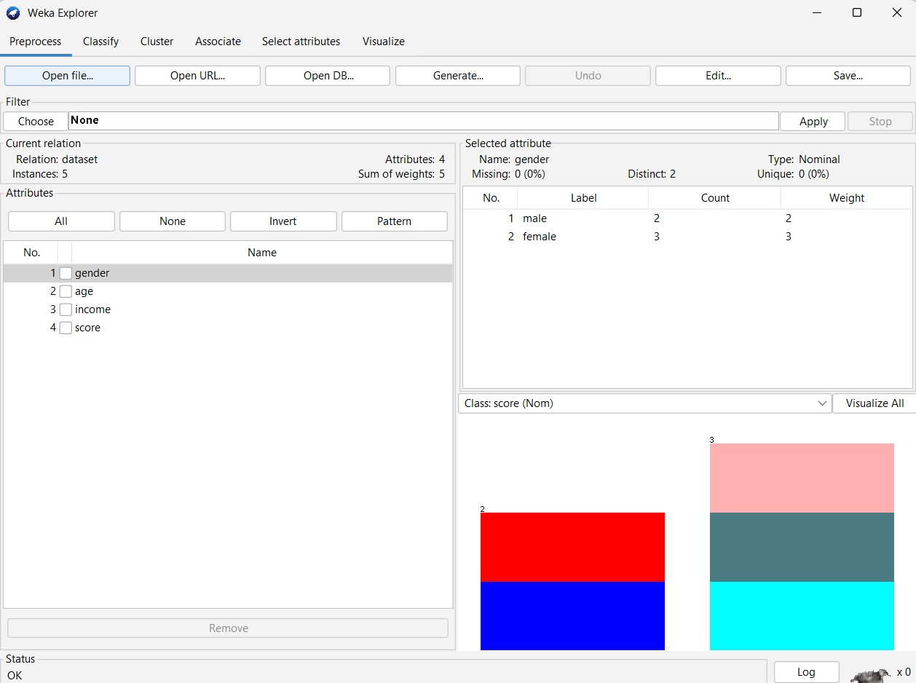

**Clustering Analysis:**

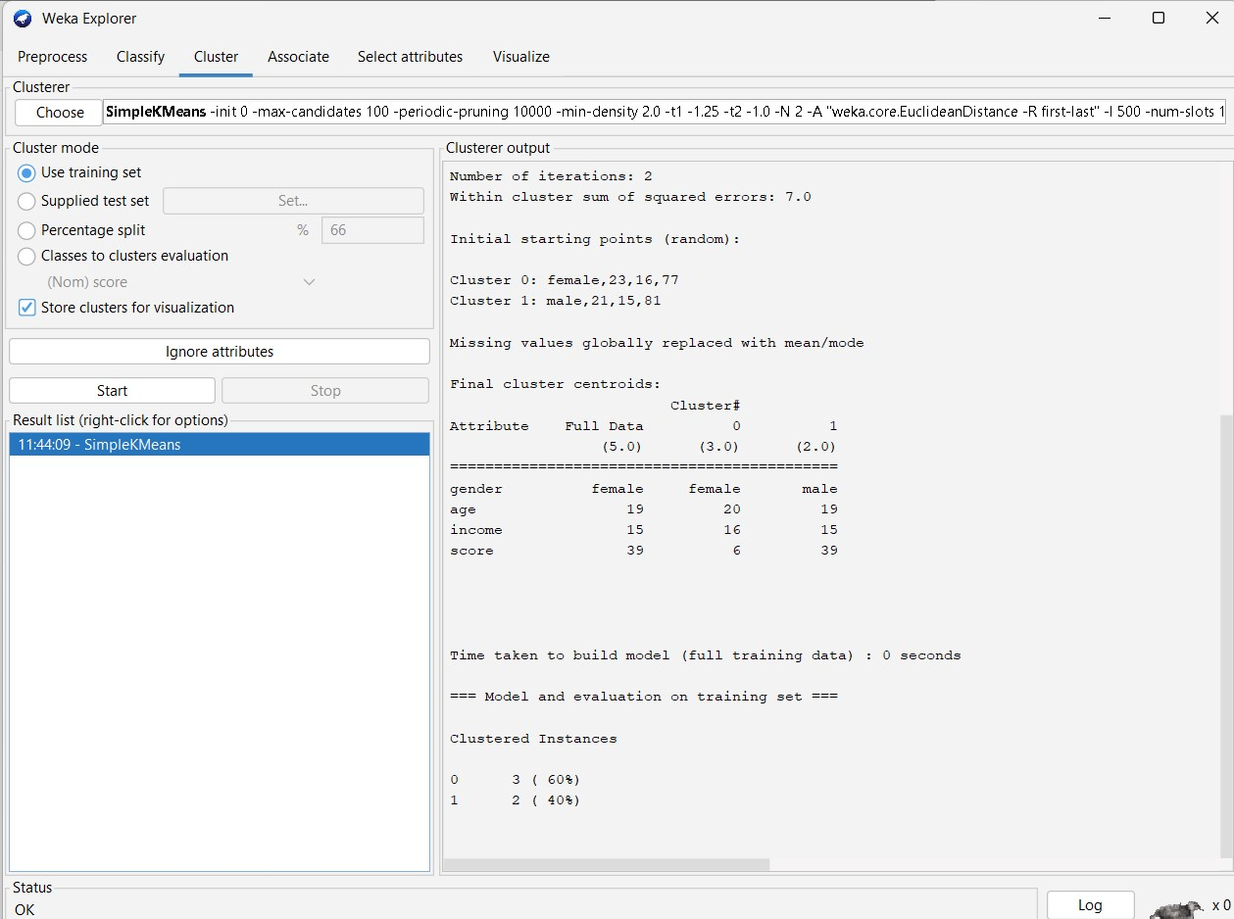

**Q21:**

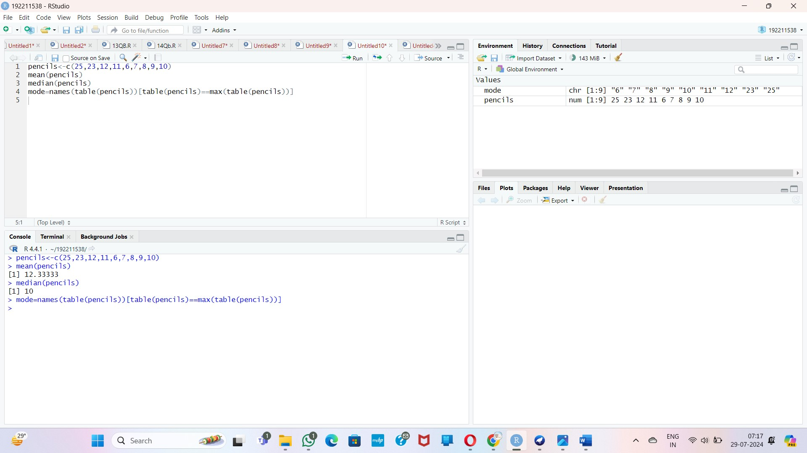

29

if(!require(cluster)) install.packages("cluster", dependencies=TRUE)

marks <- c(55, 60, 71, 63, 55, 65, 50, 55, 58, 59, 61, 63, 65, 67, 71, 72, 75)

plot_histogram <- function(data, breaks, main_title) {

hist(data, breaks=breaks, main=main_title, xlab="Marks", ylab="Frequency", col="lightblue", border="black")

}

equal_freq_breaks <- quantile(marks, probs=seq(0, 1, length.out=4))

cat("Equal-frequency bins:\n")

print(equal_freq_breaks)

plot_histogram(marks, breaks=equal_freq_breaks, main_title="Equal-frequency Partitioning")

min_marks <- min(marks)

max_marks <- max(marks)

equal_width_breaks <- seq(min_marks, max_marks, length.out=4)

cat("Equal-width bins:\n")

print(equal_width_breaks)

plot_histogram(marks, breaks=equal_width_breaks, main_title="Equal-width Partitioning")

set.seed(123)

kmeans_result <- kmeans(marks, centers=3)

cluster_breaks <- c(min(marks), sort(tapply(marks, kmeans_result$cluster, max)), max(marks))

cat("Clustering bins:\n")

print(cluster_breaks)

plot_histogram(marks, breaks=cluster_breaks, main_title="Clustering Partitioning")

32

# Given data

strike_rates <- c(100, 70, 60, 90, 90)

# (a) Min-max normalization

min_max_normalization <- function(x) {

return ((x - min(x)) / (max(x) - min(x)))

}

min_max_normalized <- min_max_normalization(strike_rates)

cat("Min-max normalized values:\n")

print(min_max_normalized)

# (b) Z-score normalization

z_score_normalization <- function(x) {

return ((x - mean(x)) / sd(x))

}

z_score_normalized <- z_score_normalization(strike_rates)

cat("Z-score normalized values:\n")

print(z_score_normalized)

# (c) Z-score normalization using the mean absolute deviation instead of standard deviation

mad_normalization <- function(x) {

mad <- mean(abs(x - mean(x)))

return ((x - mean(x)) / mad)

}

mad_normalized <- mad_normalization(strike_rates)

cat("Z-score normalized using MAD values:\n")

print(mad_normalized)

# (d) Normalization by decimal scaling

decimal_scaling_normalization <- function(x) {

j <- ceiling(log10(max(abs(x))))

return (x / 10^j)

}

decimal_scaled <- decimal_scaling_normalization(strike_rates)

cat("Decimal scaling normalized values:\n")

print(decimal_scaled)

34

# Load necessary libraries

if(!require(ggplot2)) install.packages("ggplot2", dependencies=TRUE)

# Create synthetic dataset

set.seed(123) # For reproducibility

n <- 100 # Number of samples

age <- sample(1:100, n, replace=TRUE)

tumor_size <- sample(1:50, n, replace=TRUE)

inv_nodes <- sample(0:10, n, replace=TRUE)

data <- data.frame(age=age, tumor_size=tumor_size, inv_nodes=inv_nodes)

# Histogram of age

hist(data$age, breaks=10, main="Histogram of Age", xlab="Age", ylab="Frequency", col="lightblue", border="black")

# Scatter plot of Age vs Tumor Size

plot(data$age, data$tumor_size, main="Scatter Plot of Age vs Tumor Size", xlab="Age", ylab="Tumor Size", col="blue", pch=19)

# Box plot of Tumor Size by Age Groups

age_groups <- cut(data$age, breaks=seq(0, 100, by=10), right=FALSE, labels=FALSE)

data$age_group <- factor(age_groups, labels=paste(seq(0, 90, by=10), seq(10, 100, by=10), sep="-"))

boxplot(tumor_size ~ age_group, data=data, main="Box Plot of Tumor Size by Age Groups", xlab="Age Group", ylab="Tumor Size", col="lightgreen")

38

# Given data

data <- c(200, 300, 400, 600, 1000)

# (a) Min-max normalization by setting min = 0 and max = 1

min_max_normalization <- function(x) {

return ((x - min(x)) / (max(x) - min(x)))

}

min_max_normalized <- min_max_normalization(data)

cat("Min-max normalized values:\n")

print(min_max_normalized)

# (b) Z-score normalization

z_score_normalization <- function(x) {

return ((x - mean(x)) / sd(x))

}

z_score_normalized <- z_score_normalization(data)

cat("Z-score normalized values:\n")

print(z_score_normalized)

# Calculation details

min_val <- min(data)

max_val <- max(data)

mean_val <- mean(data)

sd_val <- sd(data)

cat("\nCalculation Details:\n")

cat("Min value:", min_val, "\n")

cat("Max value:", max_val, "\n")

cat("Mean value:", mean_val, "\n")

cat("Standard Deviation:", sd_val, "\n")

# Min-max normalization calculations

min_max_calculations <- (data - min_val) / (max_val - min_val)

cat("\nMin-max normalization calculations:\n")

print(min_max_calculations)

# Z-score normalization calculations

z_score_calculations <- (data - mean_val) / sd_val

cat("\nZ-score normalization calculations:\n")

print(z_score_calculations)